

**System Analysis Design Document**

**Matchon, Rodwell**

**Talo, Rhee Jan A.**

**S.Y 2021 - 2022 1st Semester**

**Table of Contents:**

**1. Introduction ……………………………………………………………………………… *3***

**1.1 The Organization ……………………………………………………………… *3***

**1.2 Organization Brief Description …………………………………………...... *3***

**1.3 Current Business Process ……………………………………………….... *3***

**1.4 Identified Problems …………………………………………………………... *4***

**2. Proposed System …………………………………………………………………….… *4***

**2.1 Use Case Diagram ……………………………………………………………. *4***

**2.2 Domain Class Diagram ……………………………………………………… *10***

**2.3 Design Class Diagram ………………………………………………………. *11***

**2.4 User Interface …………………………………………………………………. *16***

**Appendix ……………………………………………………………………………………. *47***

**Events Table ………………………………………………………………………. *47***

**Fully Developed Use Case Description …………….………………………… *53***

**1. Introduction**

**1.1. The Organization**

The name of the dental clinic chosen for this project is Alvarado - Quinto Dental Clinic. This clinic is located at Door 2, Elimar Building, San Isidro, NHA, Buhangin, Davao City. The representative’s name is Marjorie A. Quinto and she is the owner and the dentist of the organization.

**1.2. Organization Brief Description**

The organization belongs to the medical industry. They offer dental services such as extractions, braces, false teeth, and many more. Those who wish to see the dentist can go to the clinic without reservation. Patients may also book an appointment by contacting the clinic. The organization consists of two personnel: the dentist and secretary. The dentist provides the dental services, manages the finance in income and expenses and the inventory, while the secretary assists the dentist during the operations, guides the patients, and manages the appointments. The organizational chart from the top is Mrs. Quinto as the dentist, owner, and manager of the clinic and the secretary is under her to cater the patients’ ingoing and outgoing concerns. The clinic started in 1995 near the GSIS Building in Matina, Davao City, later moved to the current address in the year 2000.

**1.3. Current Business Process**

First, the patient inquires to the clinic regarding what dental services they offer. After choosing the service/s of his/her choice, the secretary will schedule an appointment. After the treatment is done, the patient will pay the price of the treatment to the dentist.

Queueing – Walk-in patients can have their queue numbers for inquiring, scheduling an appointment, and appointing.

Appointments – Scheduled or walk-in, patients can schedule their appointment or have the treatment right away.

Inventory – The secretary does a maintenance check of the equipment and tools used in the clinic. He/she cleans the tools used after the operation, checks the inventory if some tools are defected or the number of supplies of an item is low. The result is passed to the management and necessary actions are taken.

Profiling –The database of the patients’ profiles in physical fill-up forms. It consists of the patient’s names, address, contact number, allergies, and dental record in the clinic.

Finance – The dentist, or the owner of the clinic, does not have an accountant for her financial updates. The secretary’s monthly salary, budget for new stocks and tools, electricity, water, rental, and internet bills payment come from the clinic’s daily income.

**1.4. Identified Problems** The identified problems reported and observed are: the database of patients’ profiles and the inventory of tools and supplies. The patient’s profiles are in physical form alone which　takes a lot of work and time to find one’s information such as an appointment schedule and medication/service history, when needed. For the second problem, the inventory of tools and supplies, it has no records of when the item was stocked-in and stocked-out. Also, there are no income and expense records that can show the rise and fall of their monthly financial status.

**2. Proposed System**

**2.1 Use Case Diagrams**

**2.1.1 Employee Profiling**

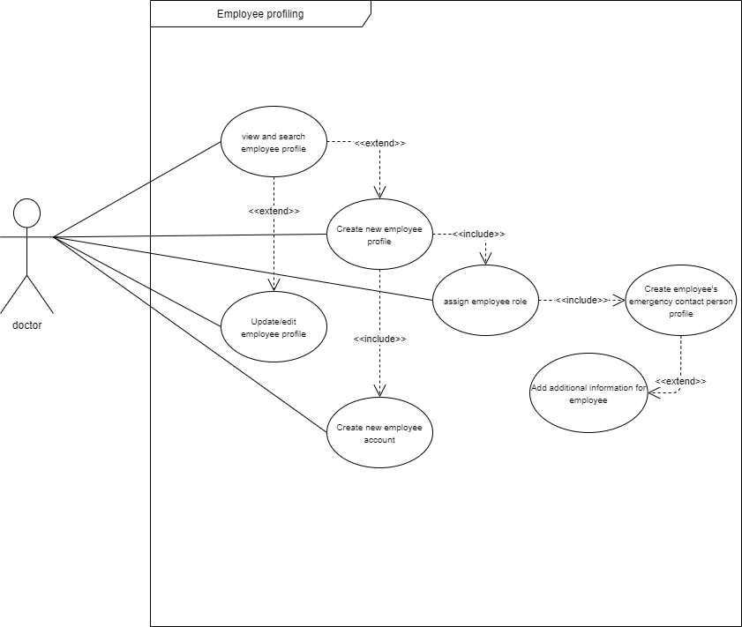

**2.1.2 Patient Profiling**

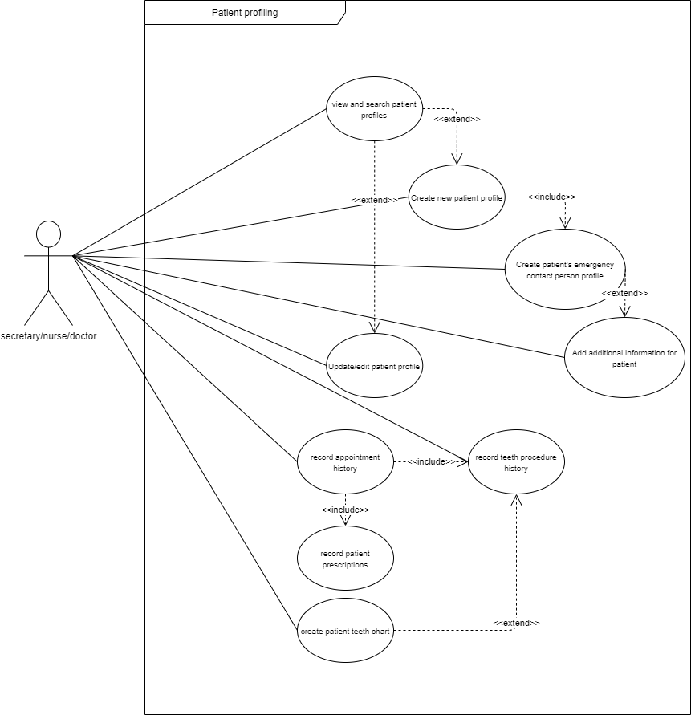

**2.1.3 Inventory Management**

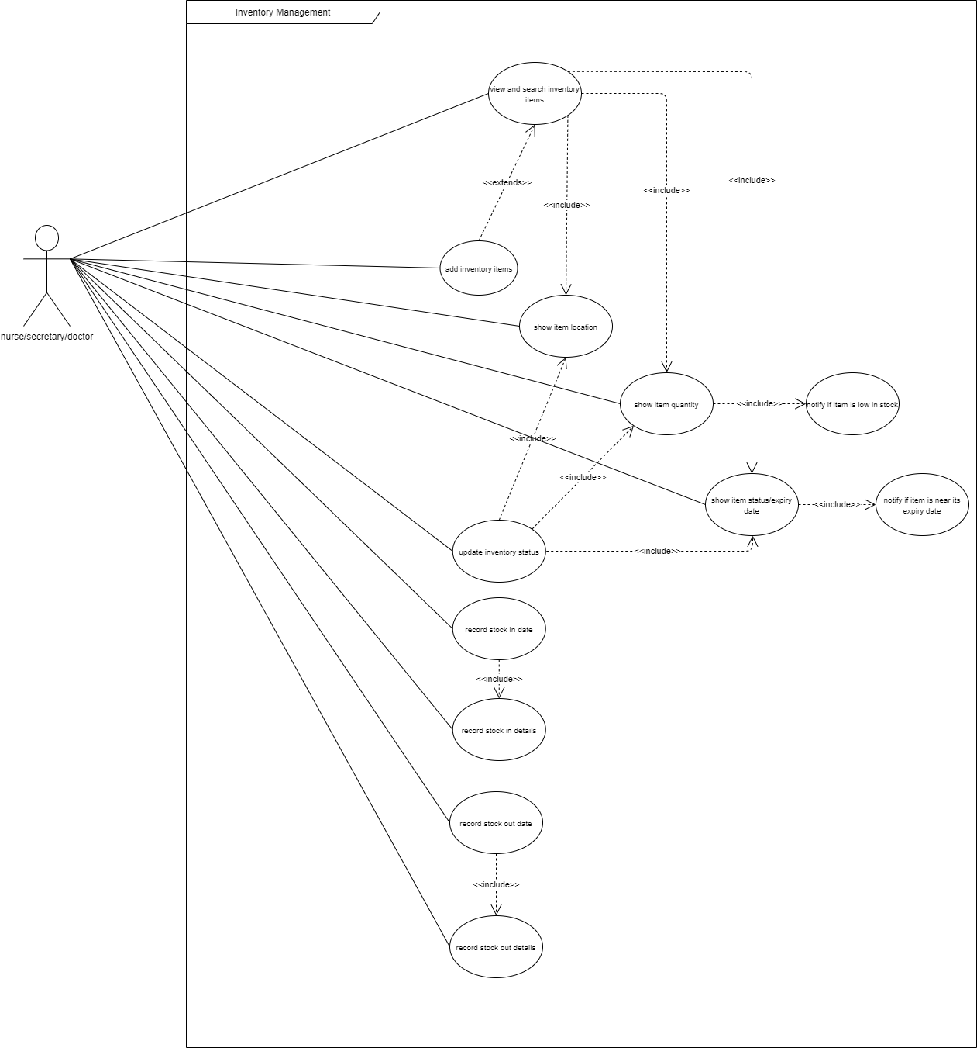

**2.1.4 Appointment Management**

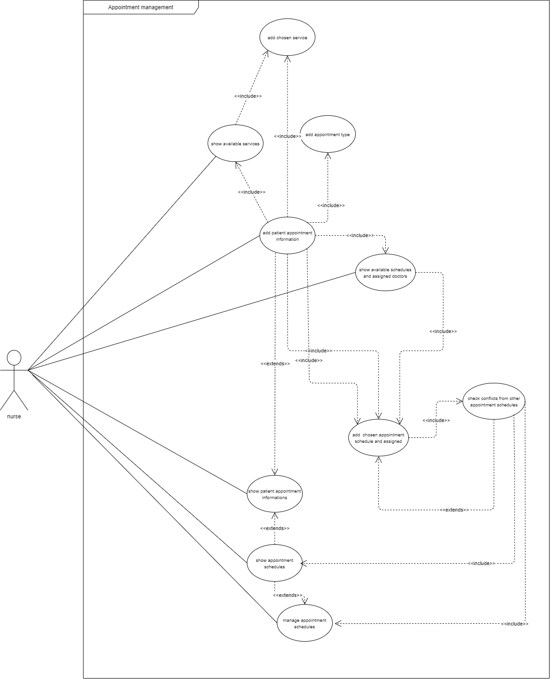

**2.1.5 After treatment Process**

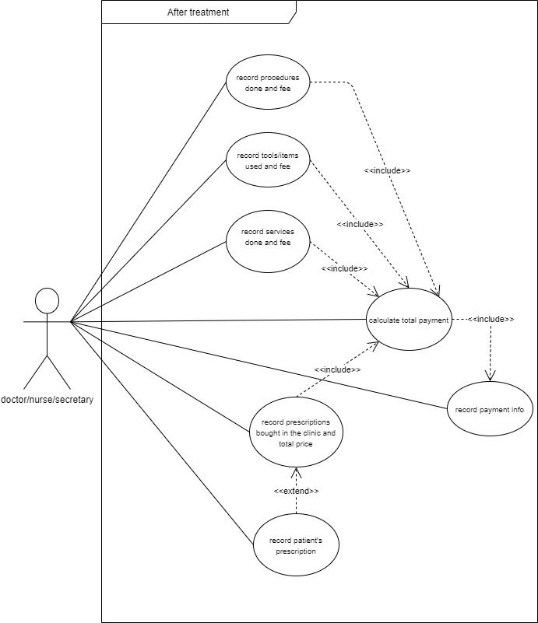

**2.1.6 Accounting Management**

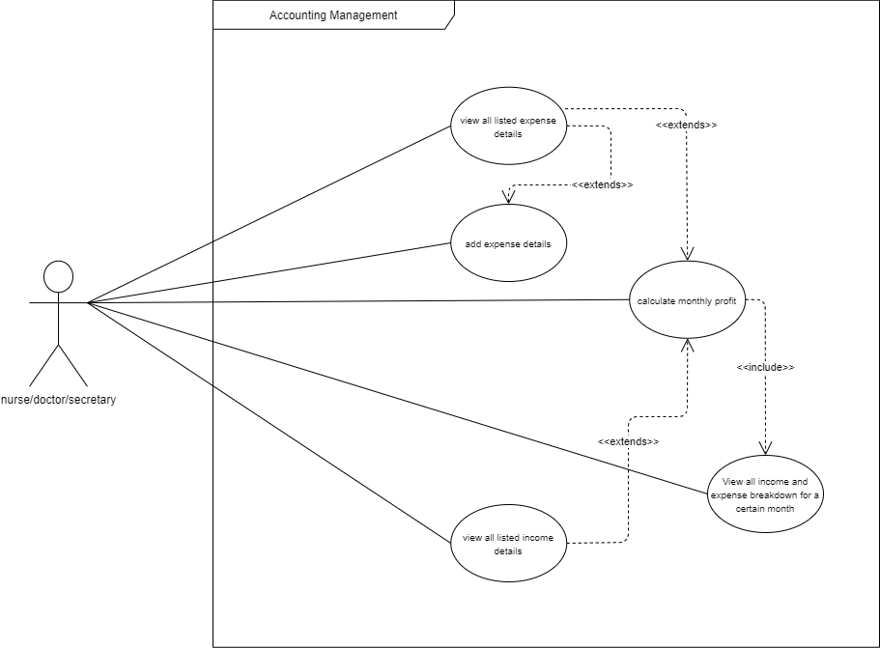

**2.2 Domain Class Diagram (**soft copy is included in the folder**)**

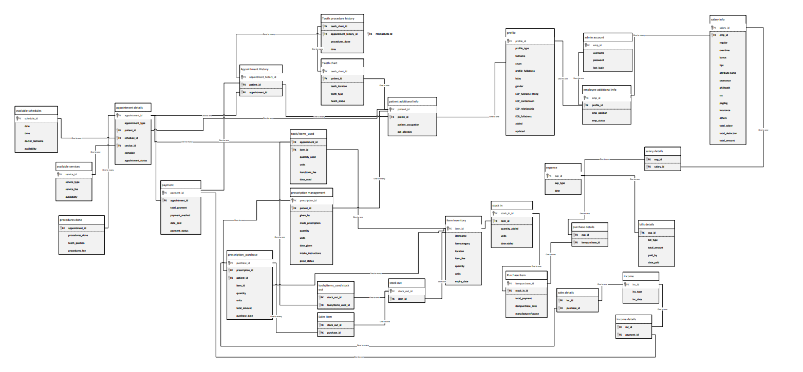

**2.3 Design Class Diagram (**soft copy is included in the folder**)**

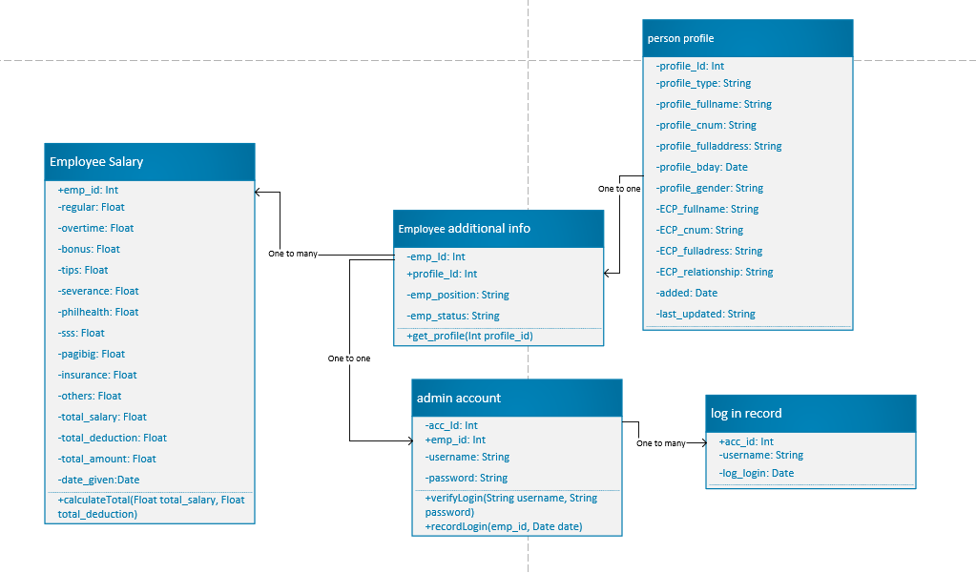**2.3.1 Employee Profiling**

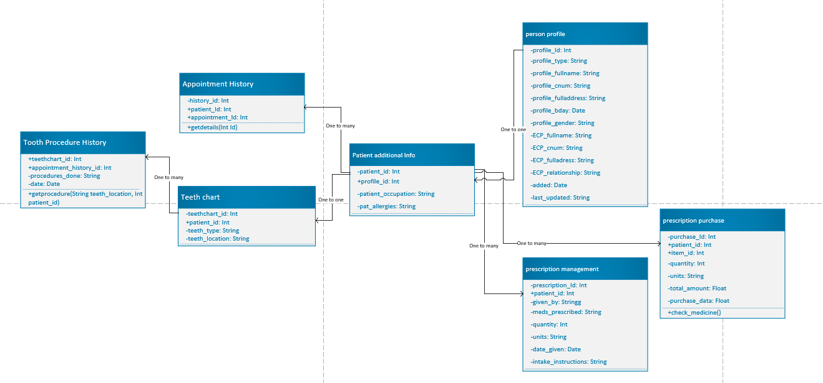**2.3.2 Patient Profiling**

**2.3.3 Inventory Management**

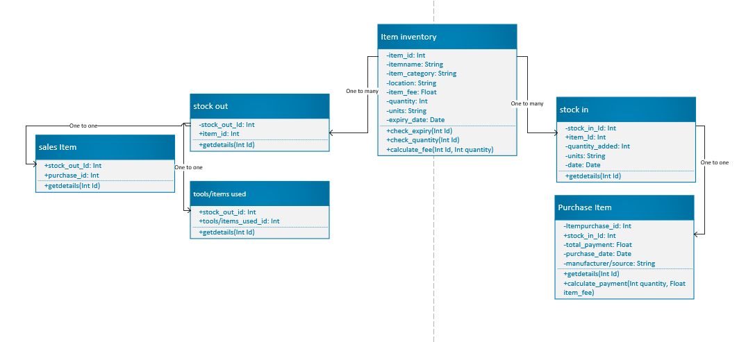

**2.3.4 Appointment Management**

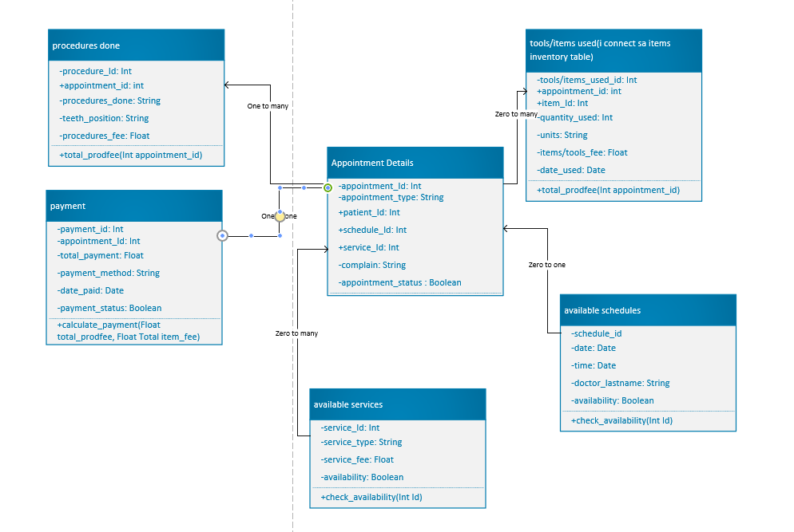

**2.3.5 Accounting Management**

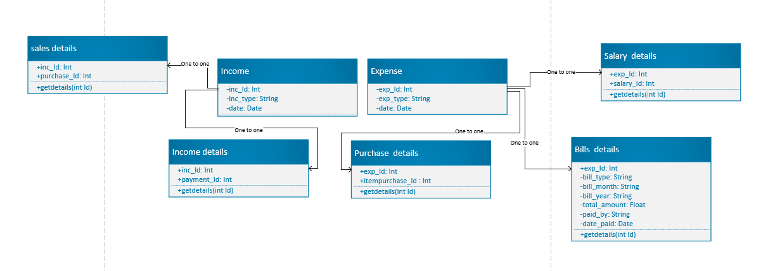

**2.4 User Interface**

**LOG IN SCREEN**

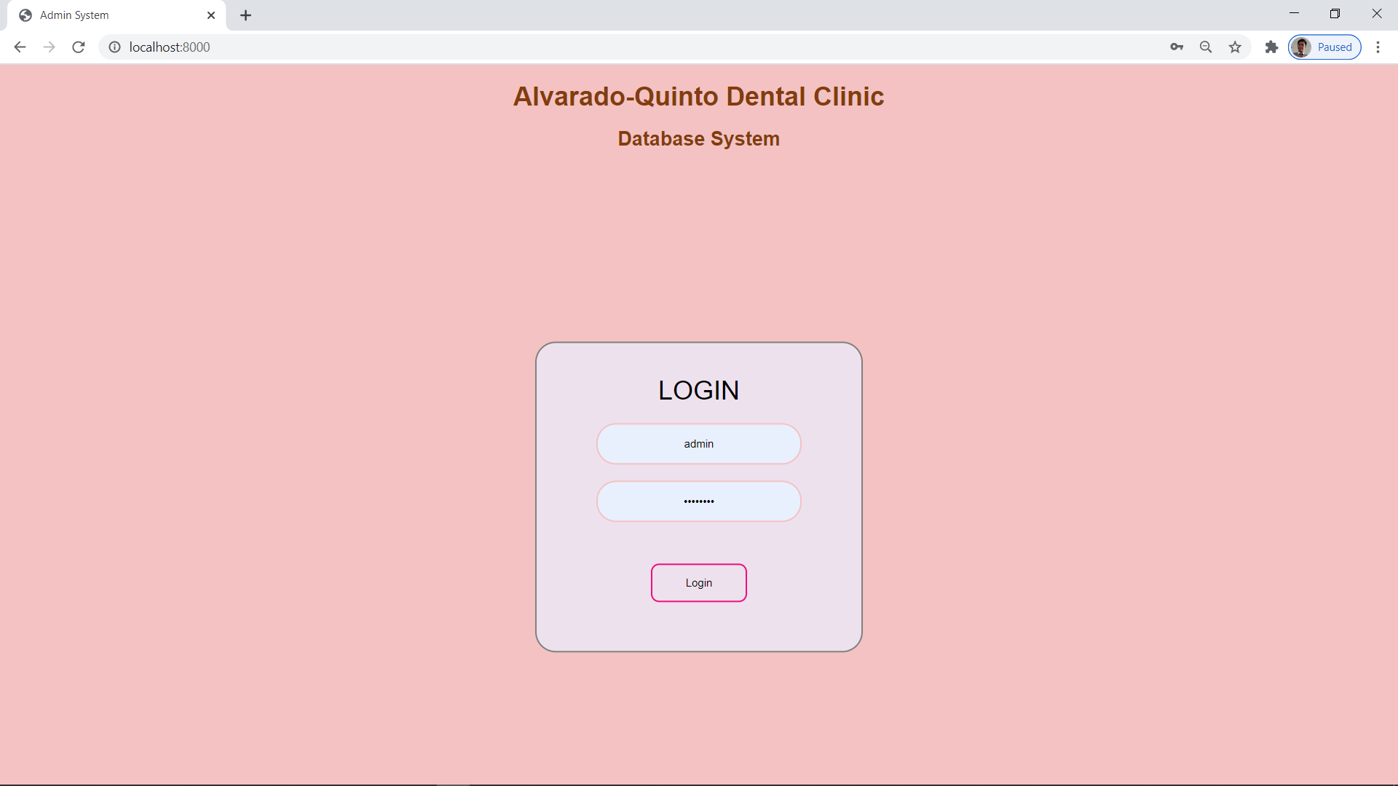

**HOME SCREEN (with notification tables)**

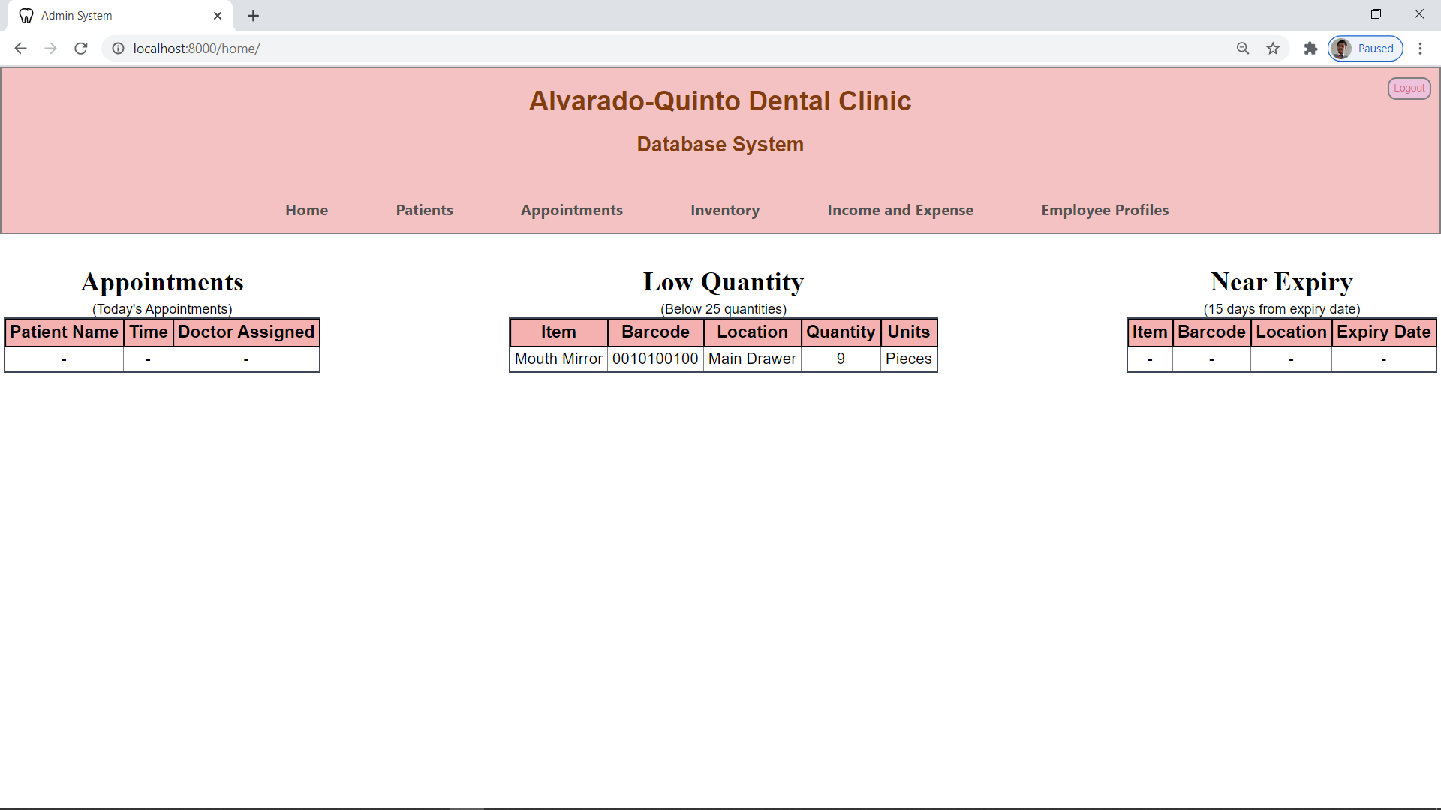

**LIST OF PATIENT**

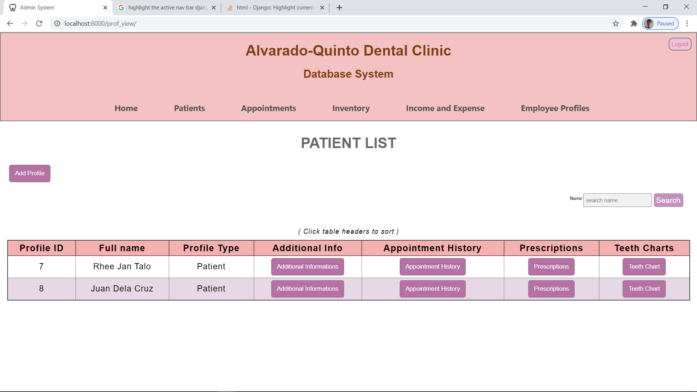

**ADDING NEW PATIENT PROFILE**

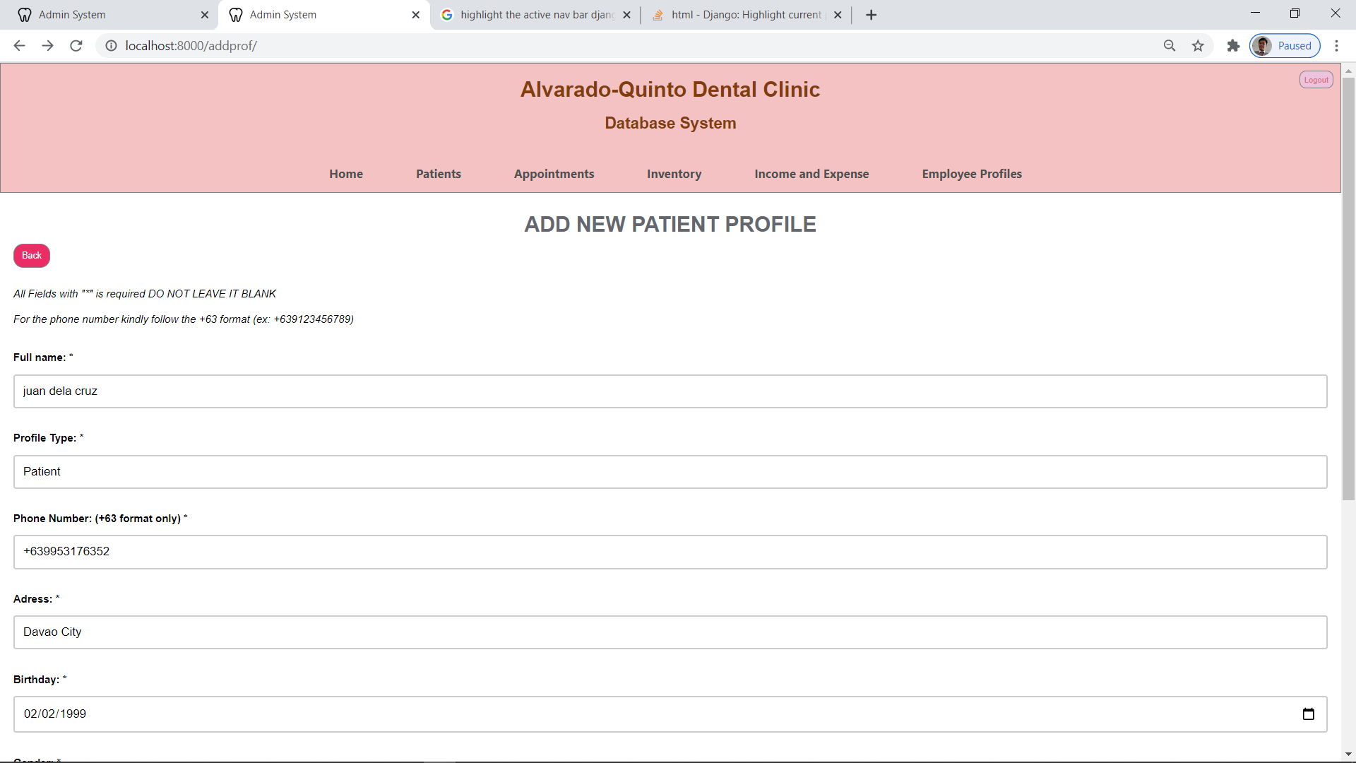

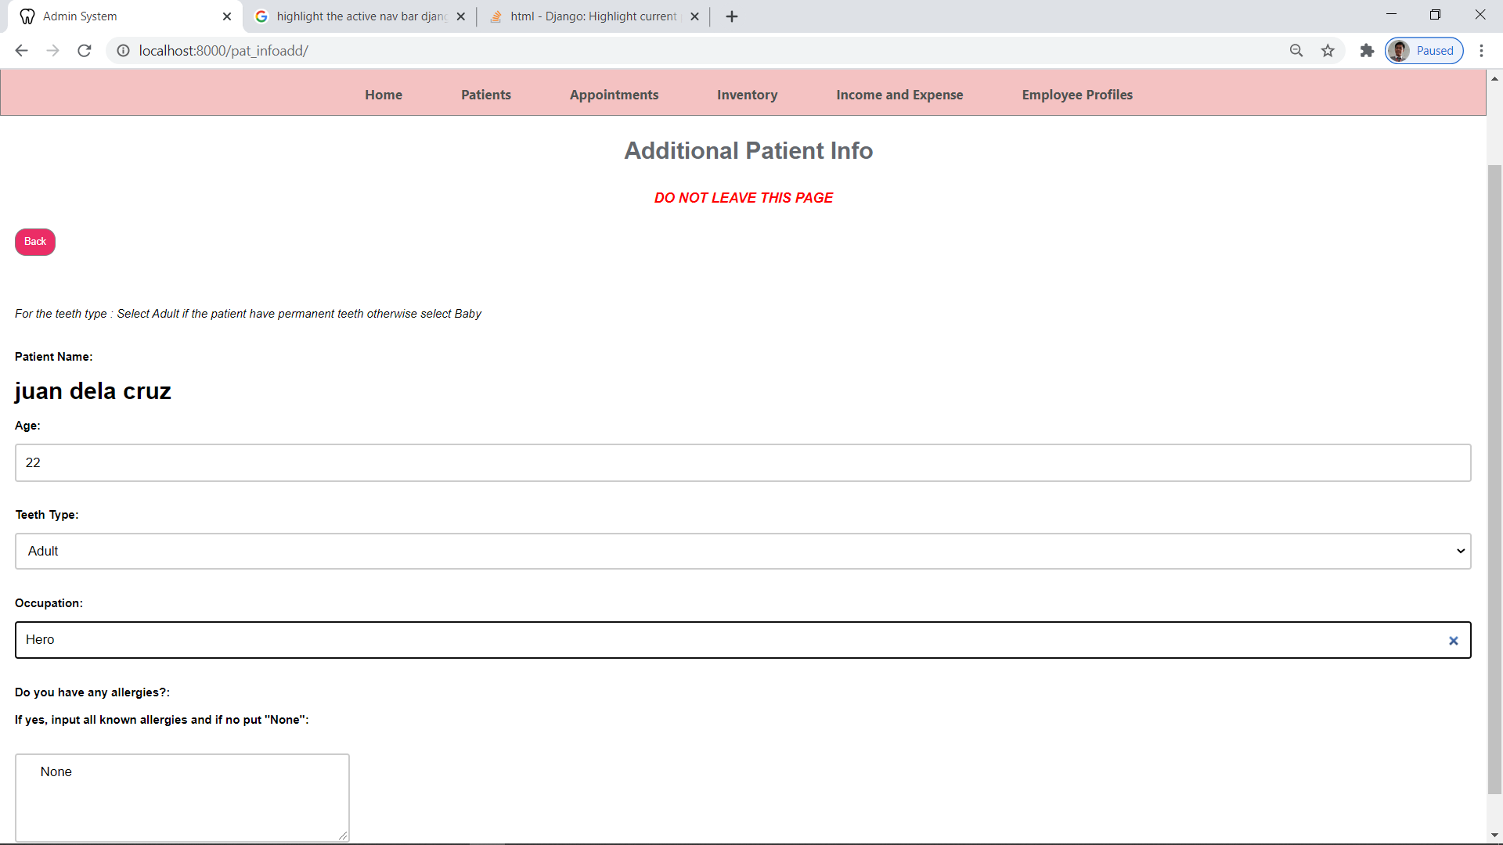

**PATIENT INFORMATION VIEW**

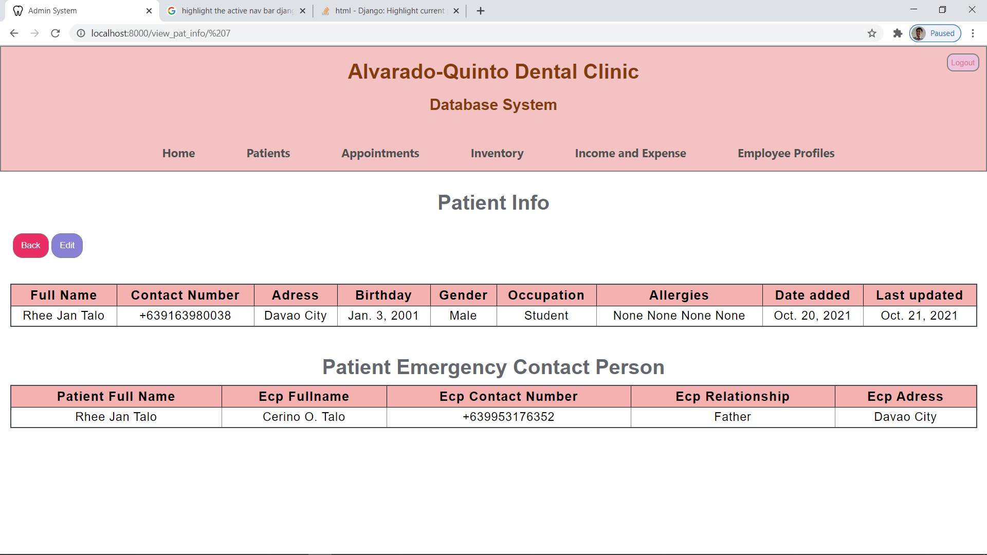

**EDIT PATIENT INFORMATION**

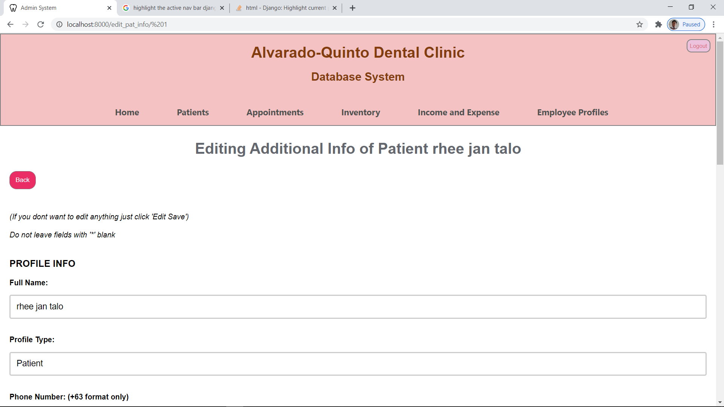

**APPOINTMENT HISTORY (PER PATIENT)**

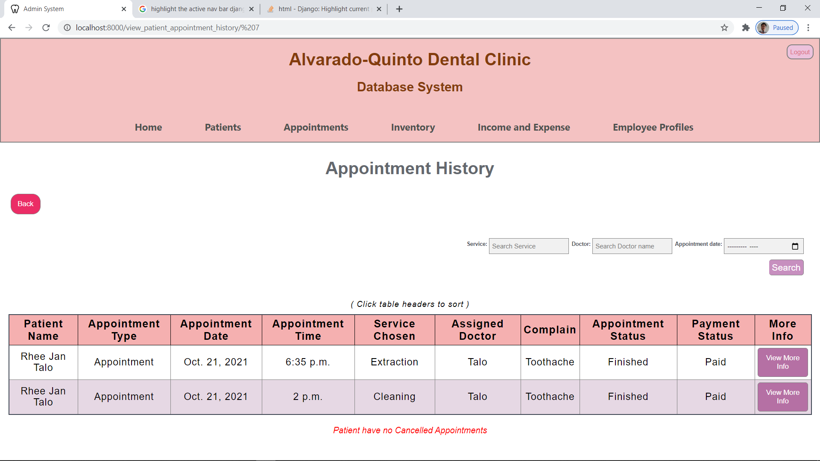

**APPOINTMENT INFORMATION**

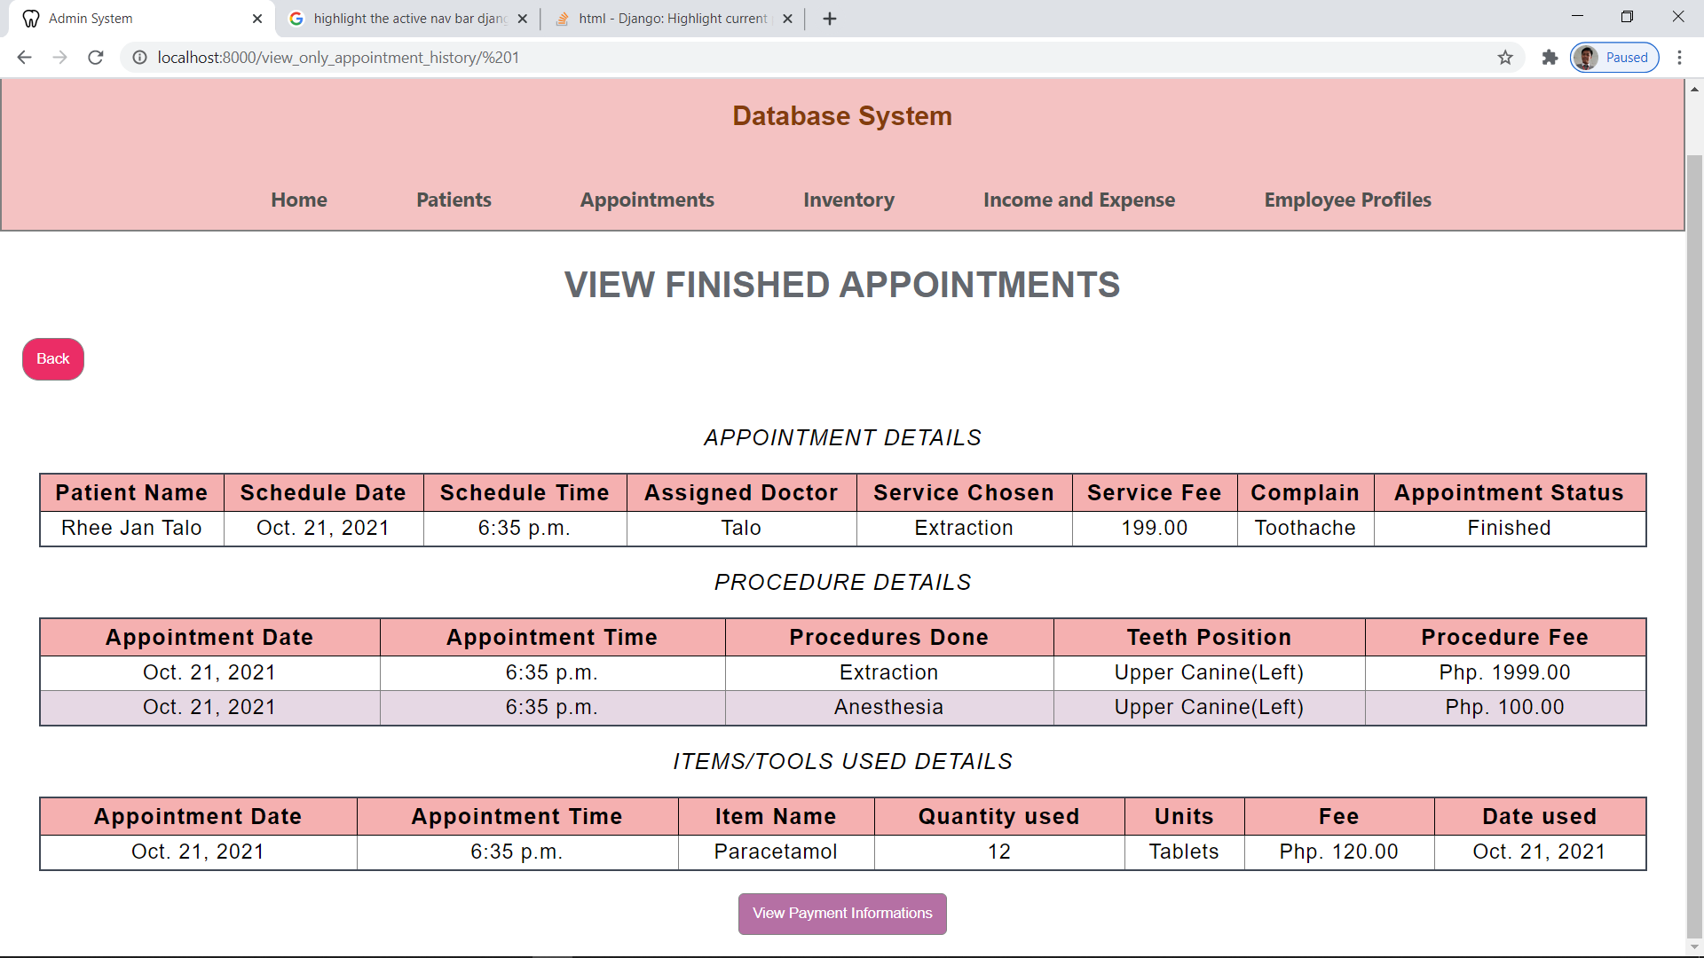

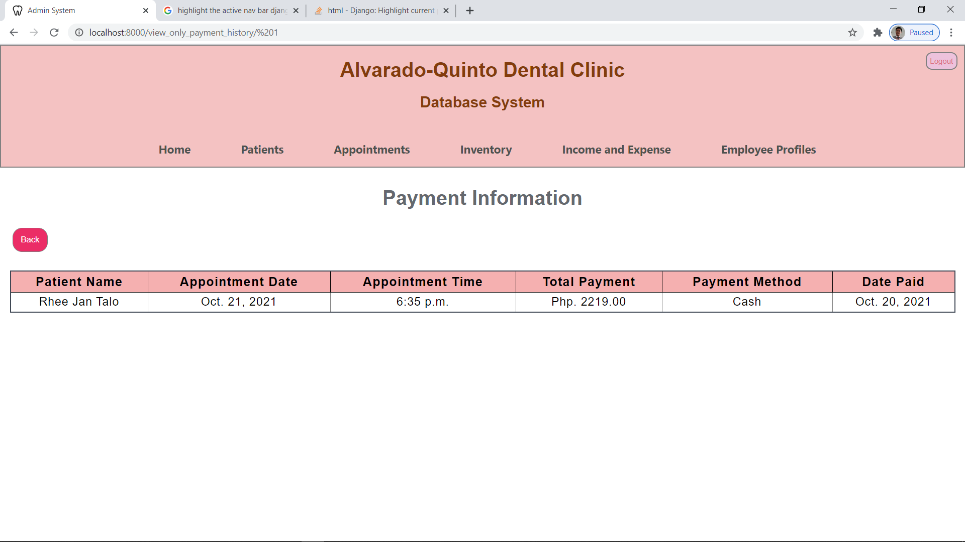

**PATIENT PRESCRIPTIONS**

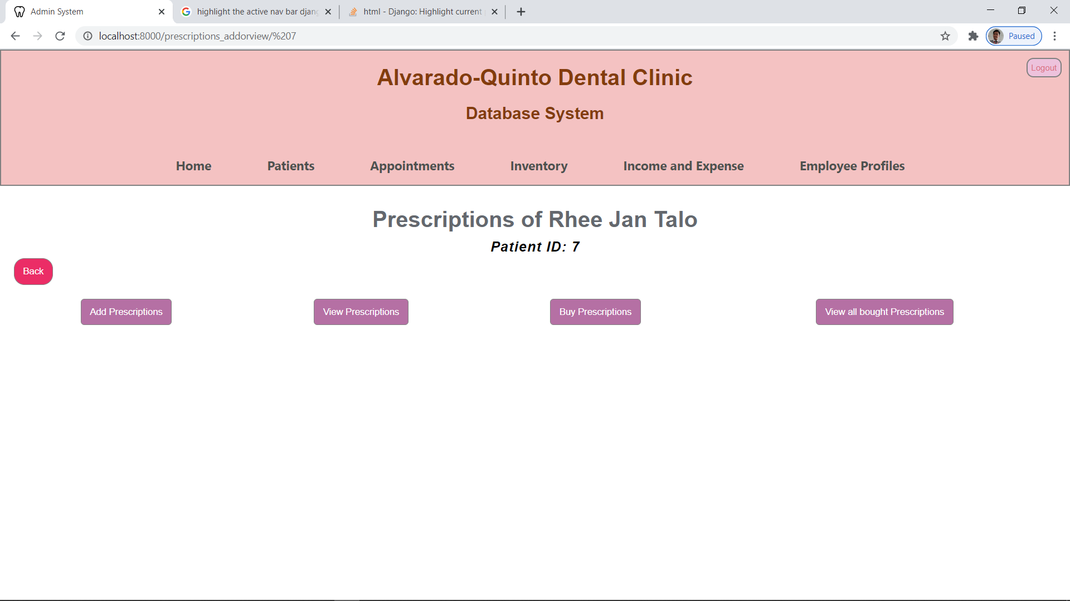

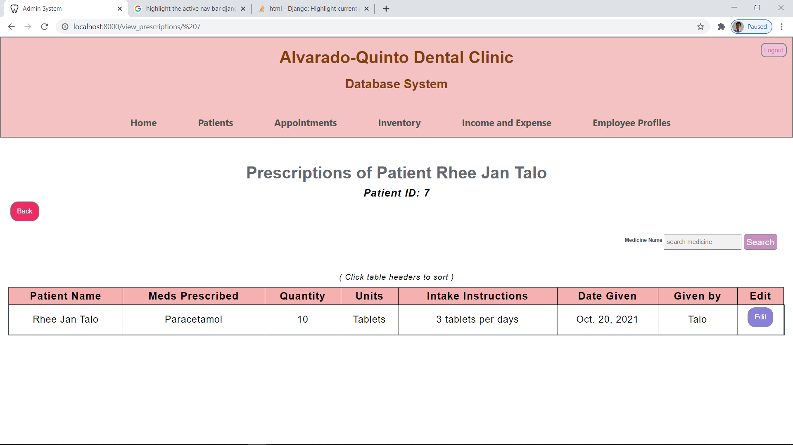

**ADDING OF PRESCRIPTION**

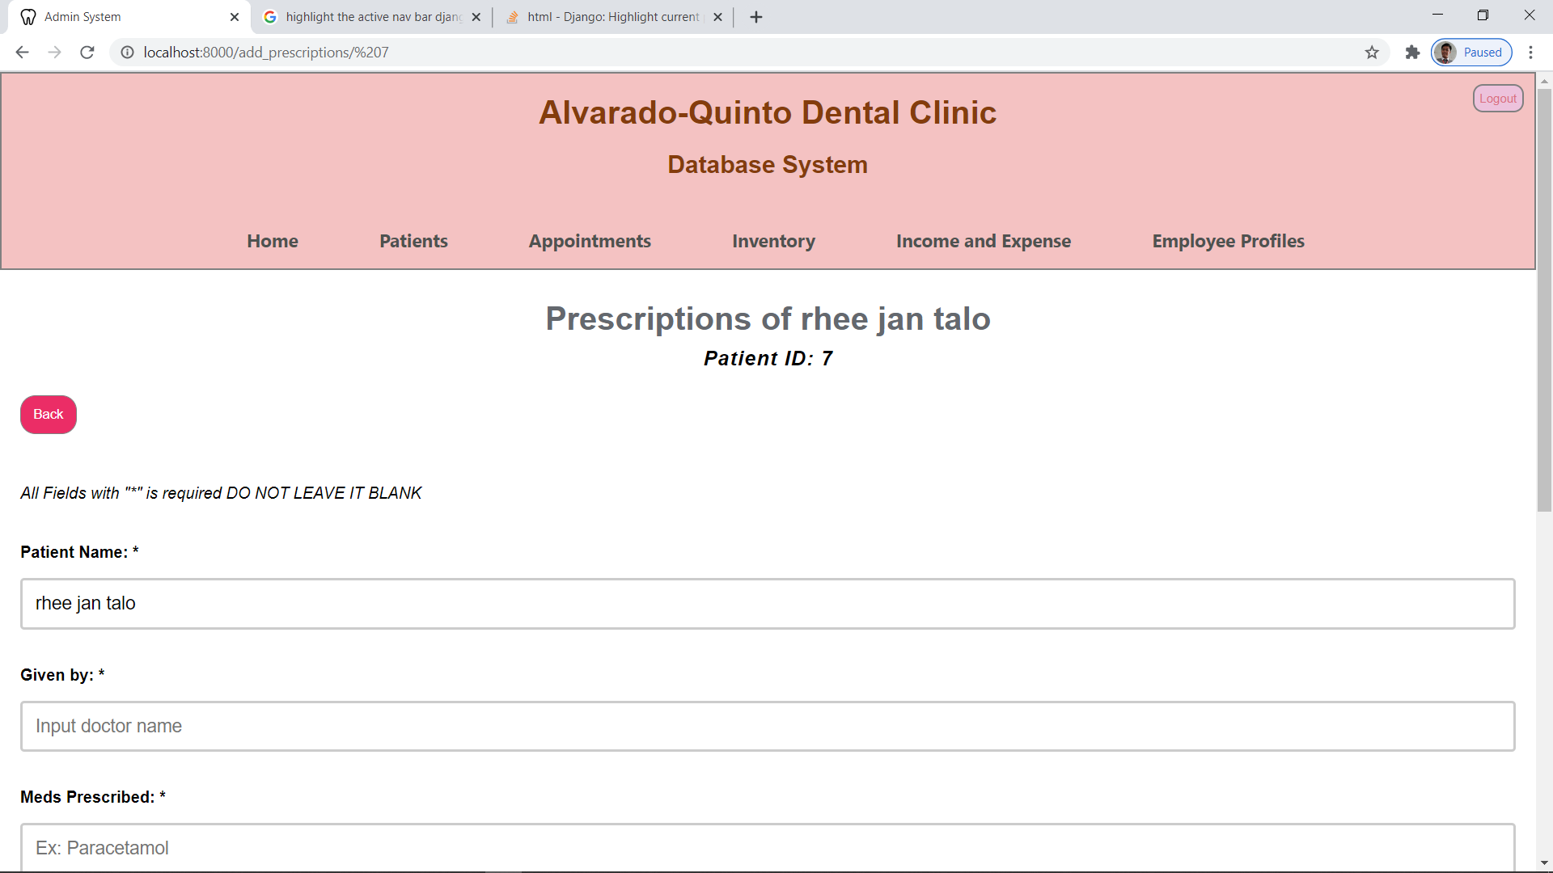

**EDITING OF PRESCRIPTION**

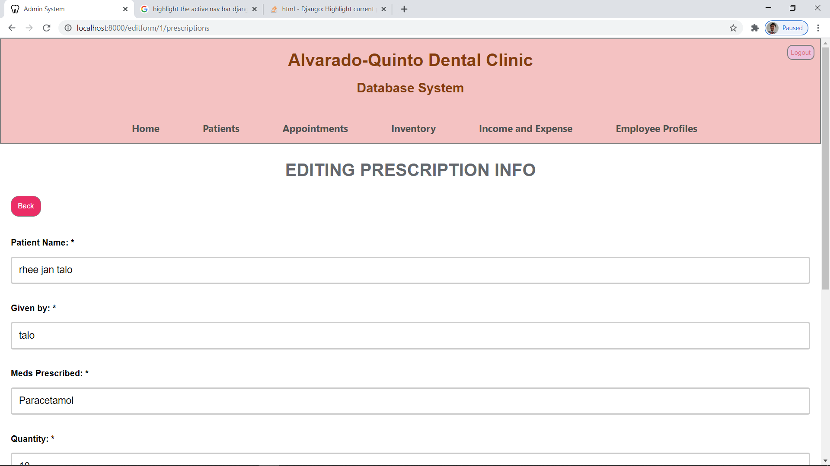

**PATIENT BOUGHT PRESCRIPTION FROM THE CLINIC**

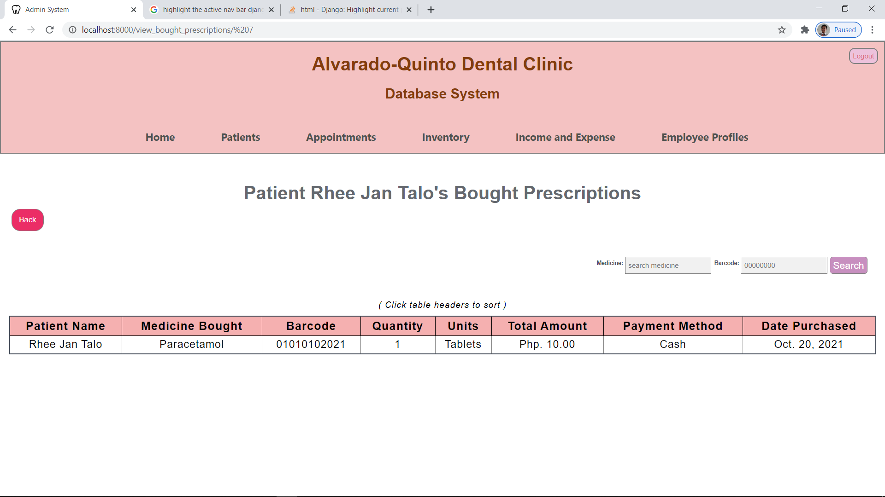

**BUYING OF PRESCRIPTION**

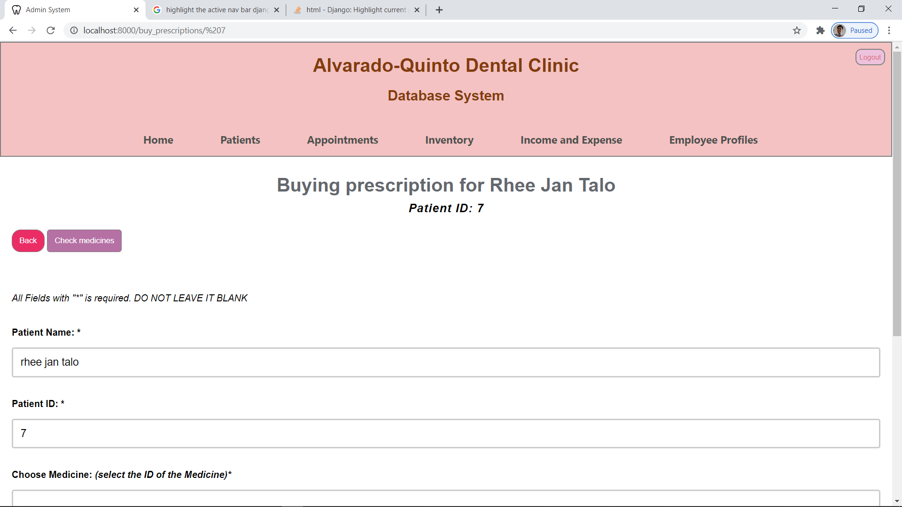

**PATIENT TEETH CHART**

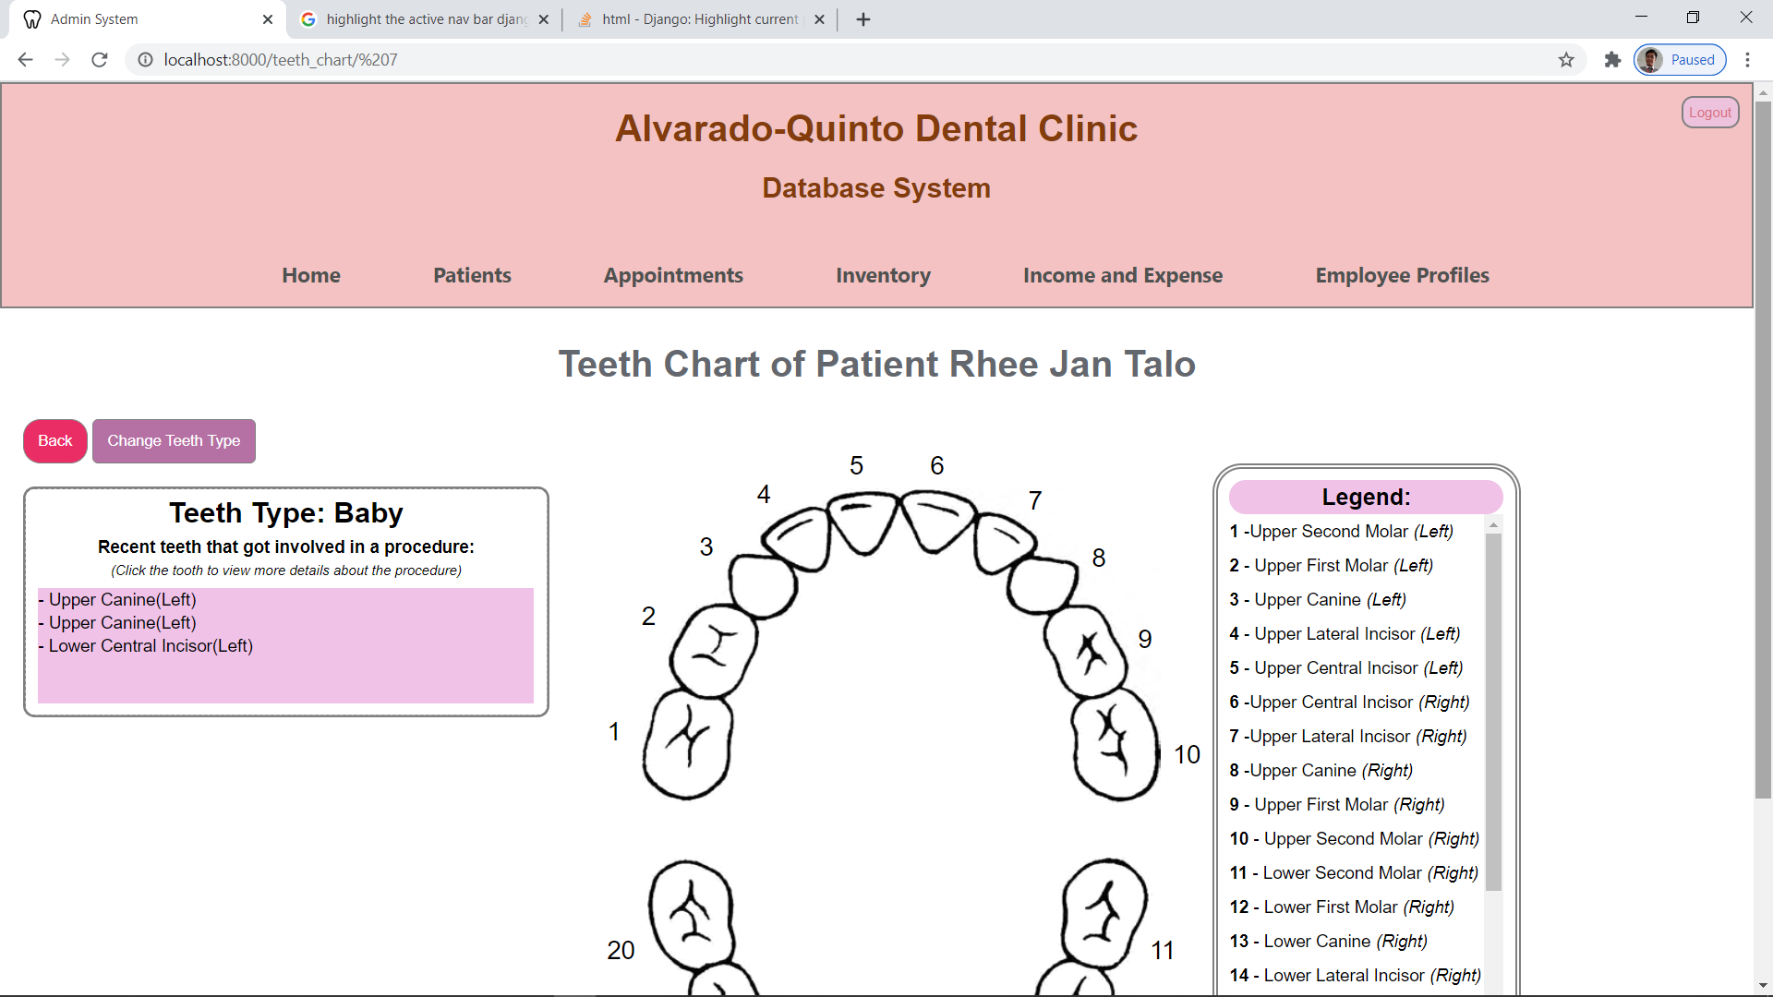

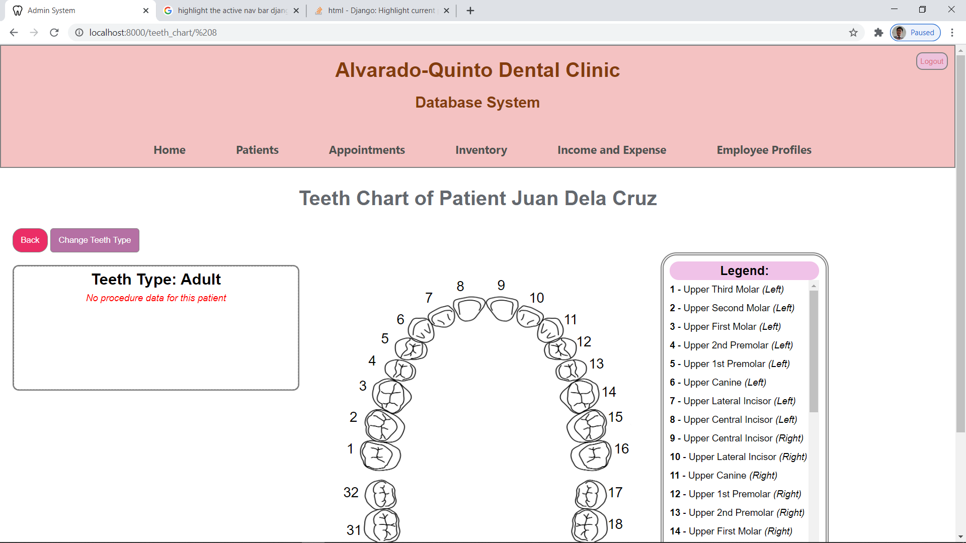

**TEETH CHART PROCEDURE HISTORY**

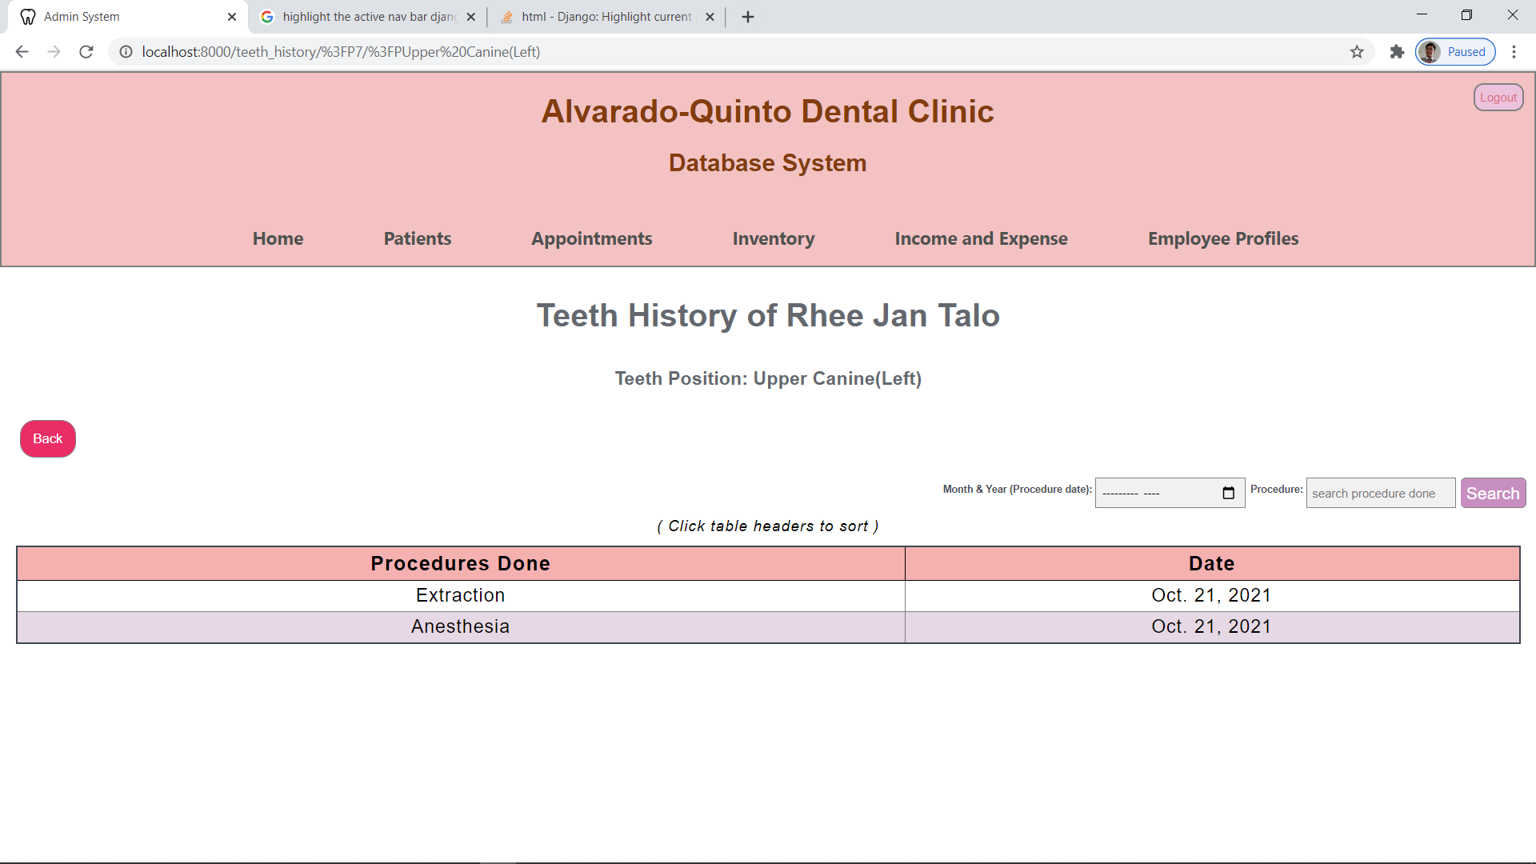

**EMPLOYEE LIST**

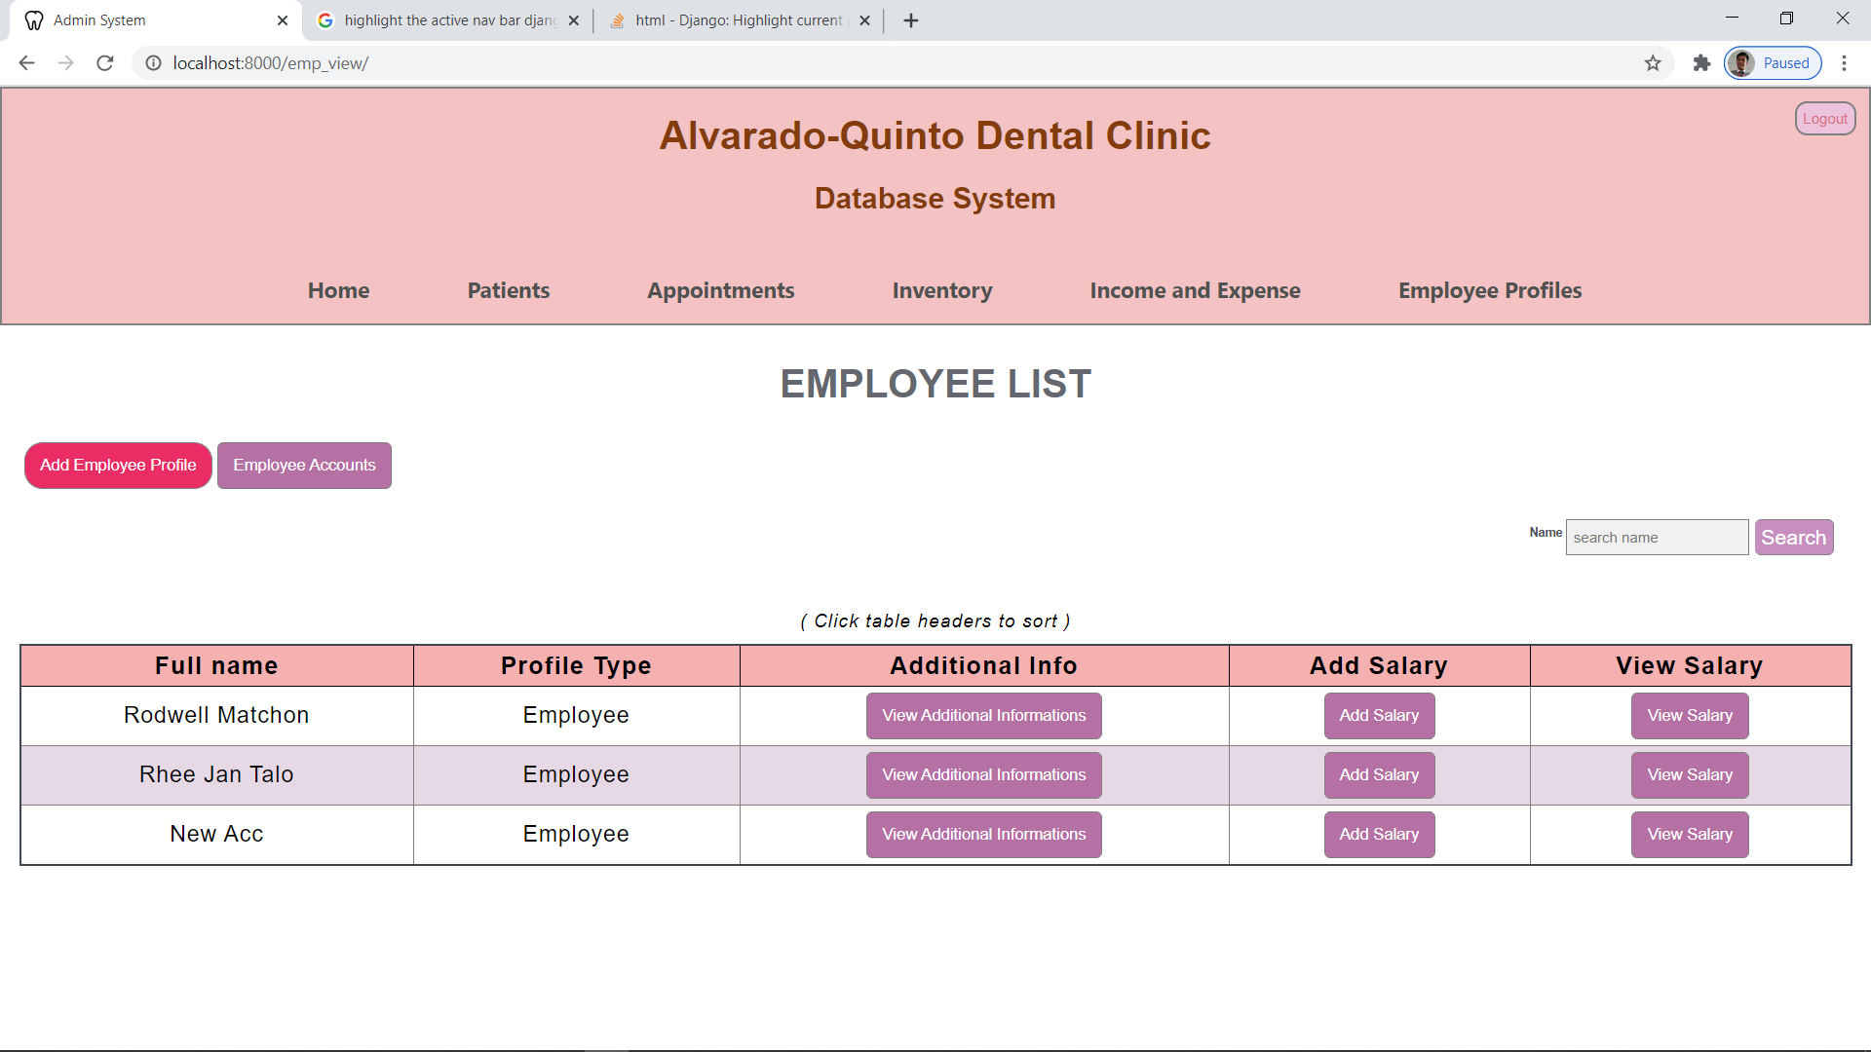

**ADDING OF EMPLOYEE PROFILE**

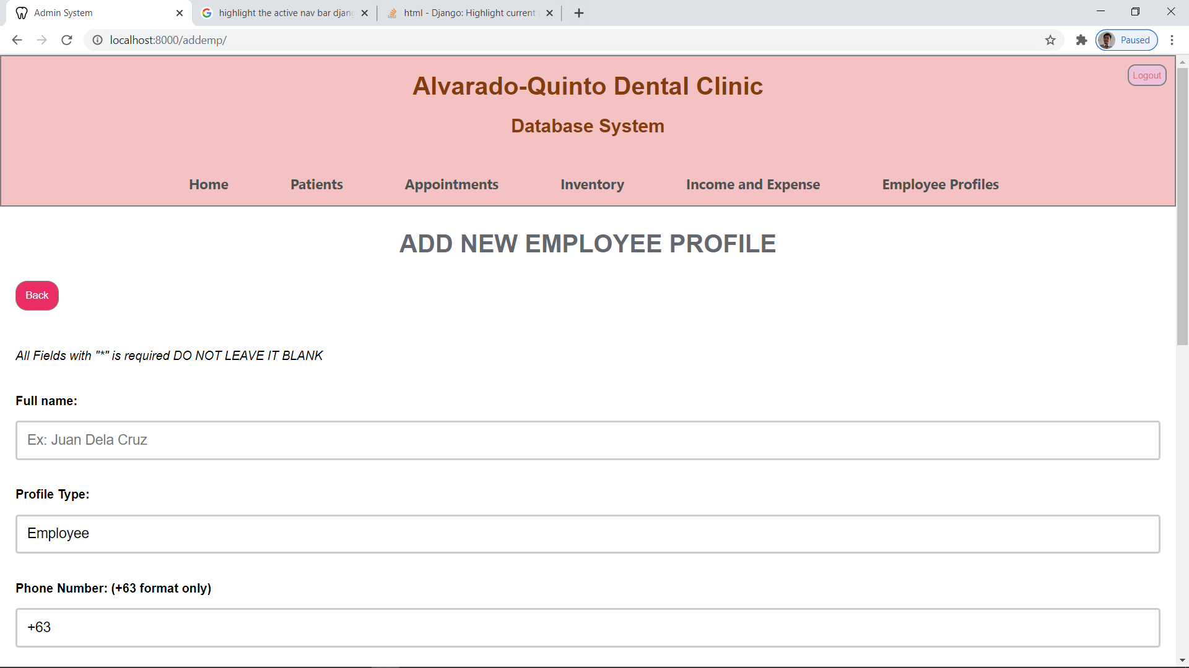

**EMPLOYEE INFORMATION DETAILS**

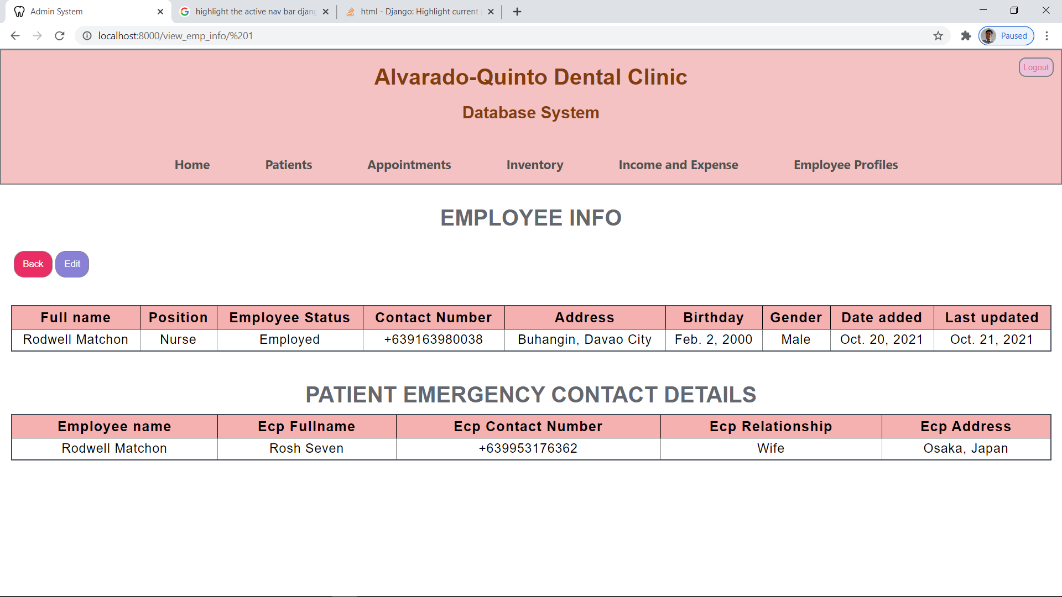

**EDITING OF EMPLOYEE INFORMATION**

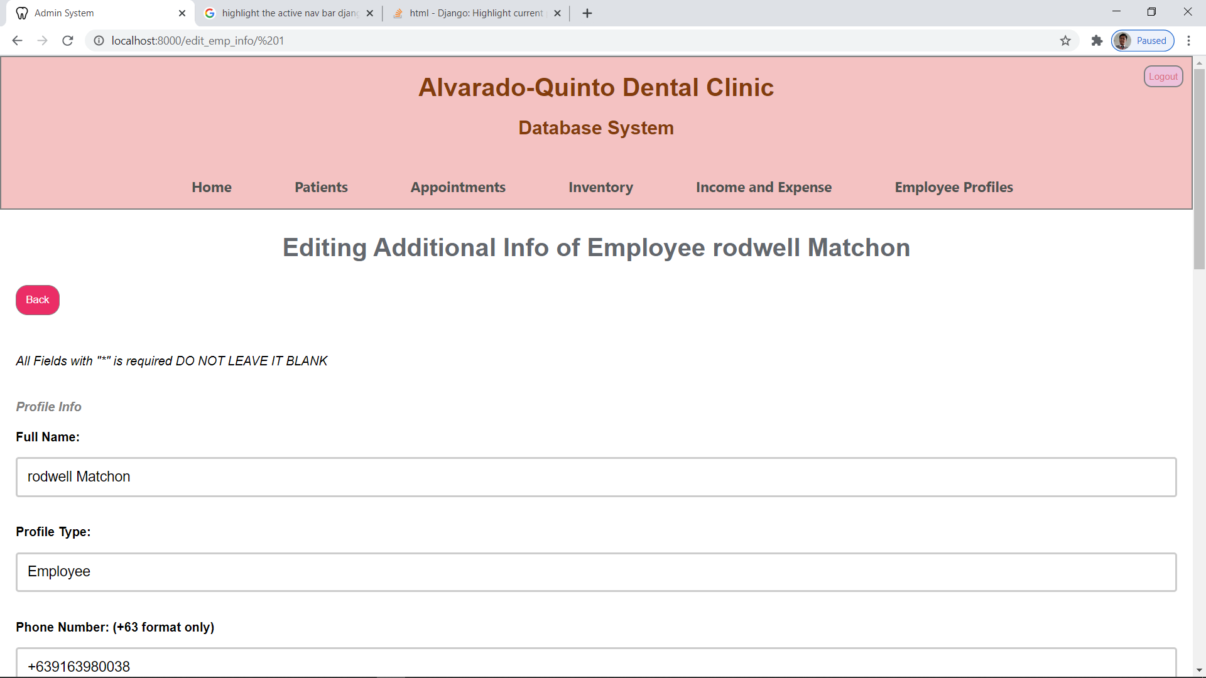

**EMPLOYEE SALARY**

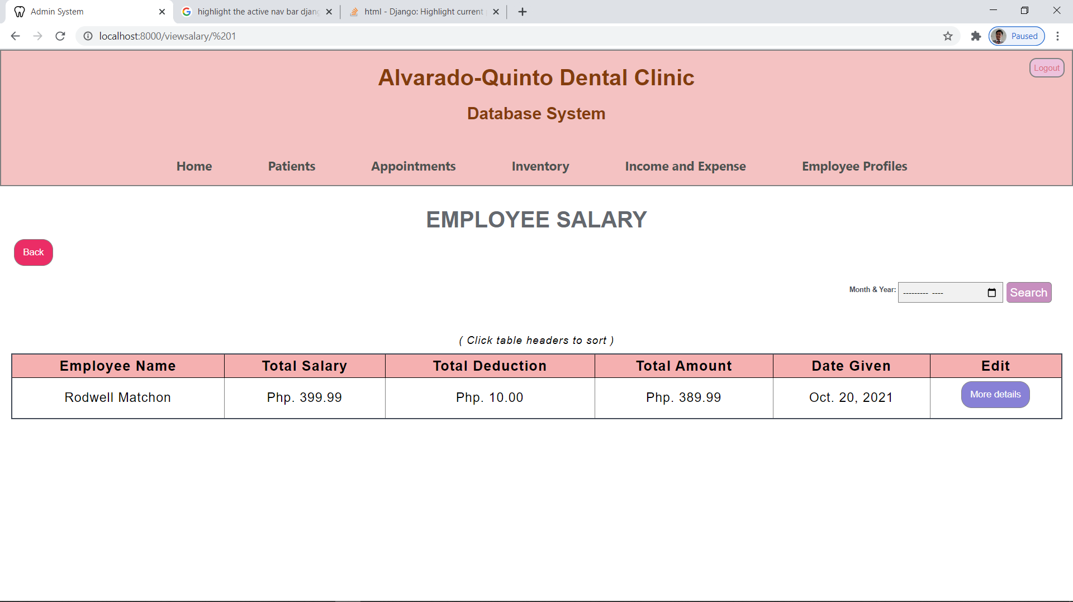

**ADDING EMPLOYEE SALARY**

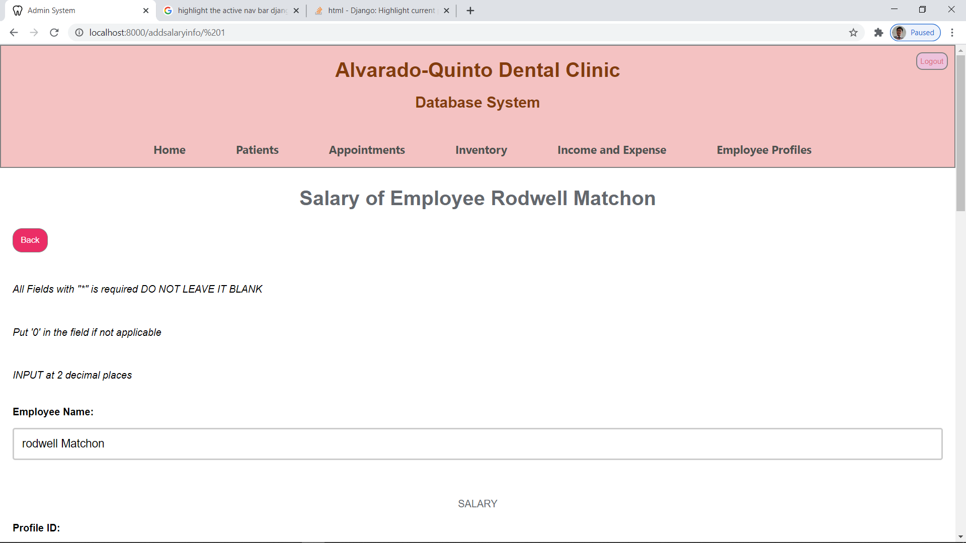

**SALARY DETAILS OF EMPLOYEE**

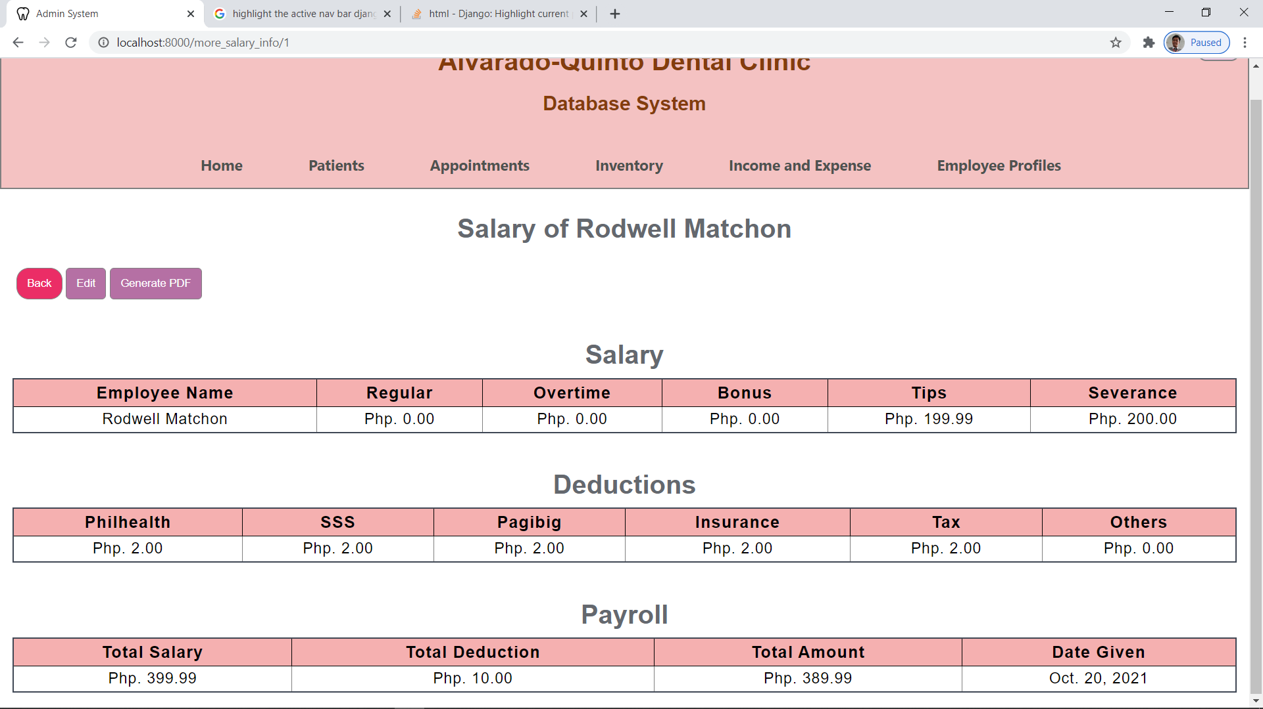

**EDITING SALARY DETAILS OF EMPLOYEE**

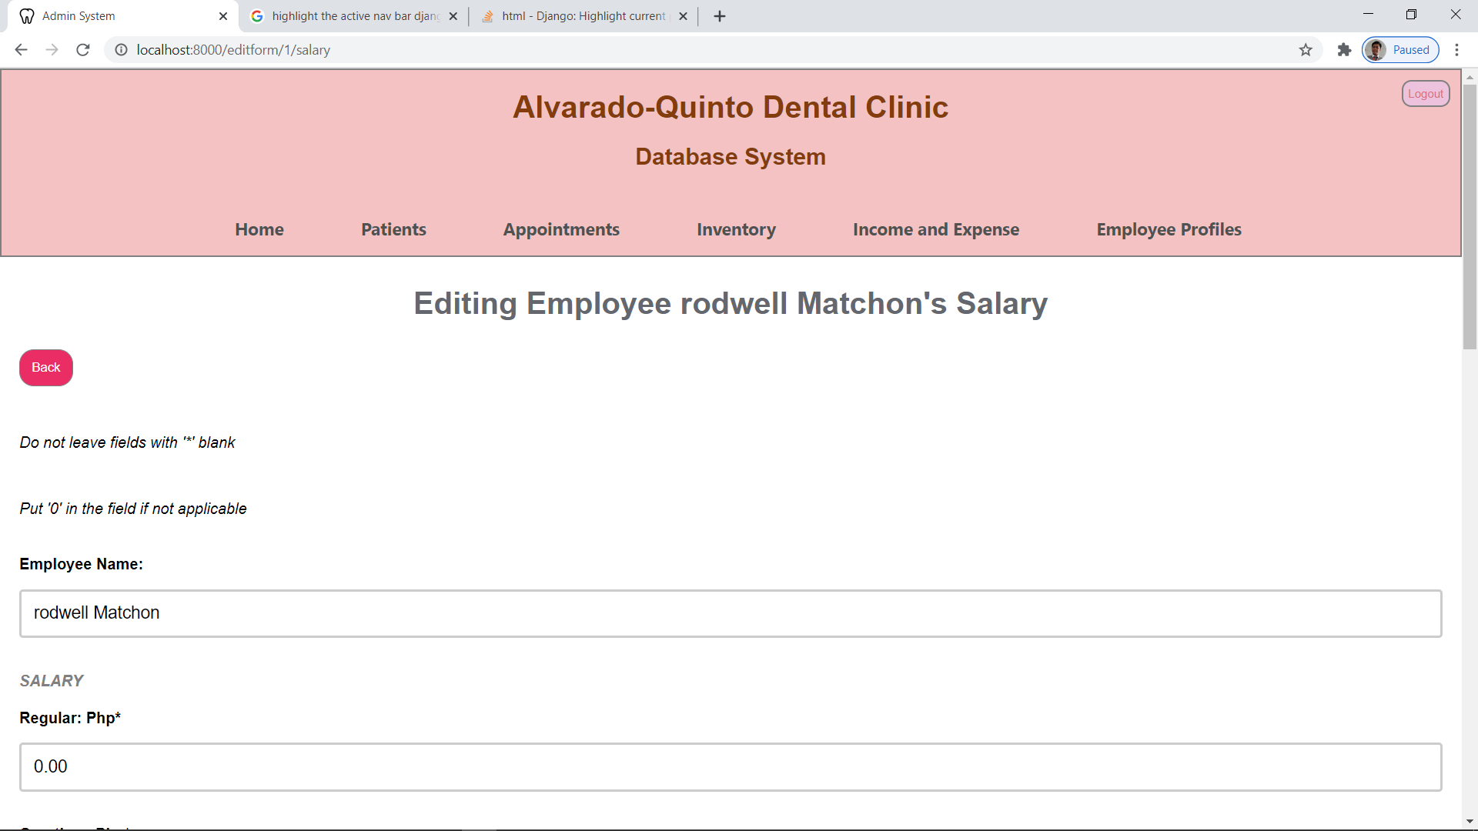

**SALARY REPORT OF EMPLOYEE**

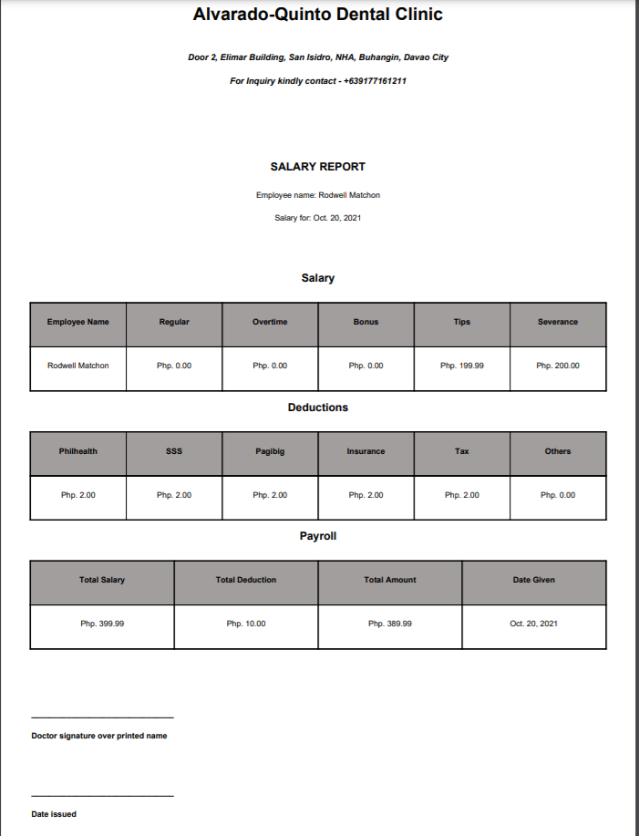

**EMPLOYEE ACCOUNTS**

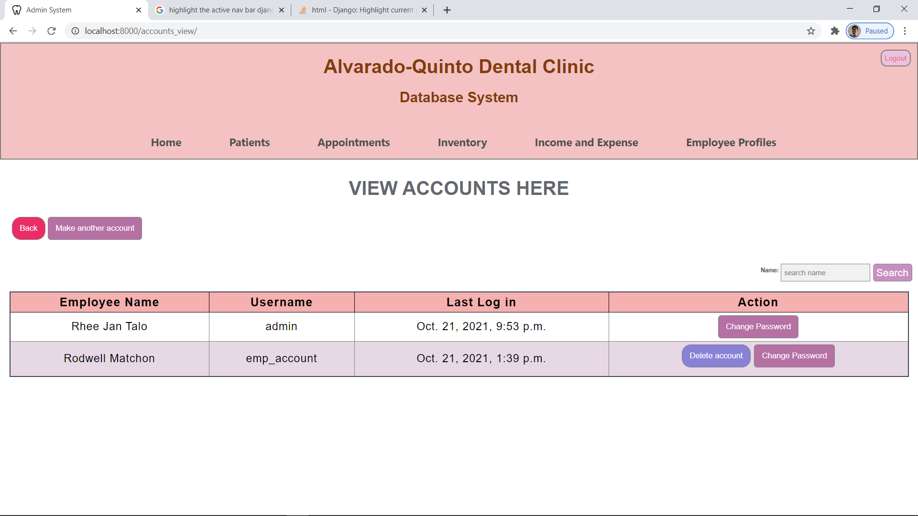

**CREATION OF EMPLOYEE ACCOUNT**

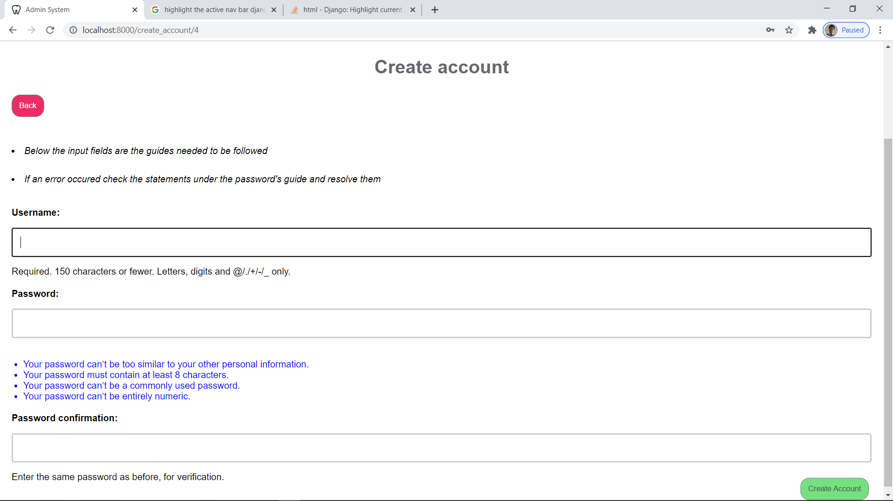

**CHANGING OF PASSWORD FOR EMPLOYEE ACCOUNT**

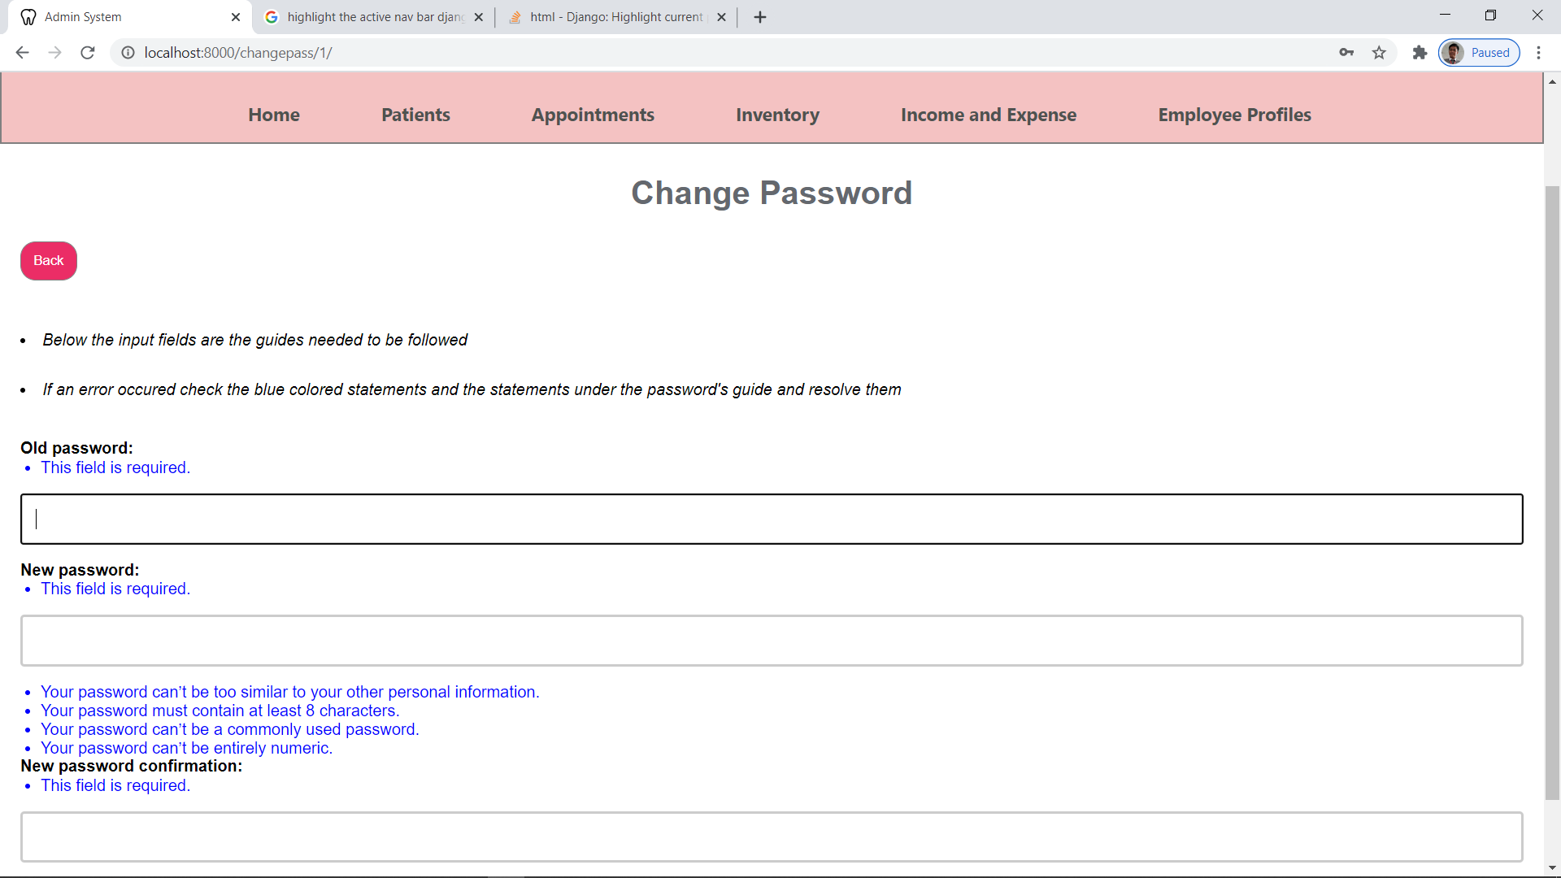

**DELETING OF ACCOUNT (account gets deleted but the employee profile stays)**

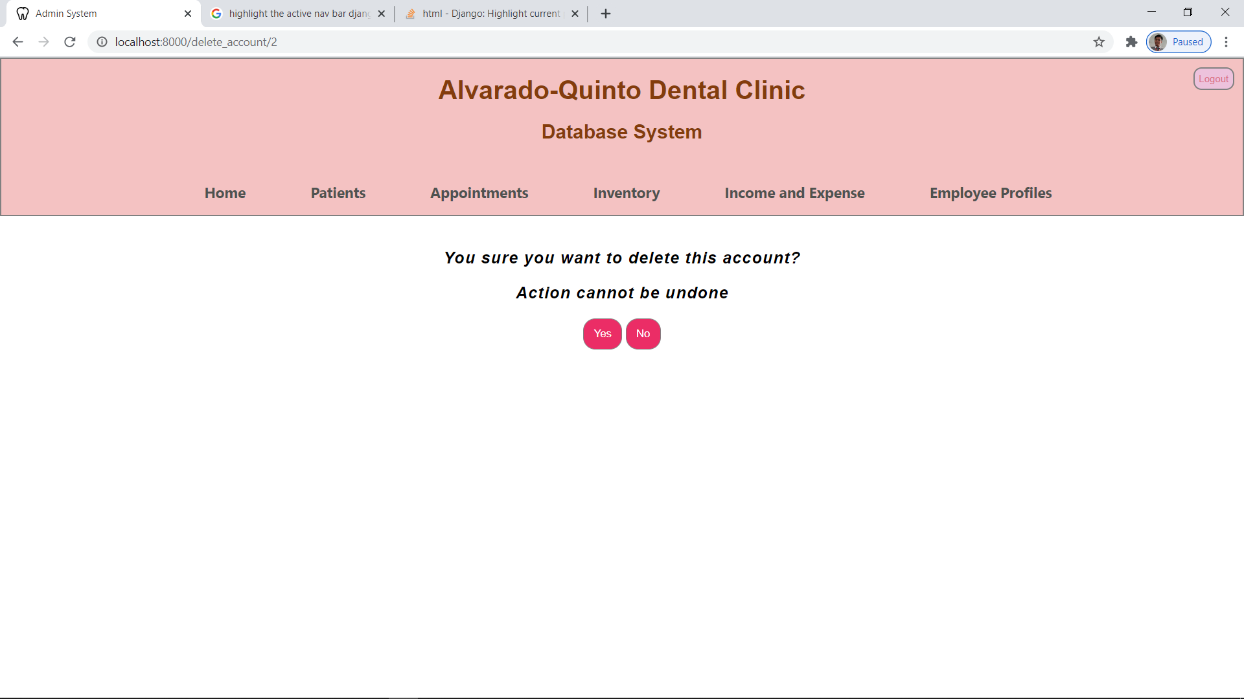

**APPOINTMENTS PAGE**

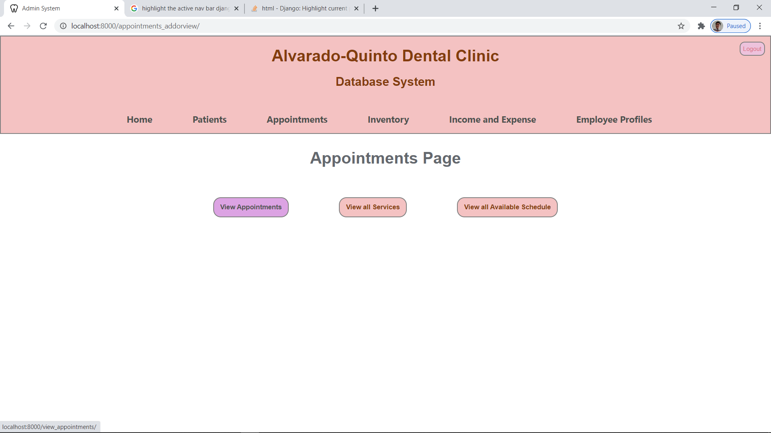

**APPOINTMENTS CALENDAR VIEW**

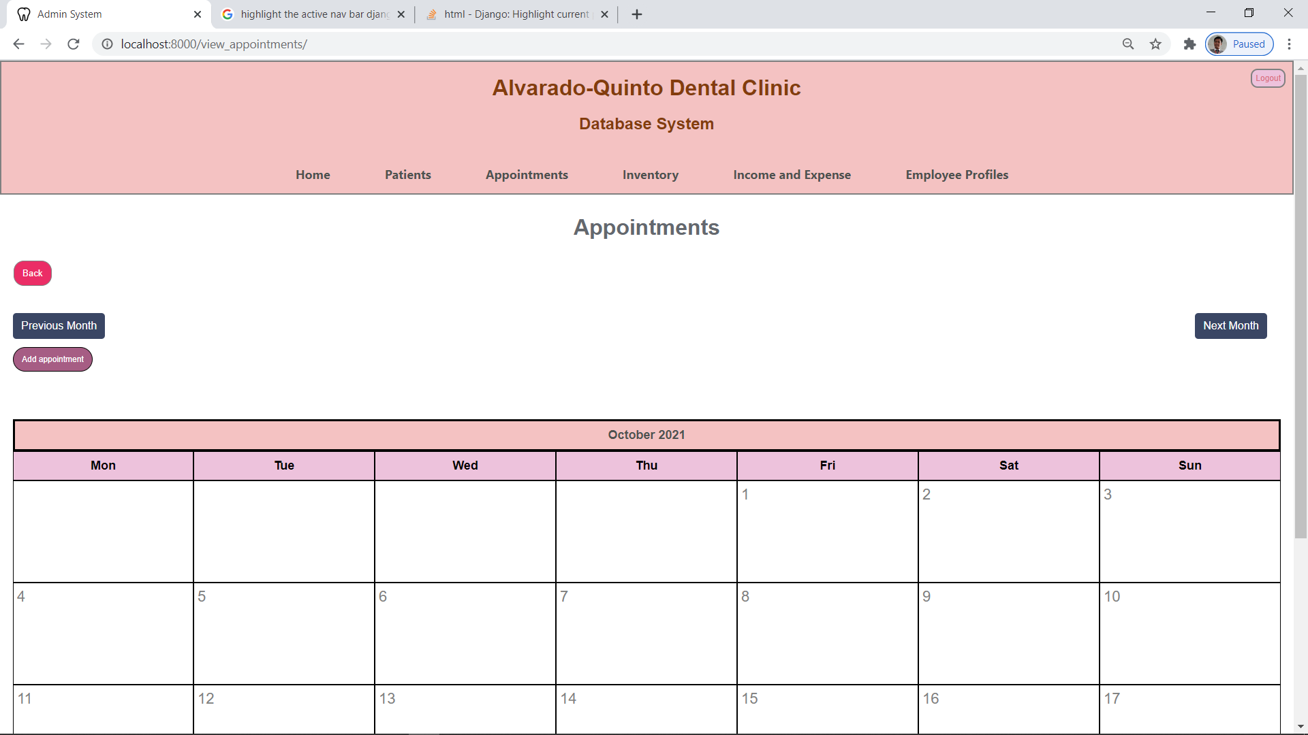

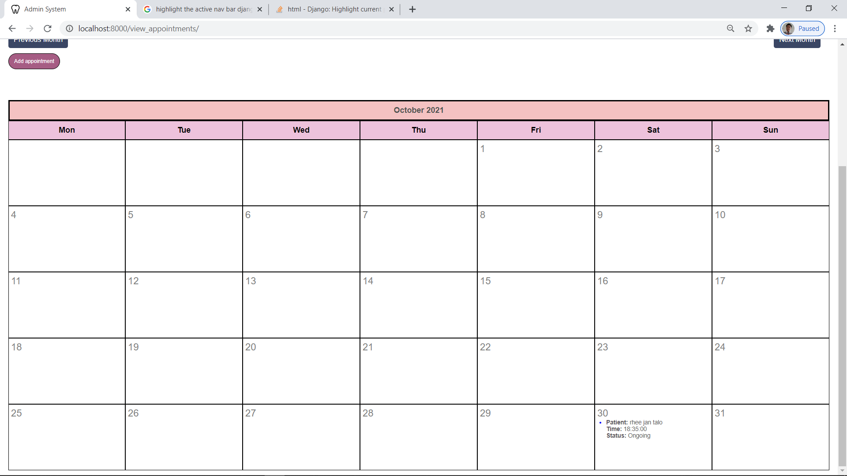

**APPOINTMENT DETAILS**

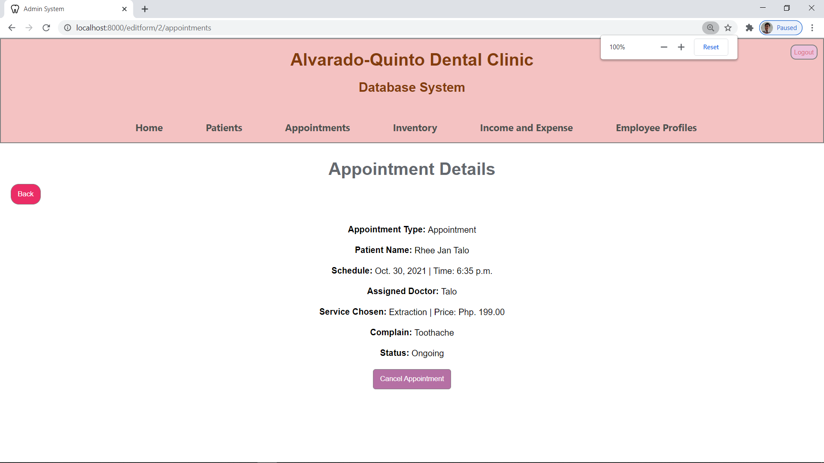

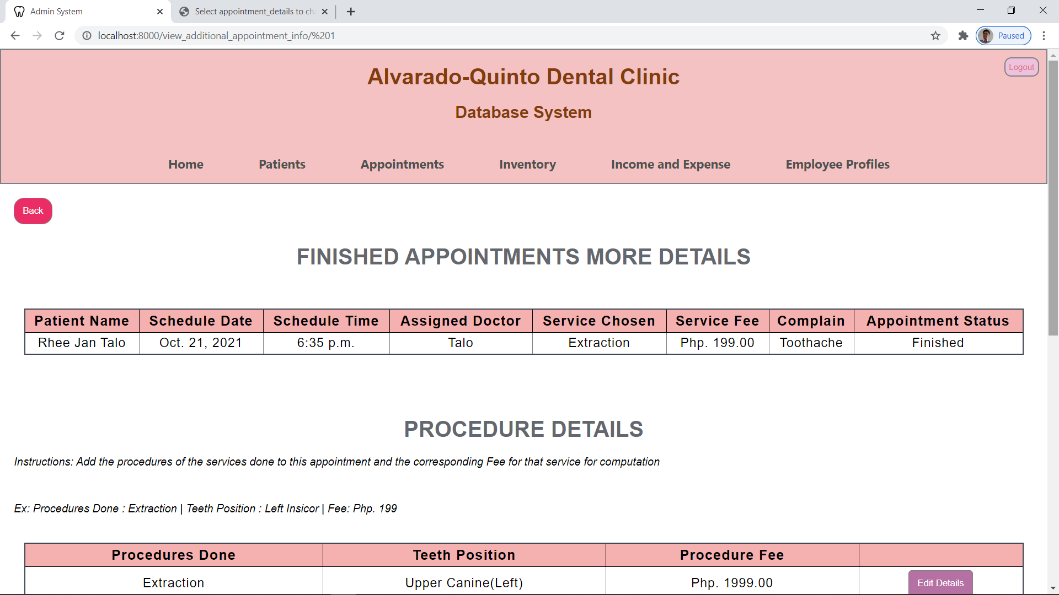

PROCEDURES DONE DETAILS

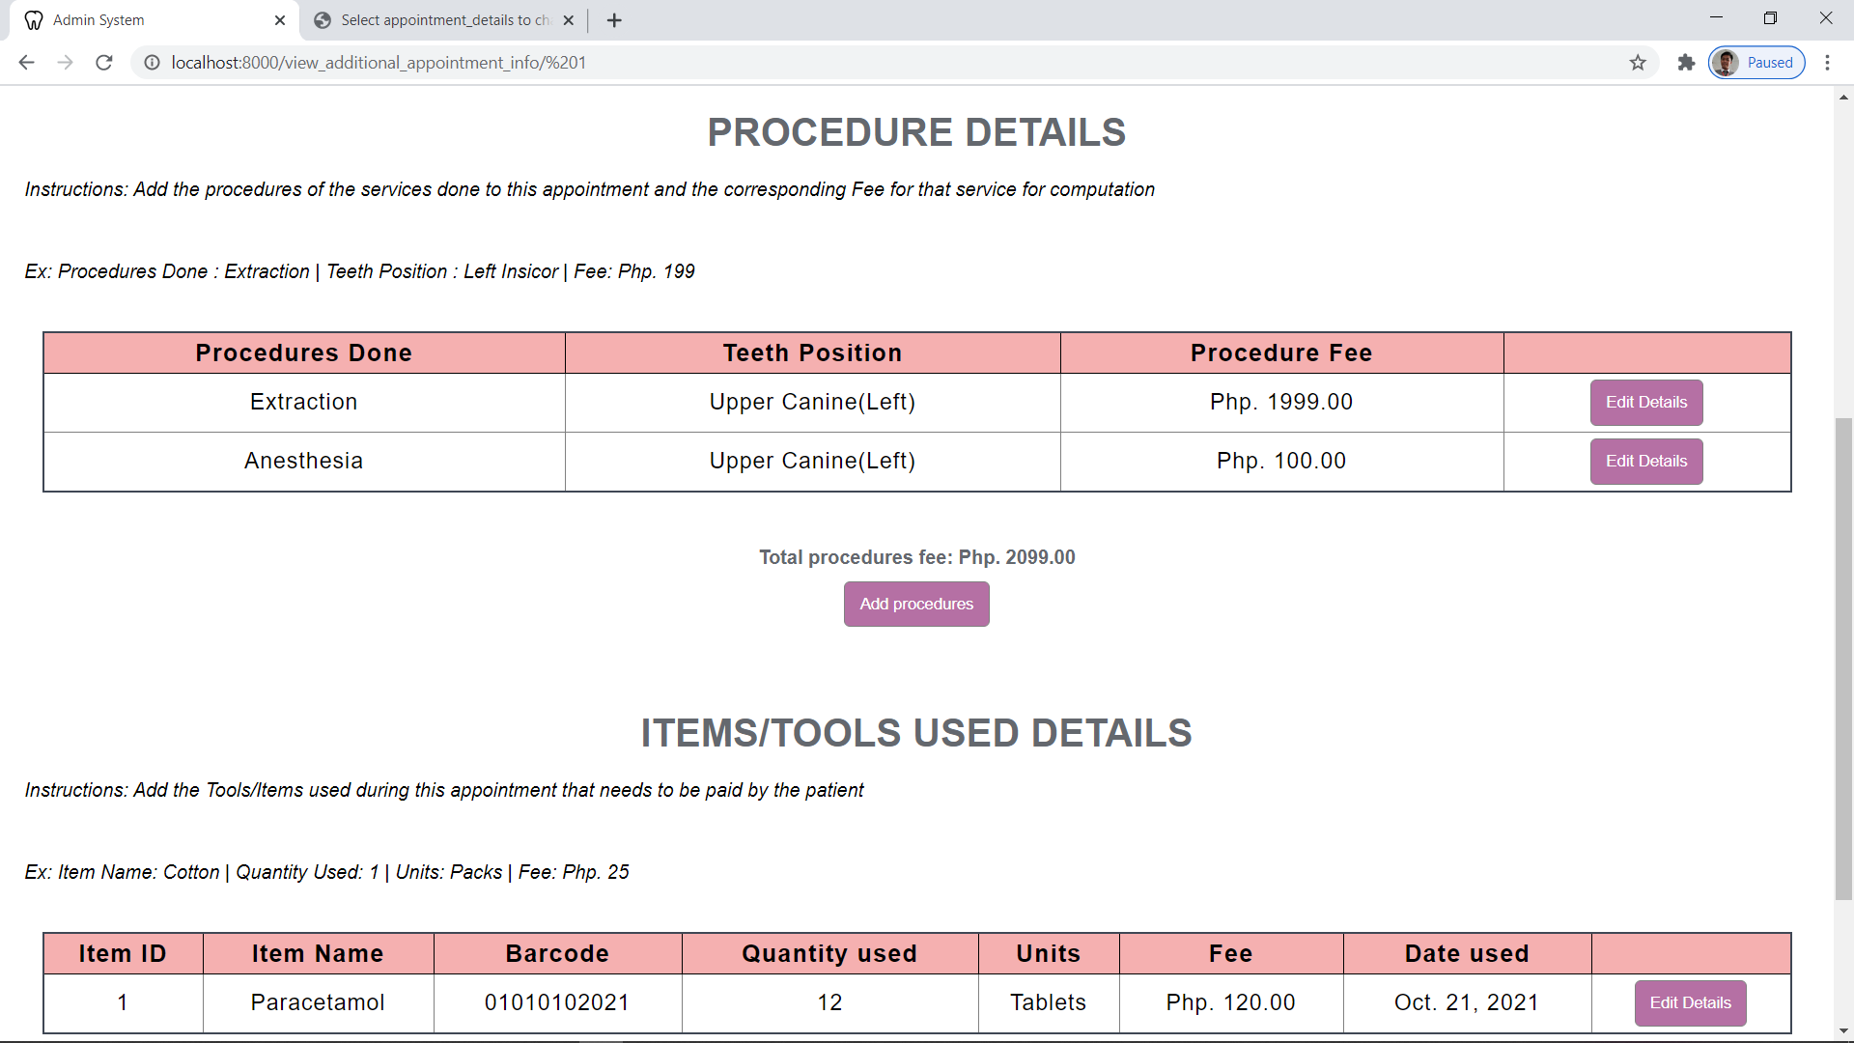

**ITEM/TOOLS USED DETAILS**

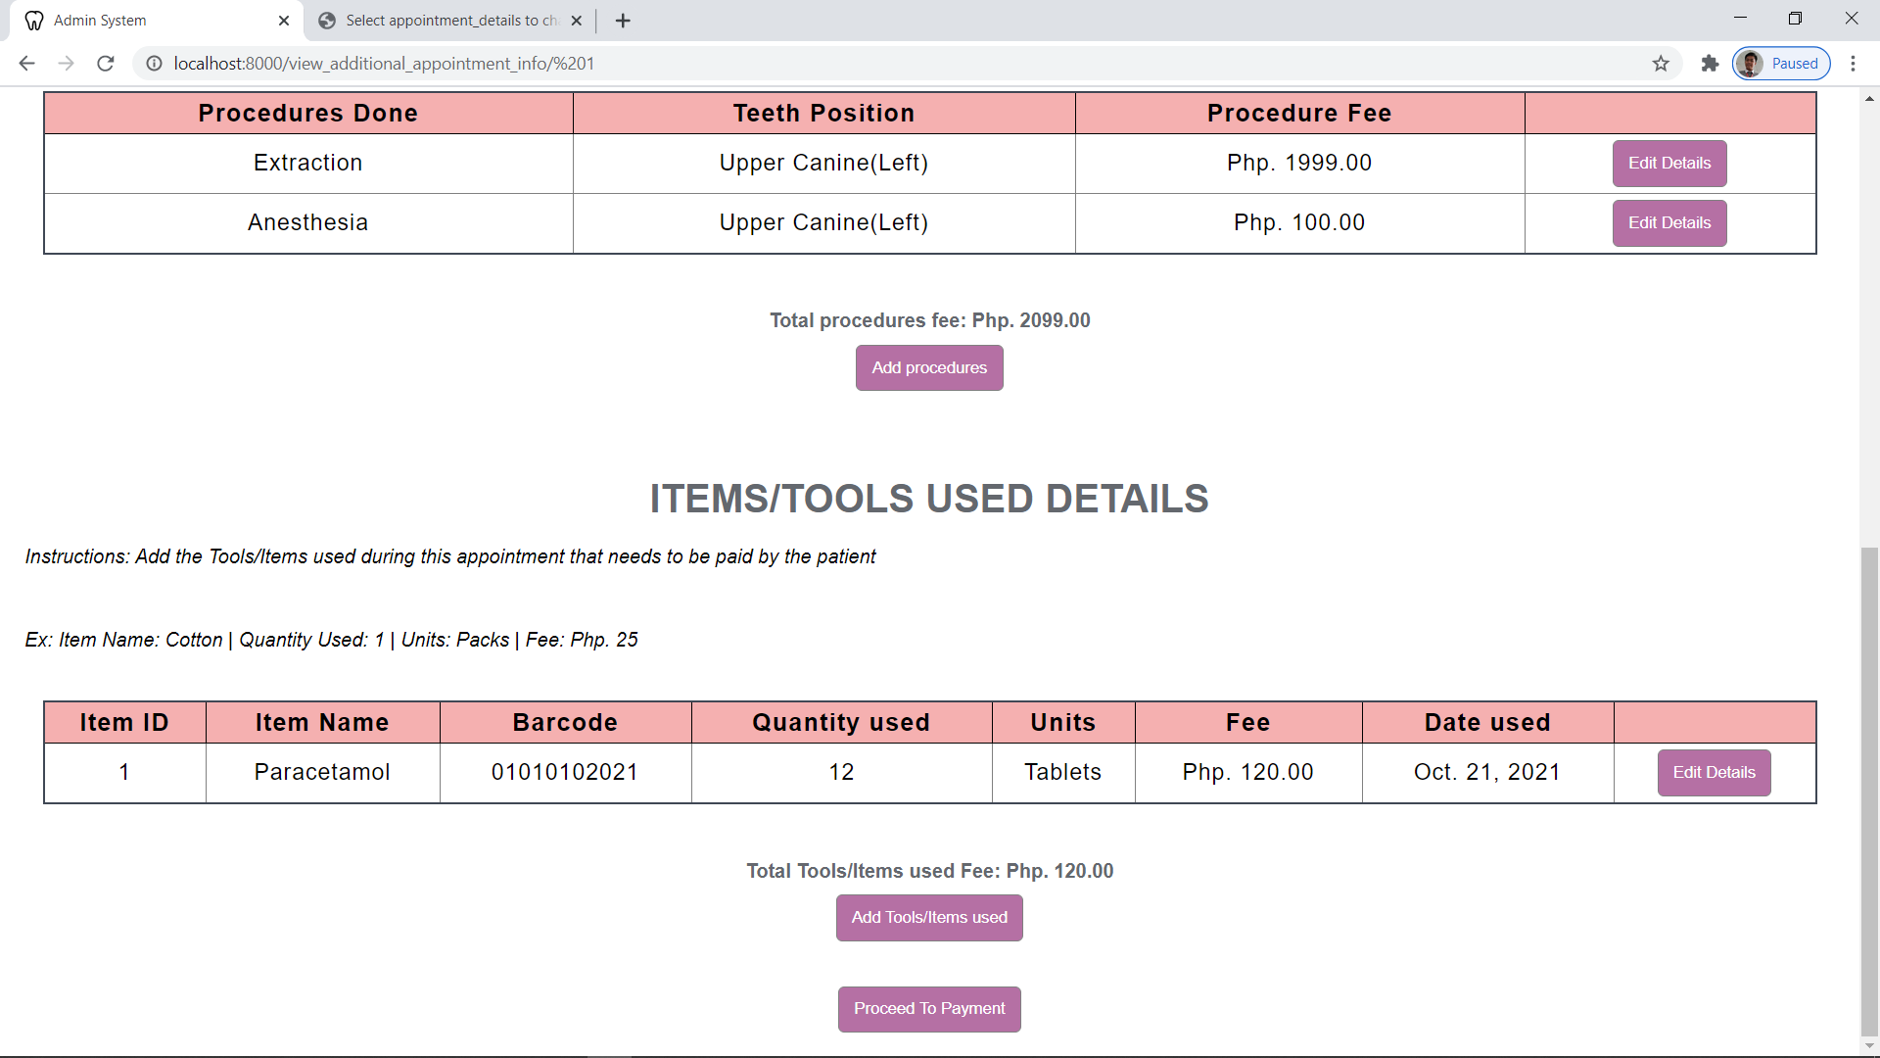

**ADDING PROCEDURES DONE DETAILS**

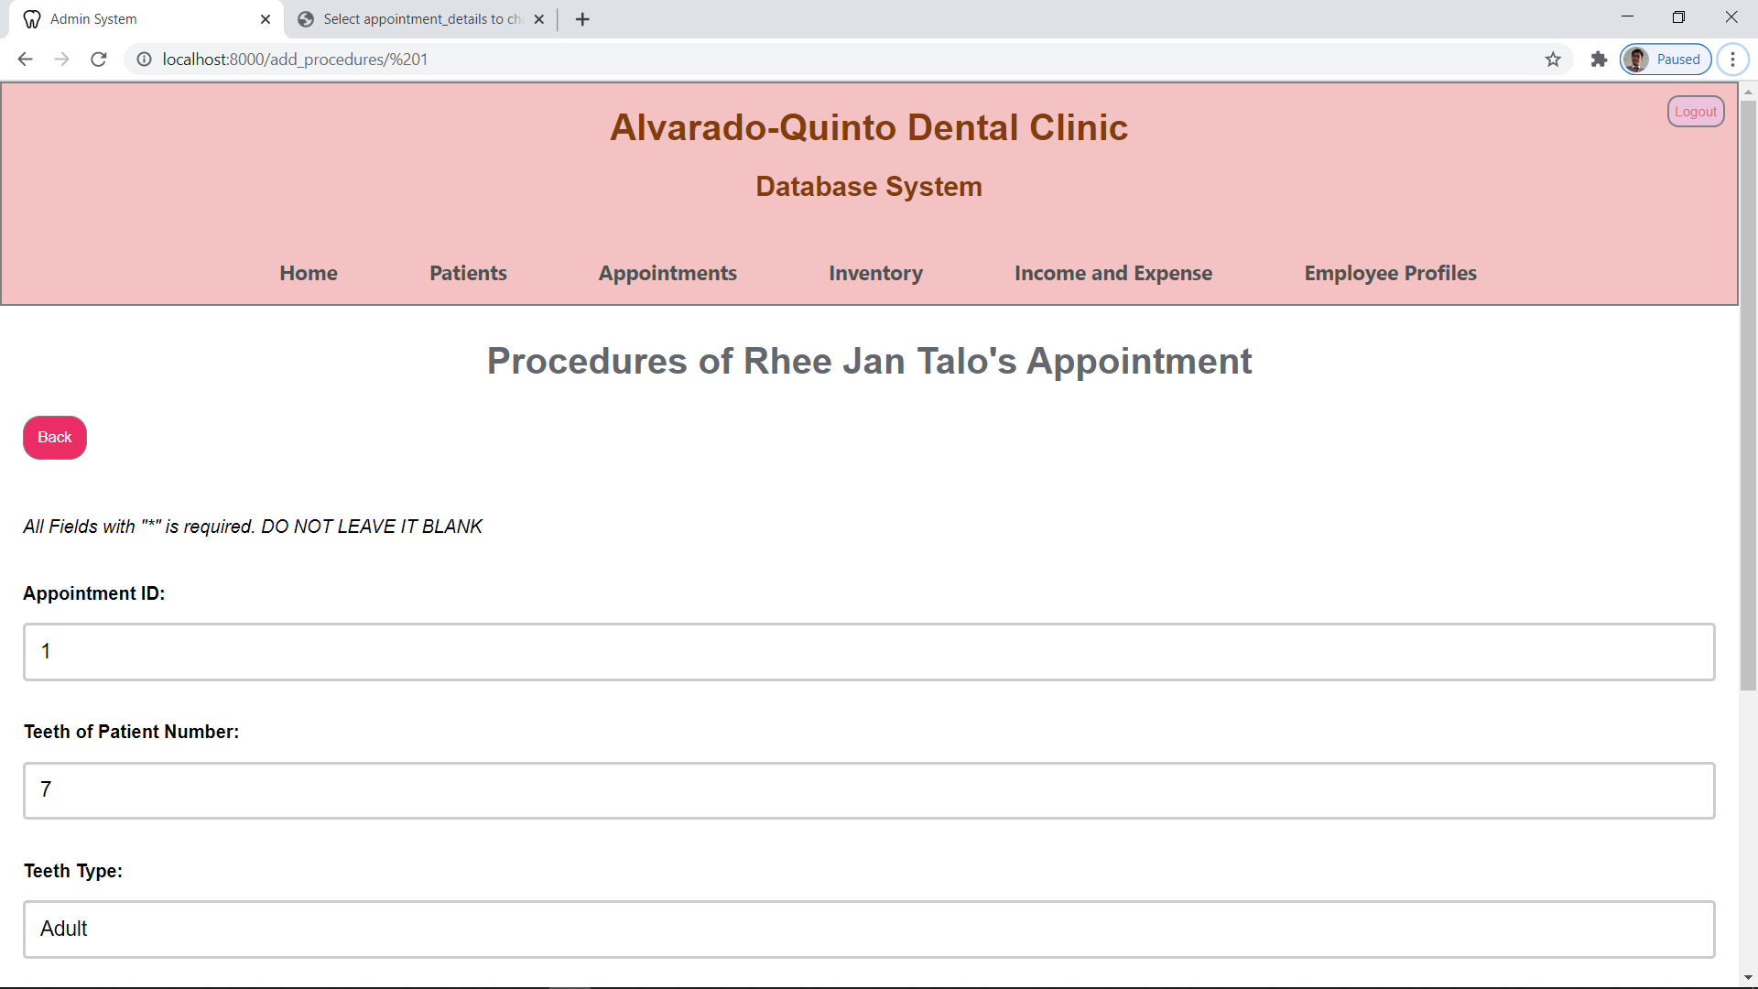

**ADDING TOOLS/ITEMS USED DETAILS**

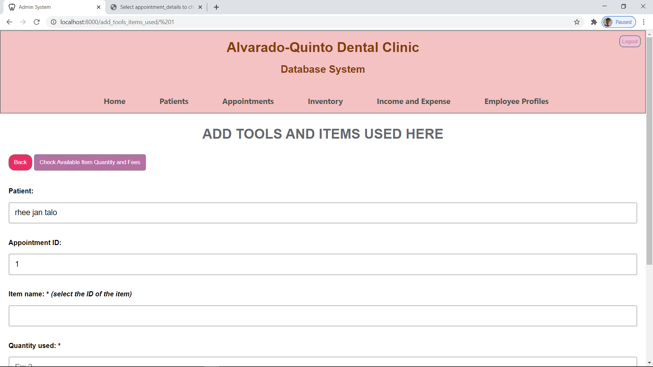

**CHECKING OF INVENTORY ITEMS**

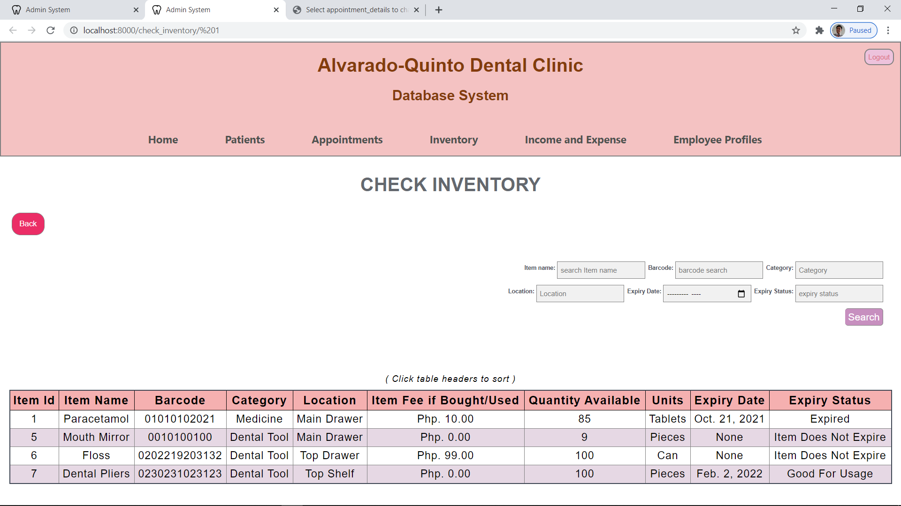

**ADDING PAYMENT INFORMATIONS**

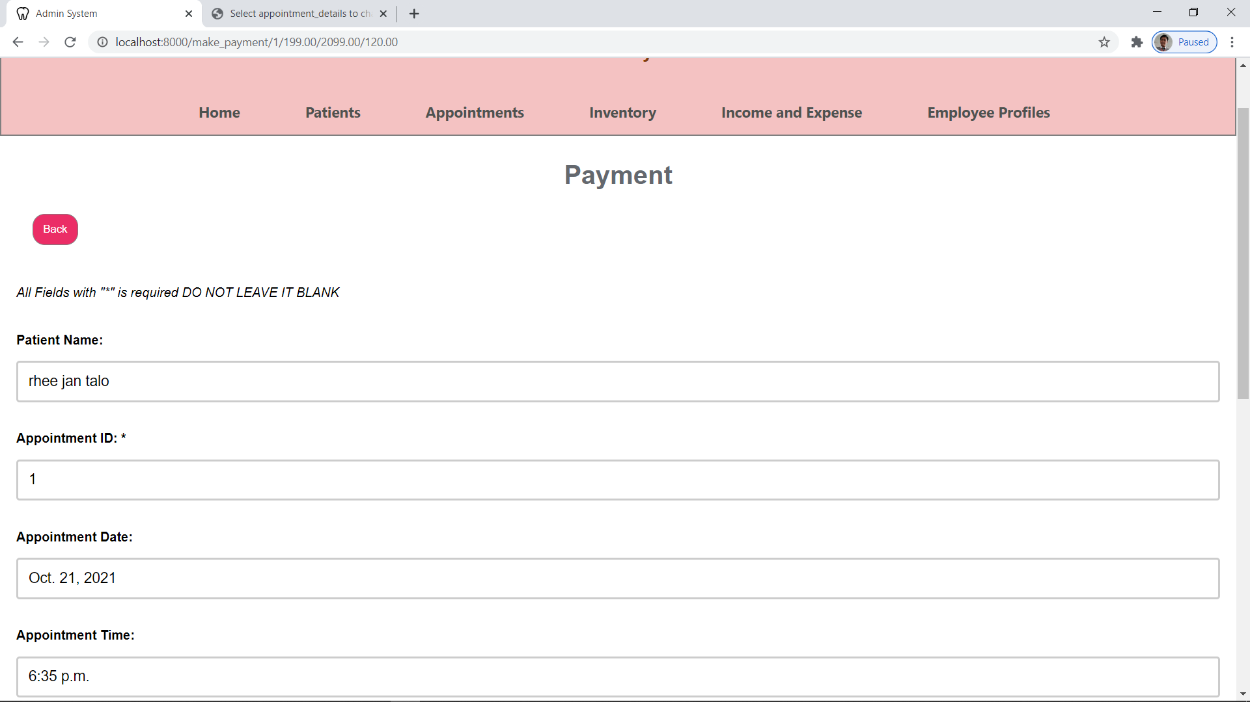

**EDITING PROCEDURES DONE DETAILS**

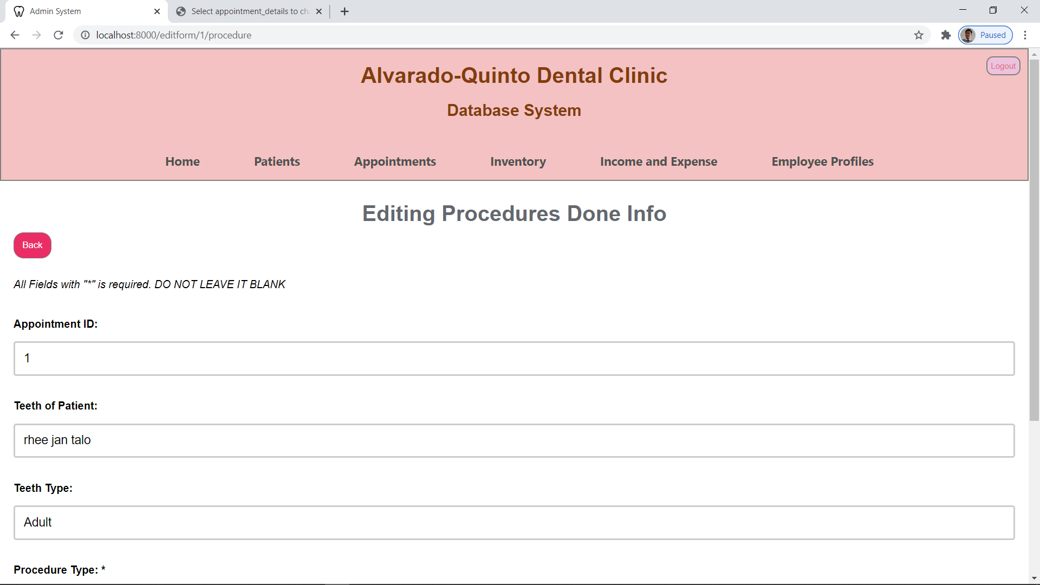

**EDITING TOOLS/ITEMS USED DETAILS**

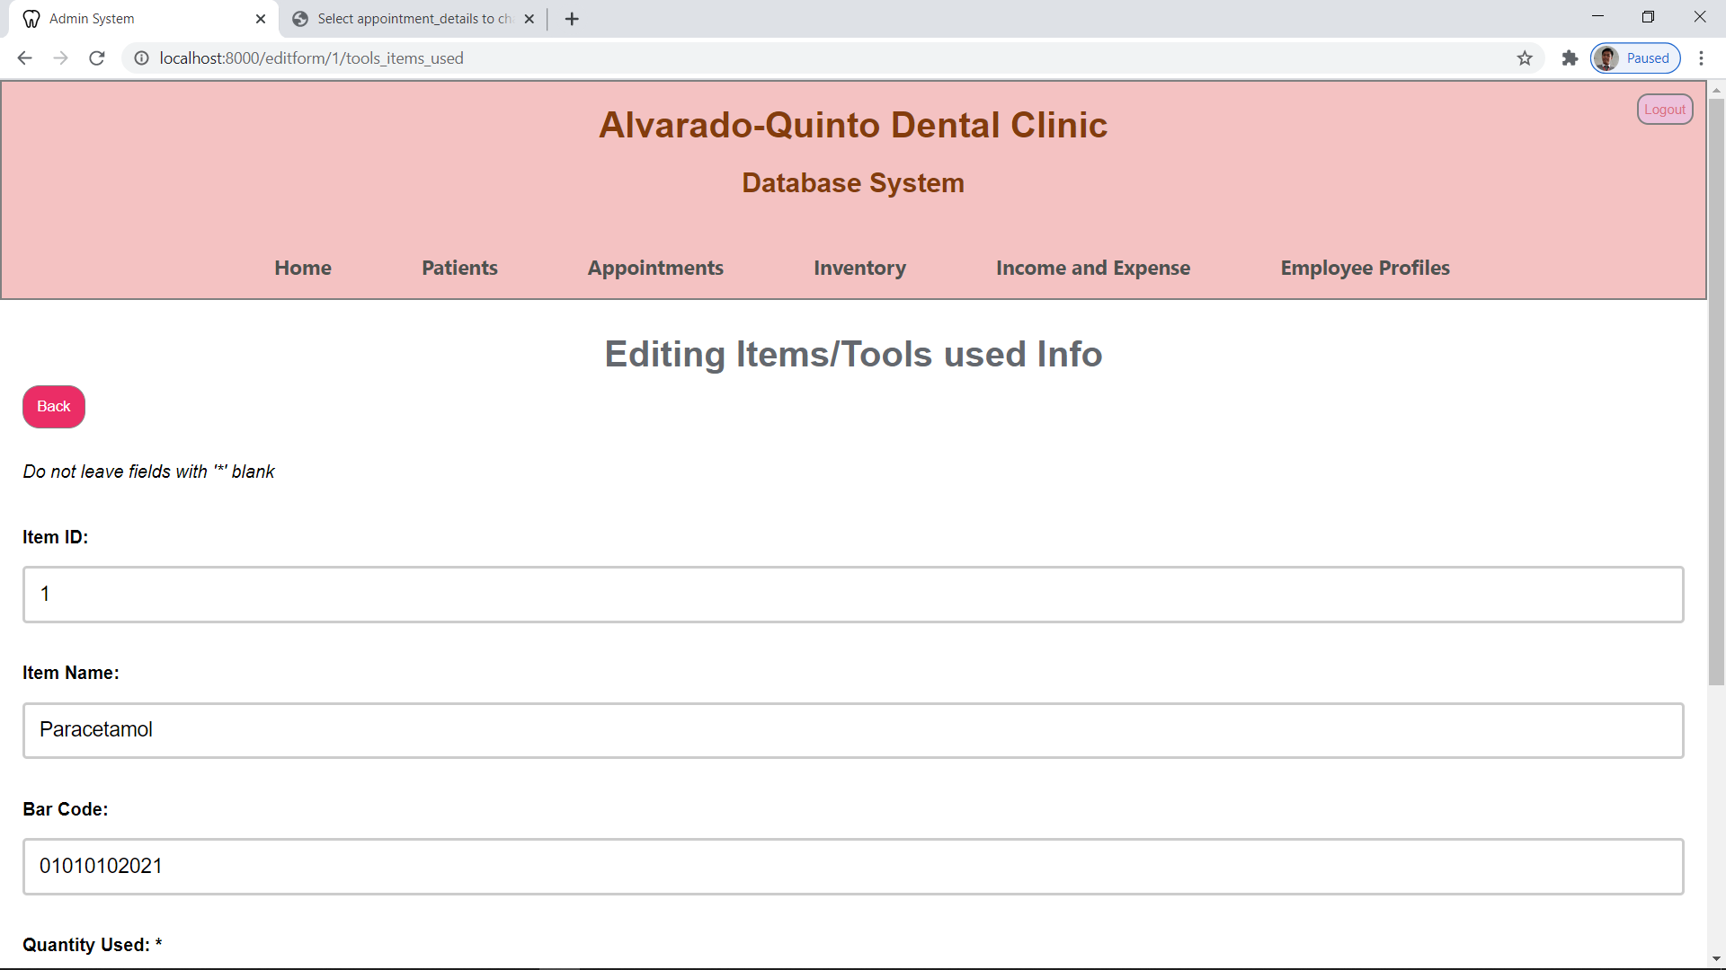

**INVENTORY PAGE**

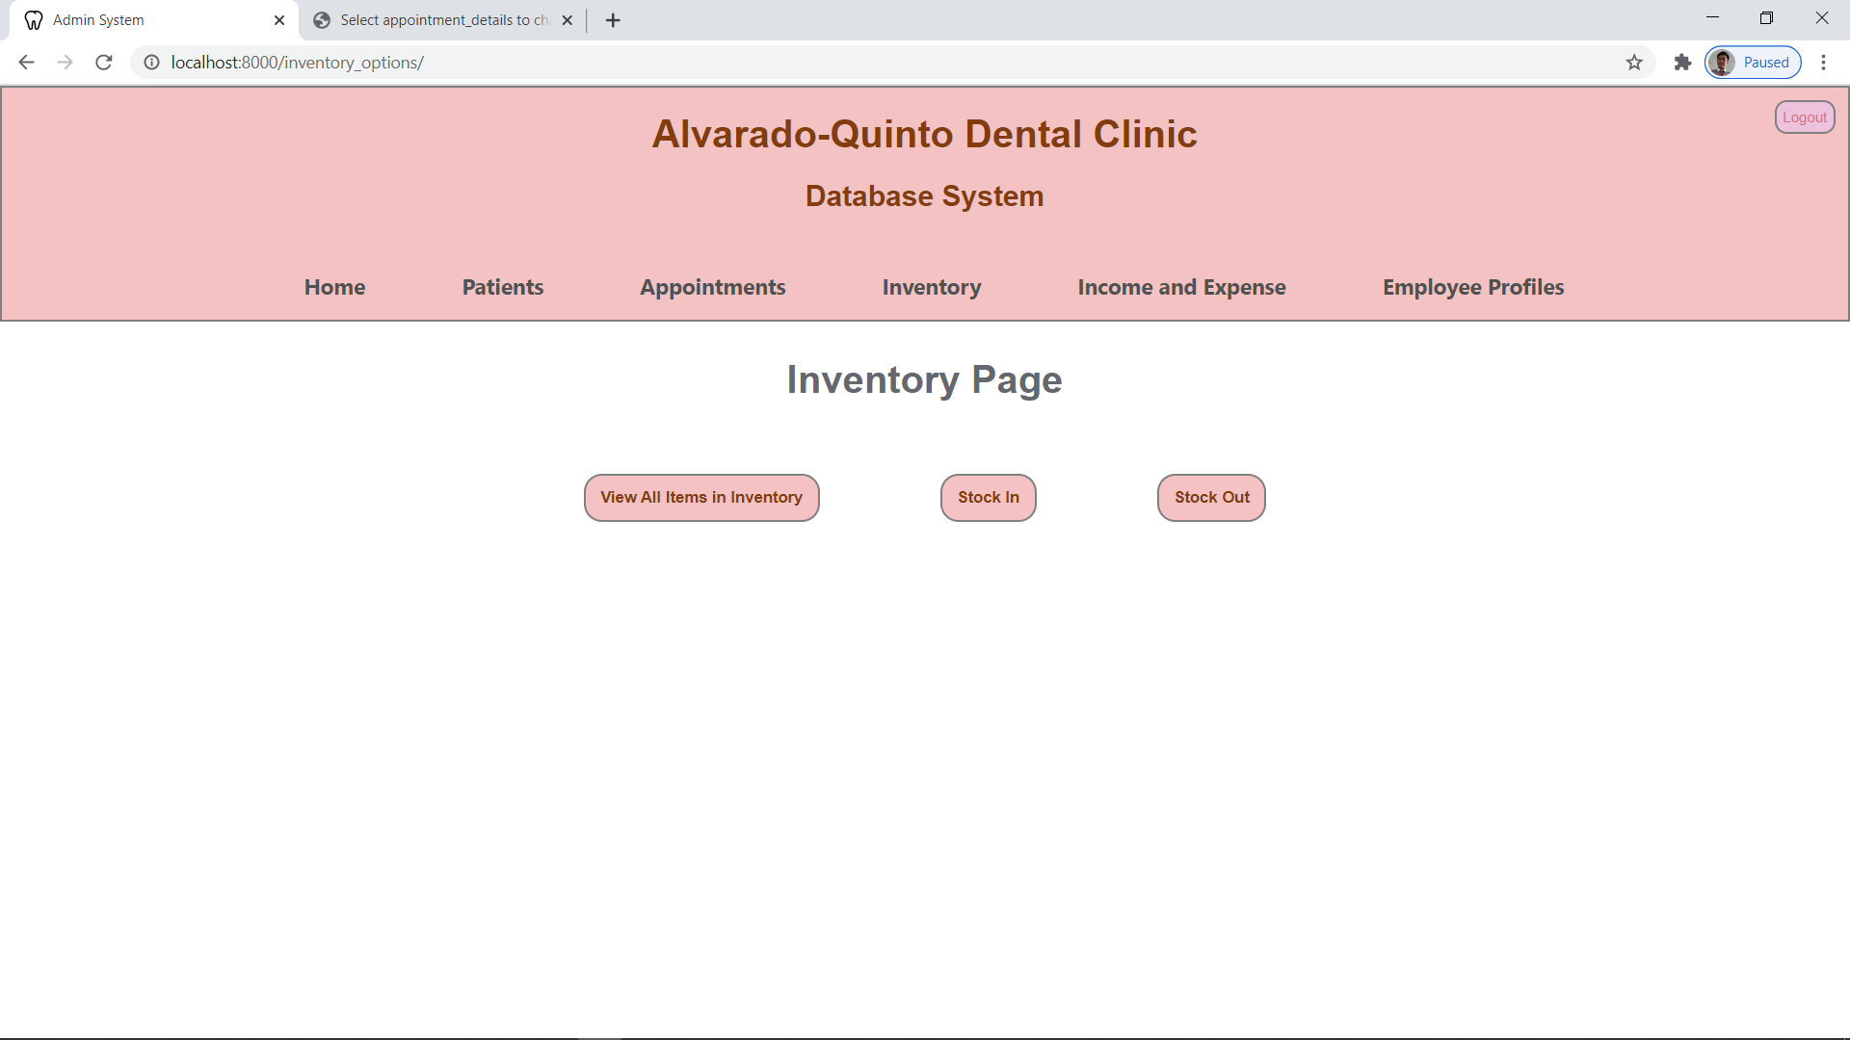

**INVENTORY LIST**

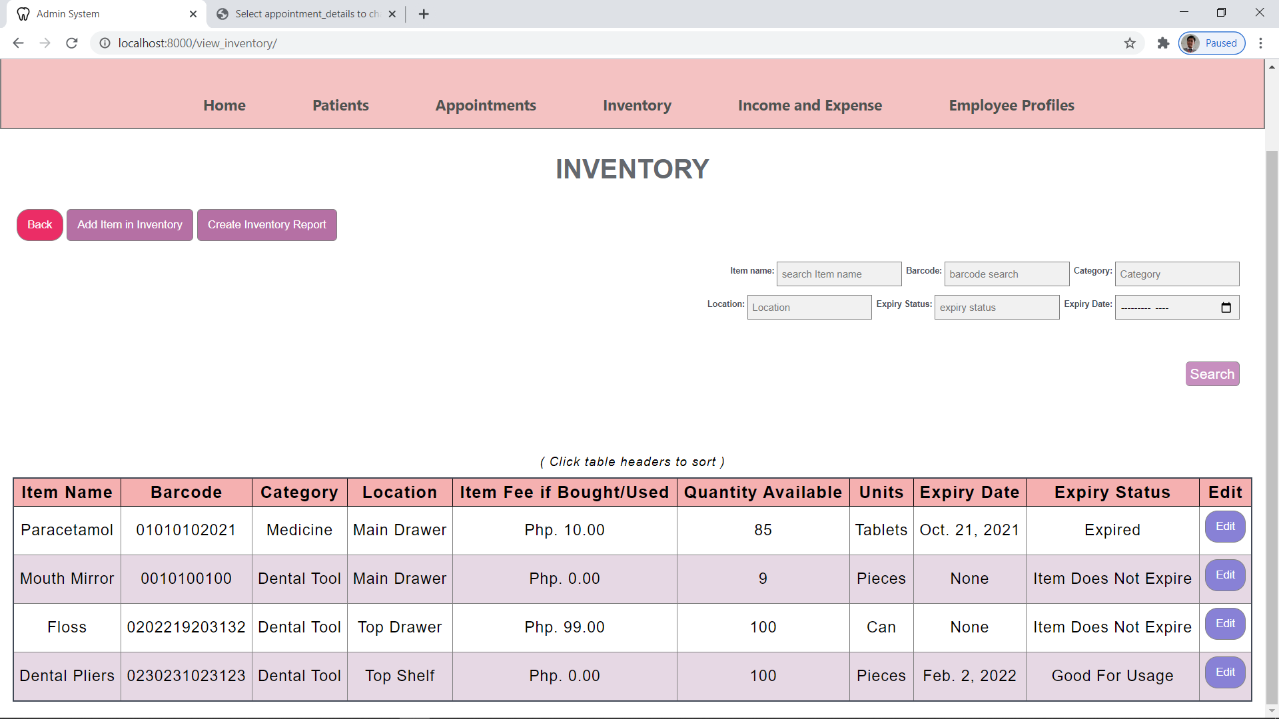

**ADDING NEW ITEM IN THE INVENTORY**

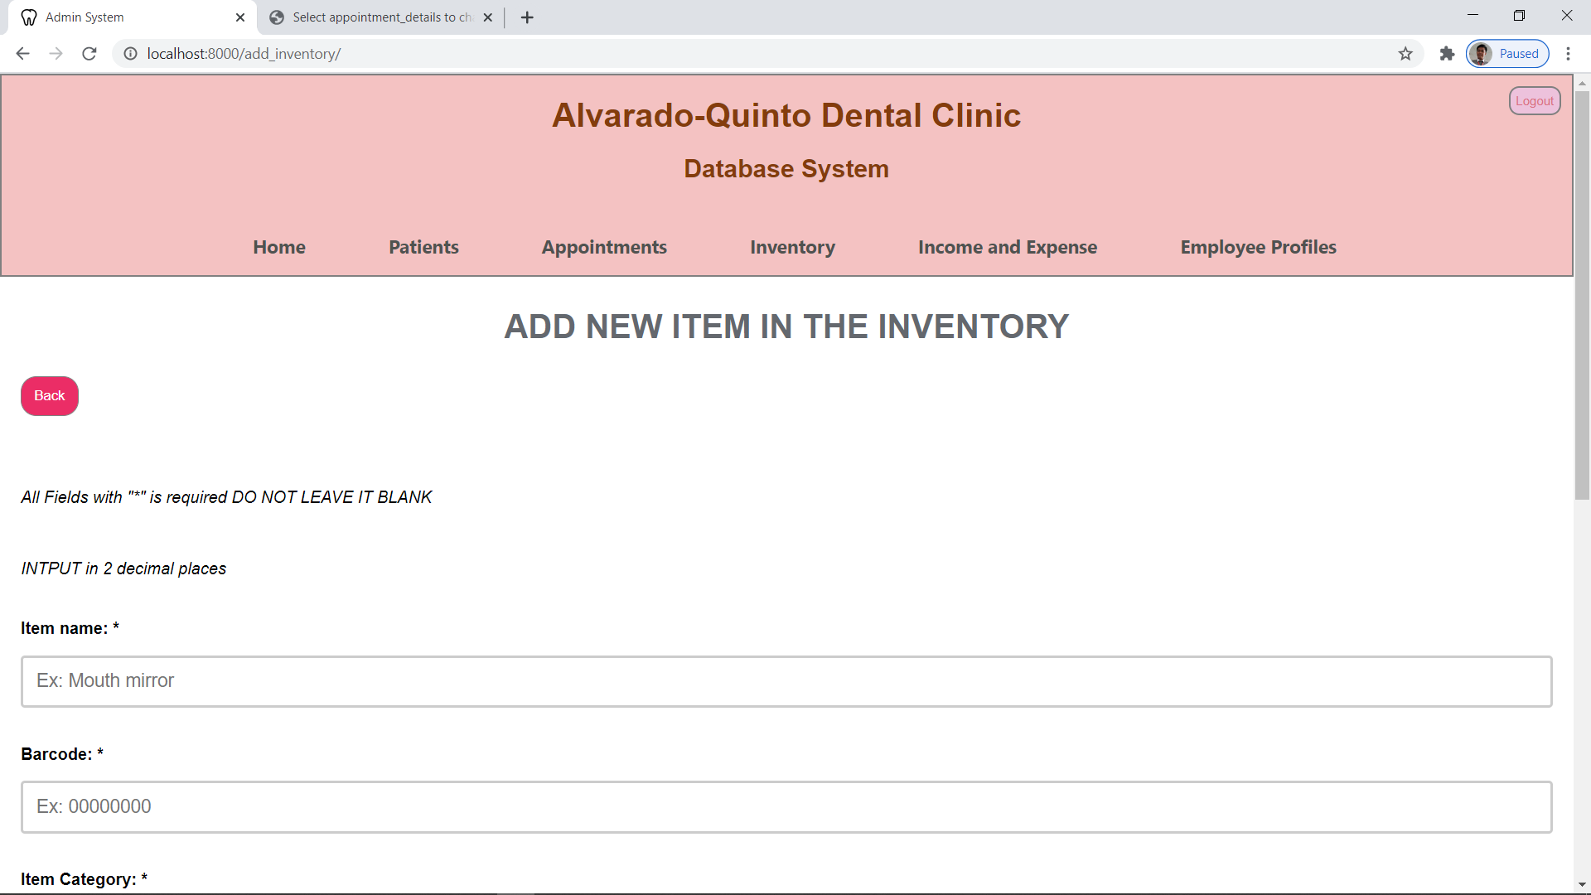

**EDITING AN ITEM IN INVENTORY**

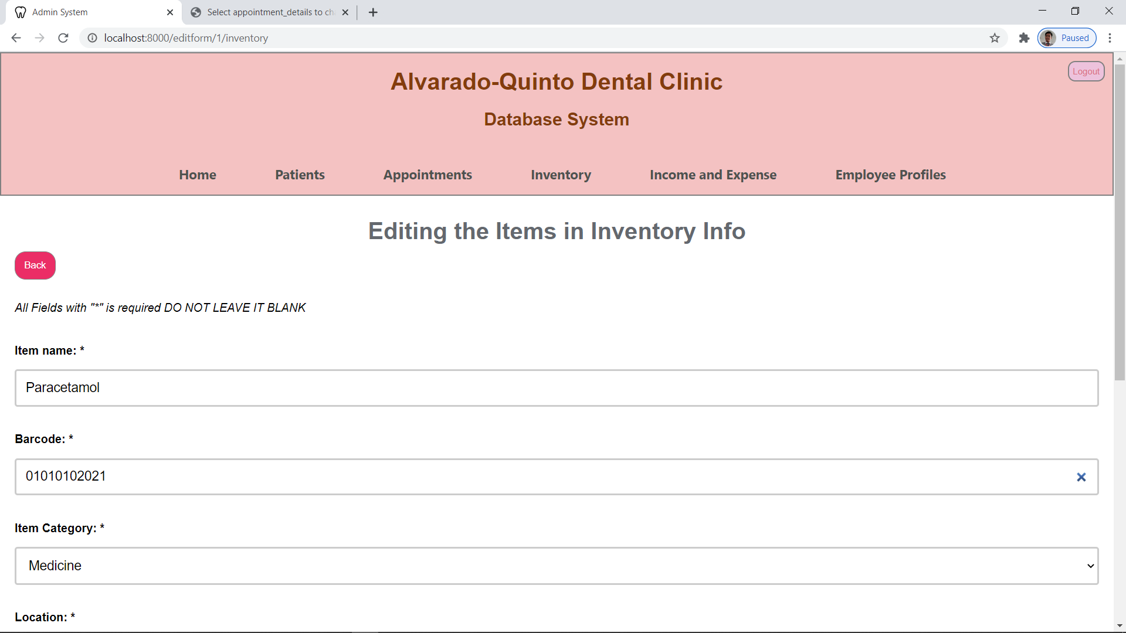

**INVENTORY REPORT**

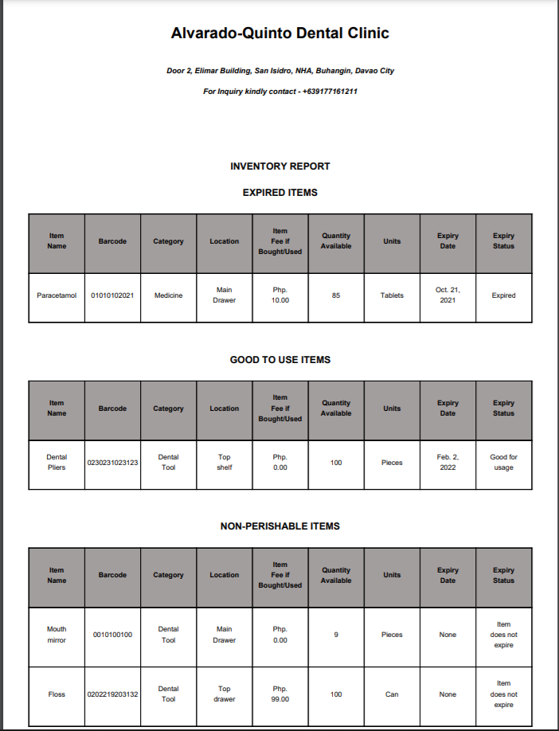

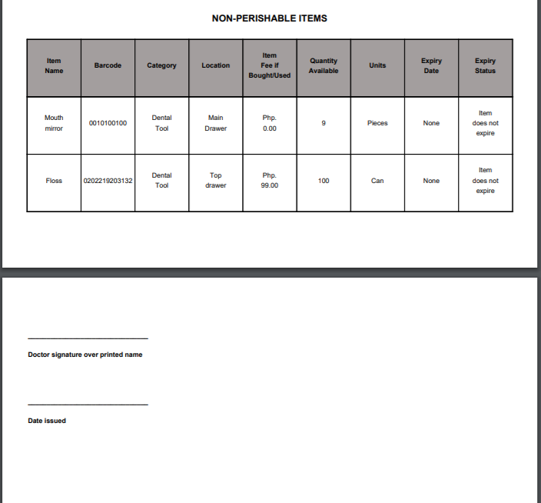

**STOCK IN PAGE**

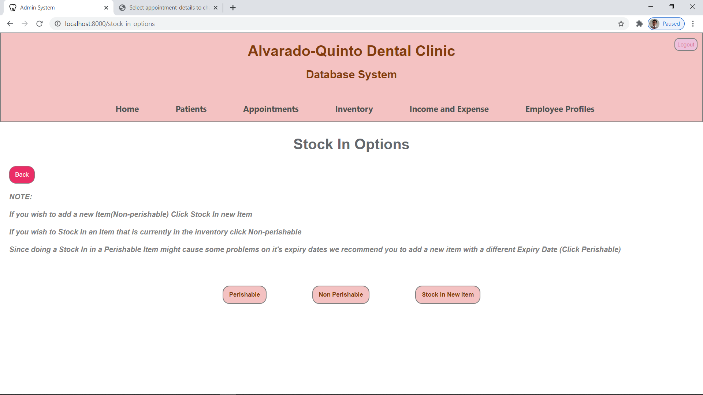

**STOCK IN (PERISHABLE)**

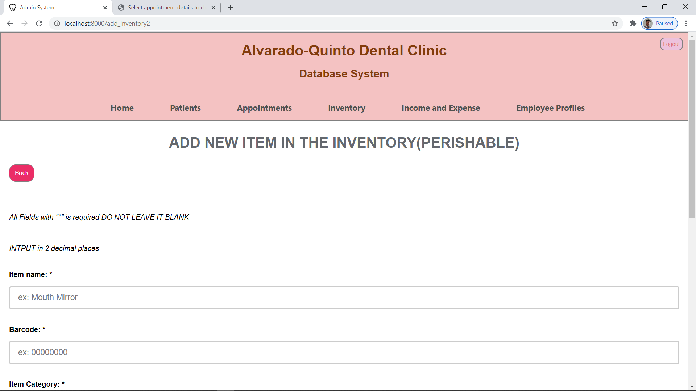

**STOCK IN (NON-PERISHABLE)**

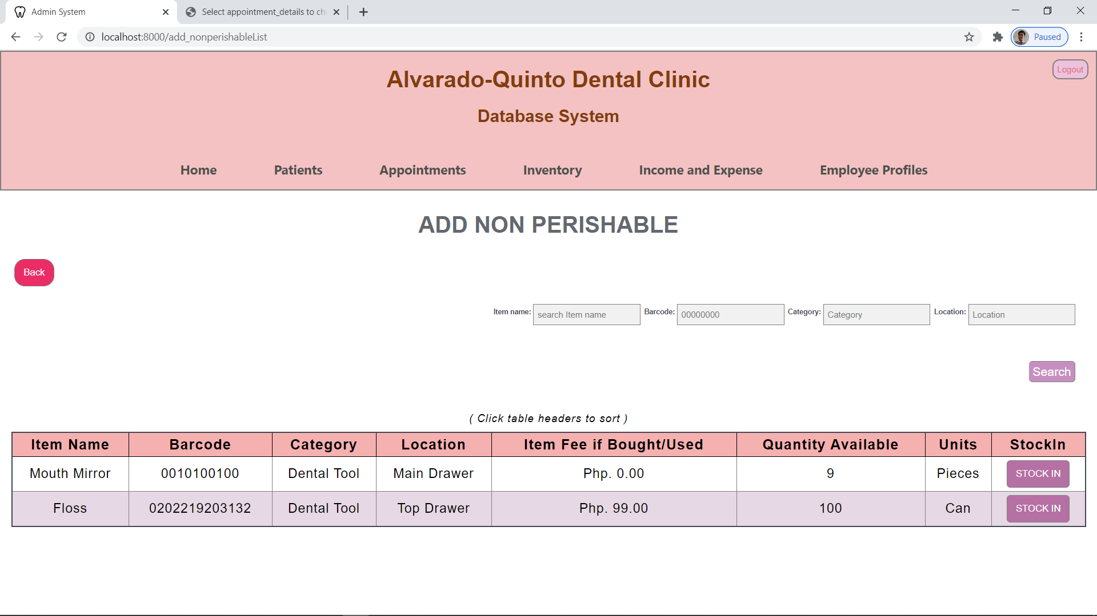

**STOCK IN (NON-PERISHABLE, NEW ITEM)**

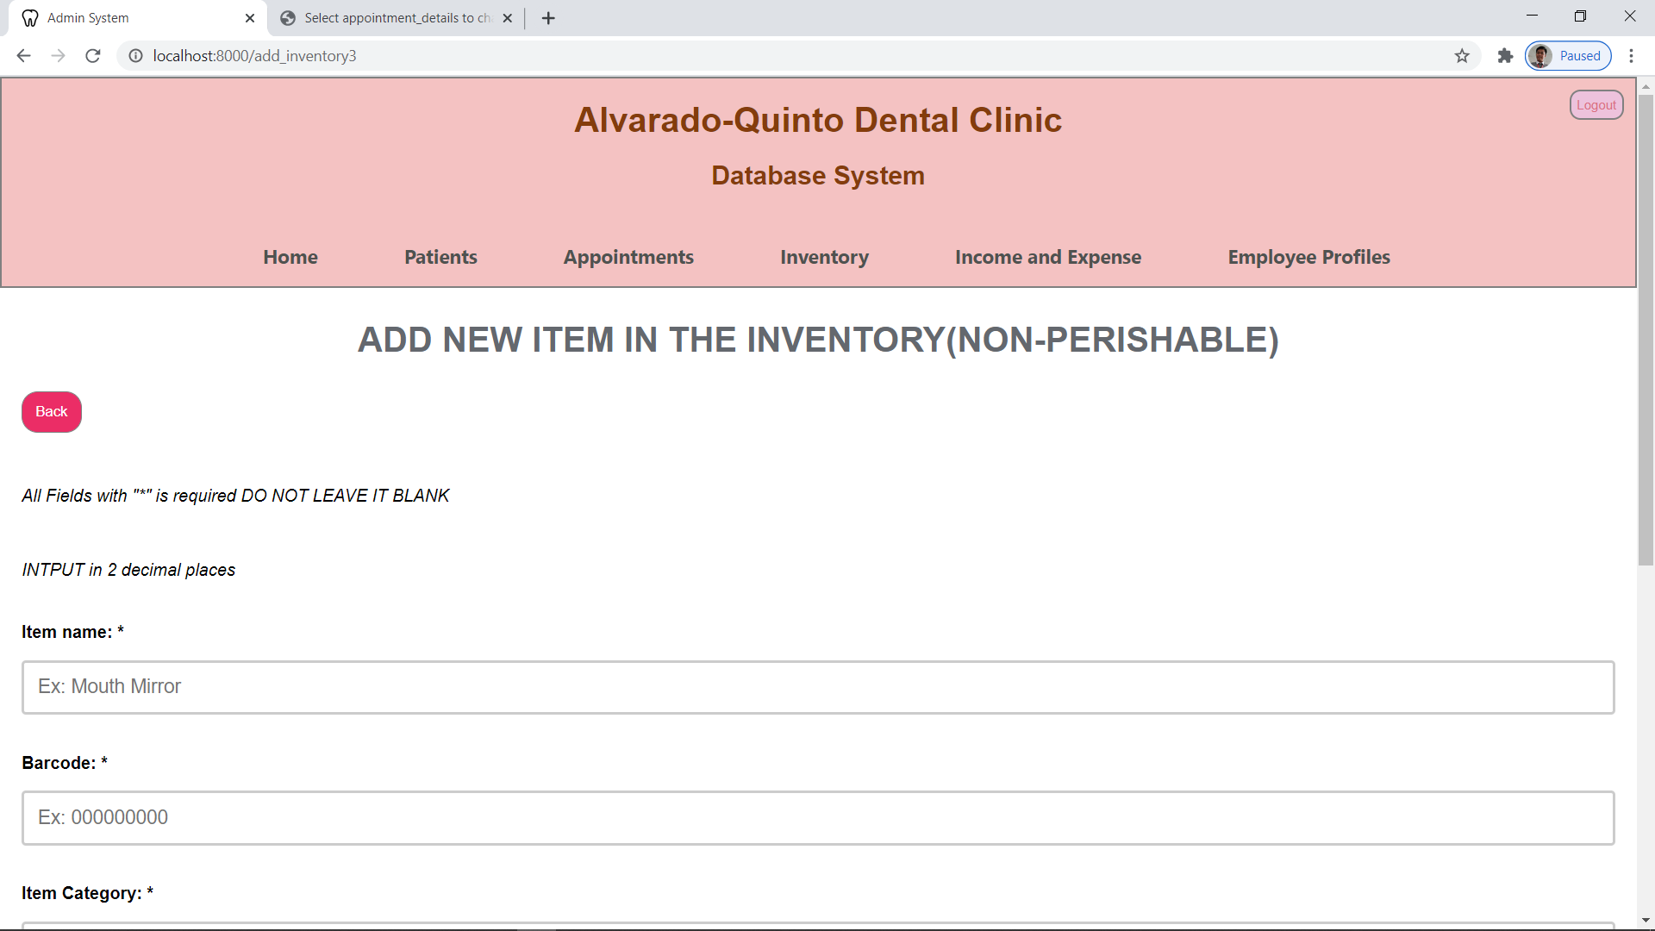

**STOCK OUT PAGE**

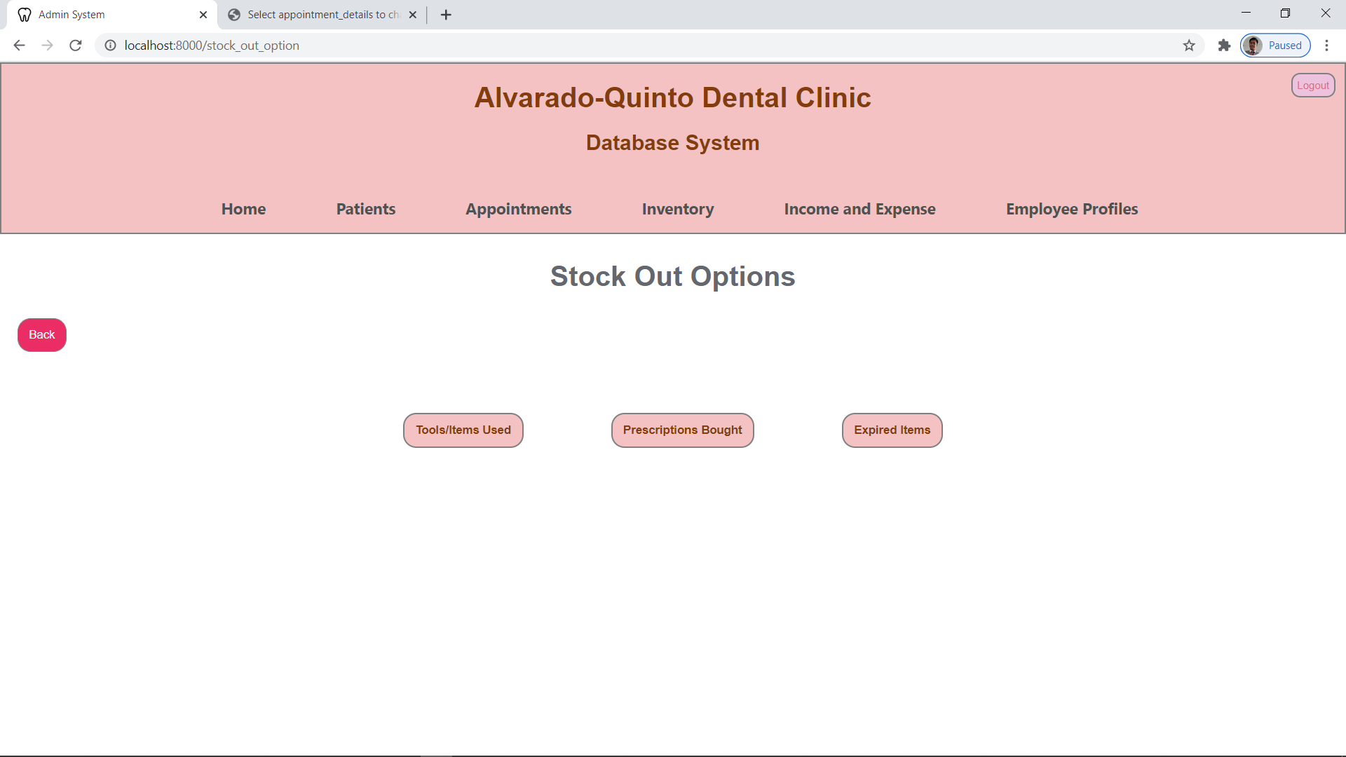

**TOOLS/ITEMS STOCK OUT**

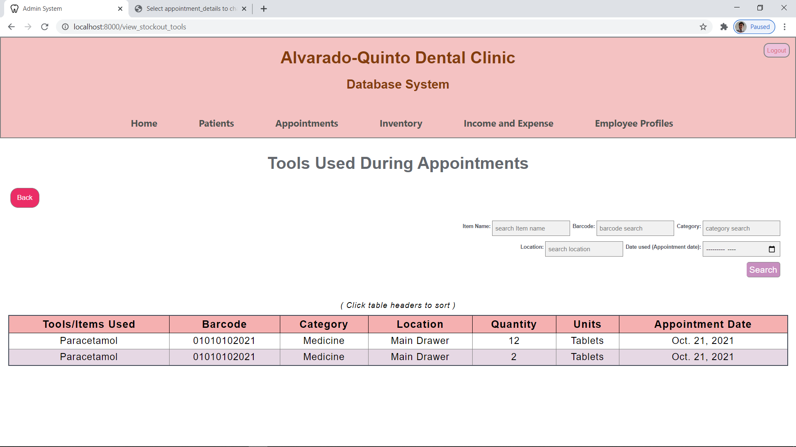

**PRESCRIPTION SALES STOCK OUT**

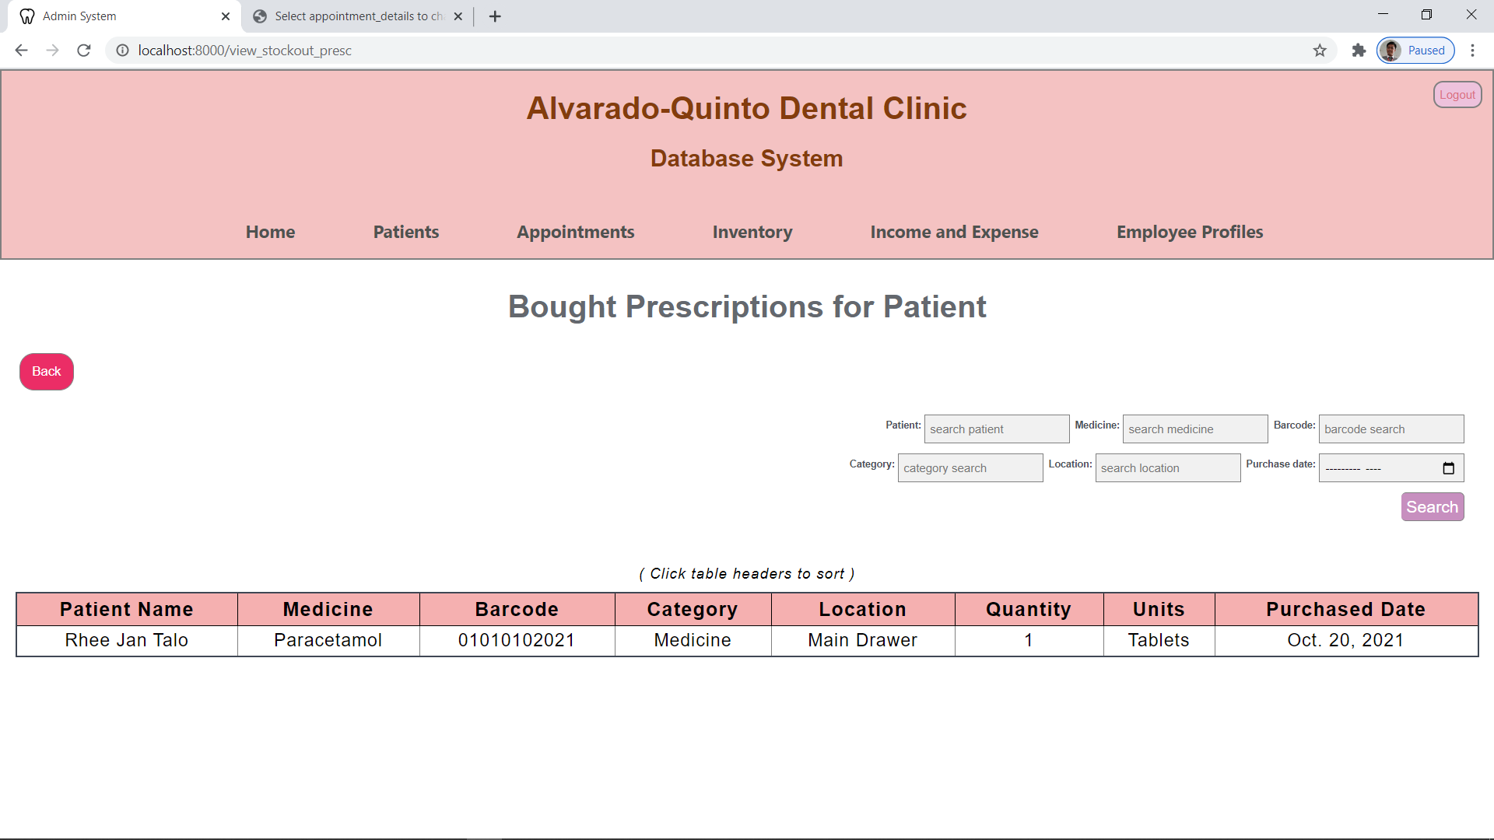

**EXPIRED ITEMS STOCK OUT**

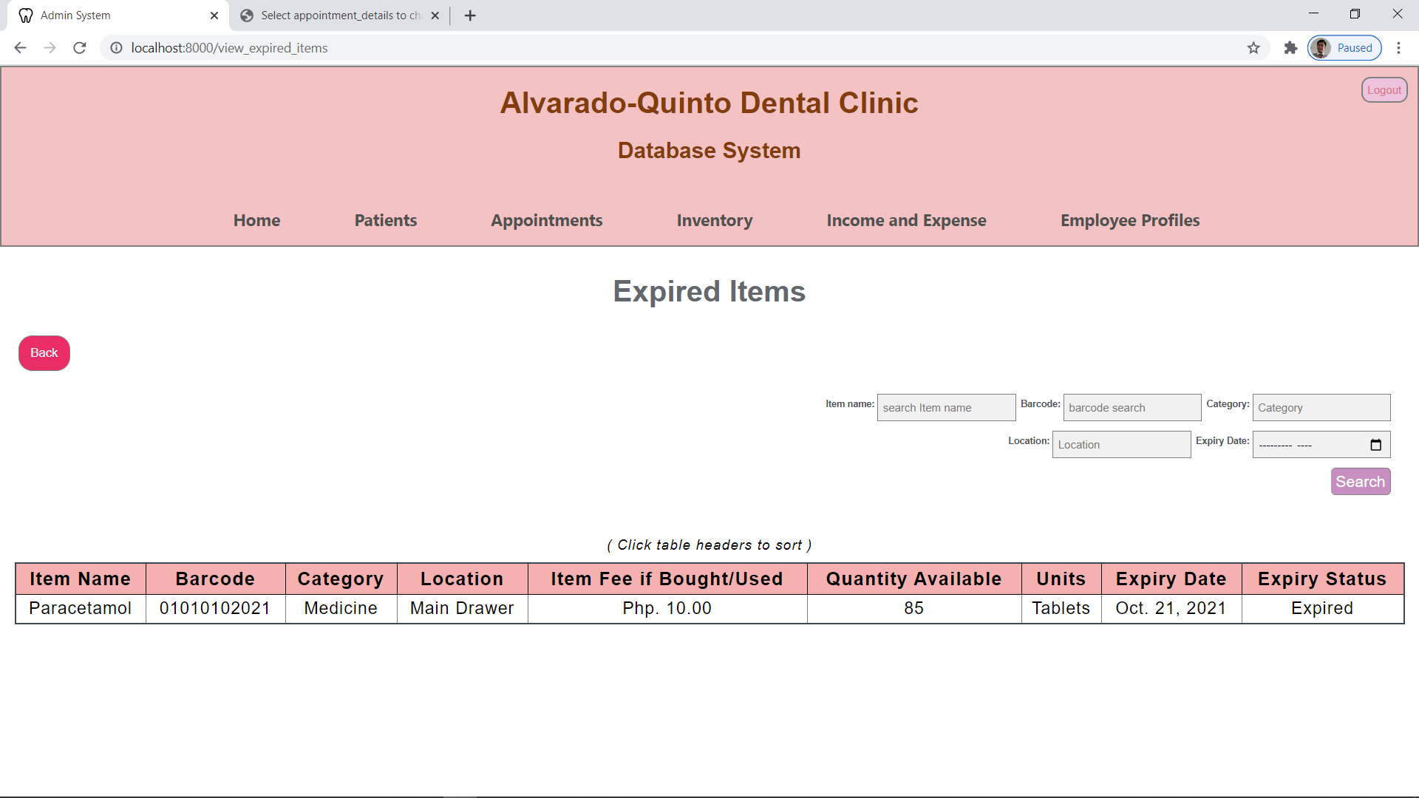

**INCOME EXPENSE PAGE**

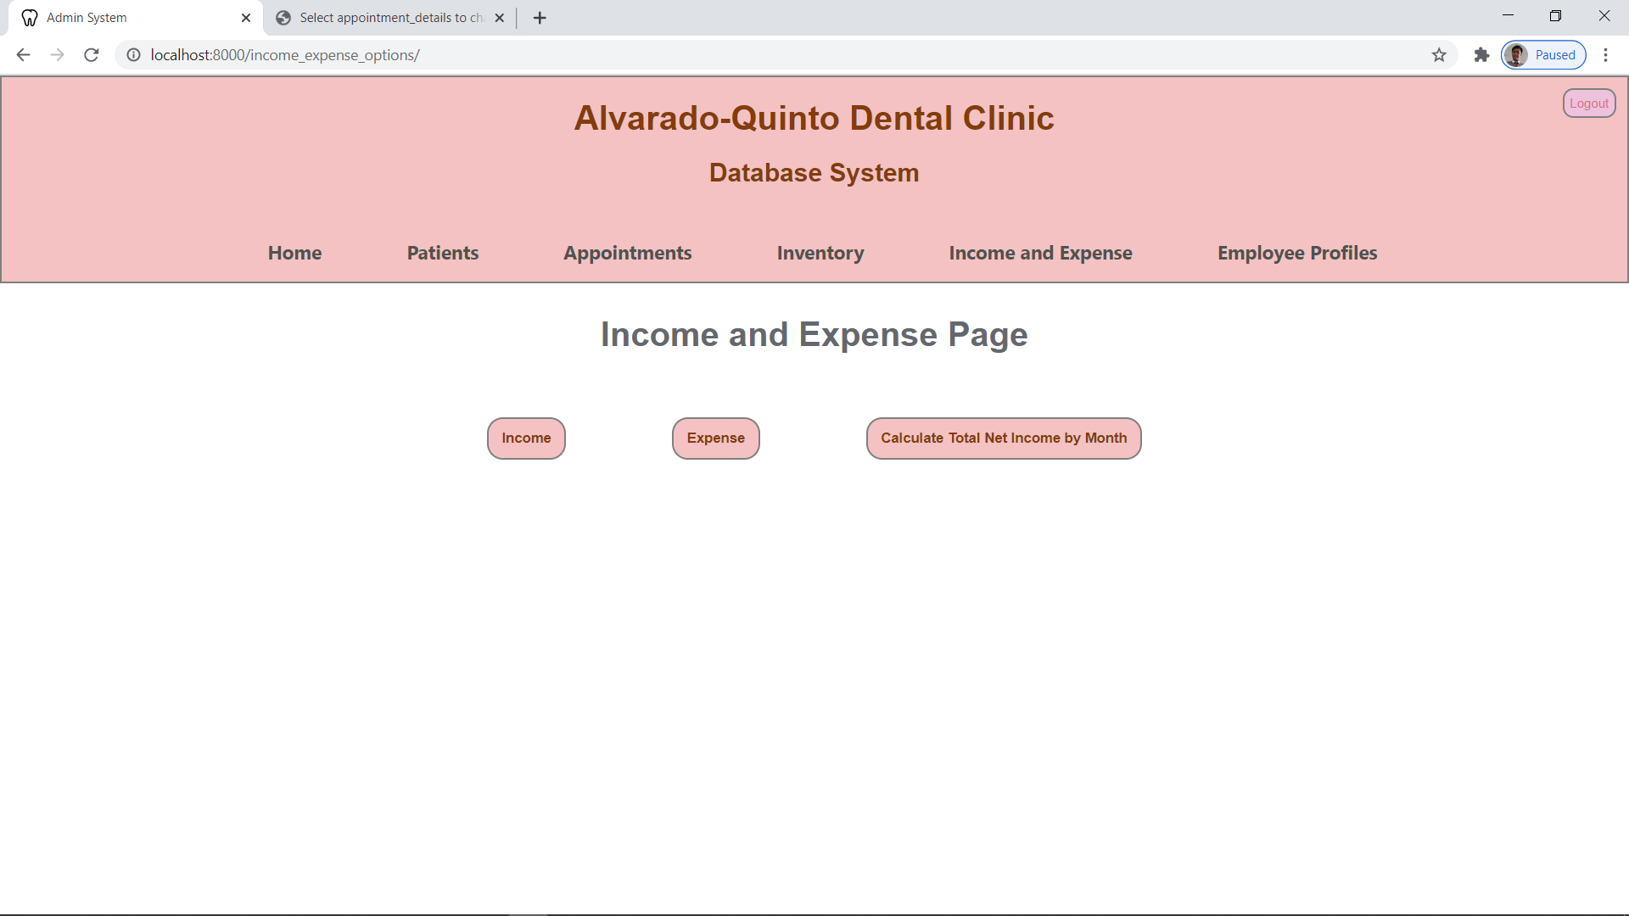

**INCOME PAGE**

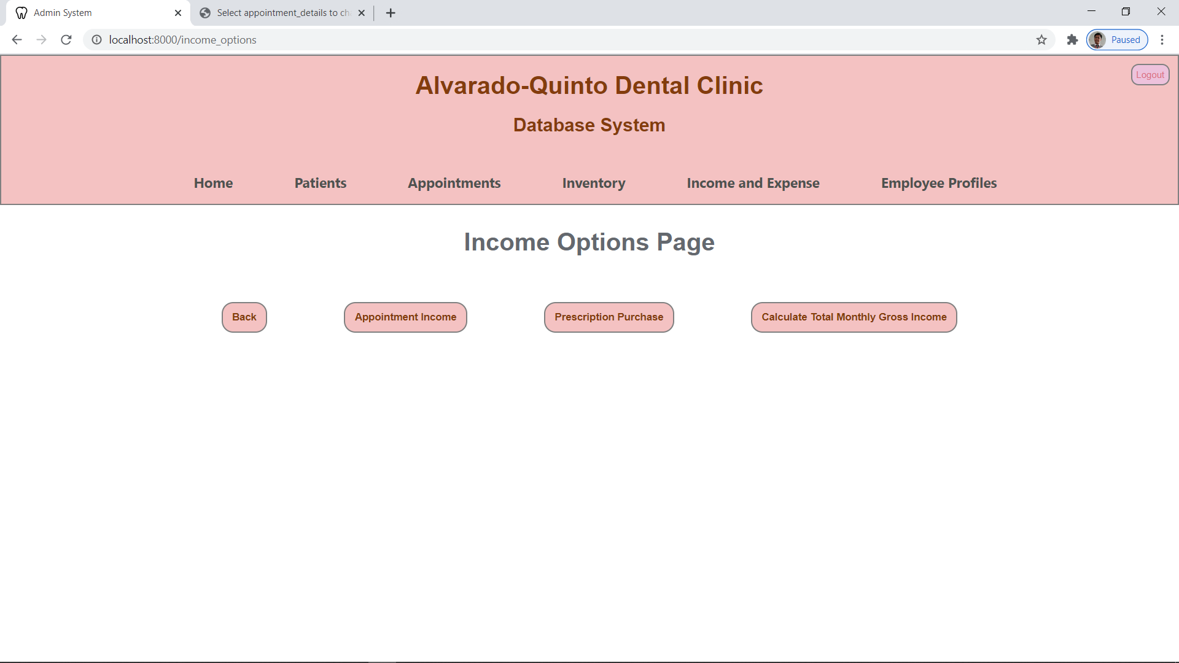

**APPOINTMENT INCOME DETAILS**

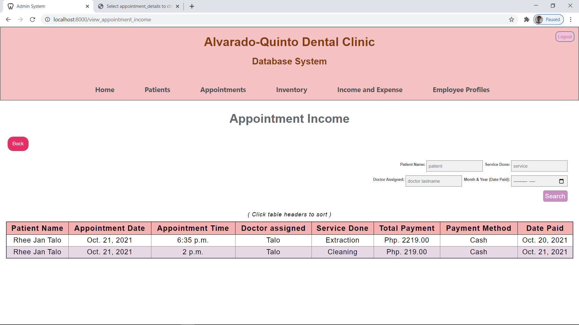

**PRESCRIPTION SALES INCOME DETAILS**

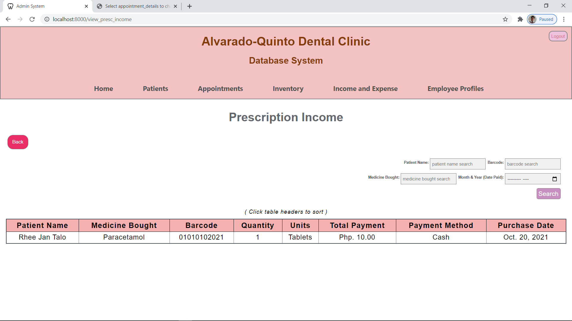

**TOTAL GROSS INCOME PAGE**

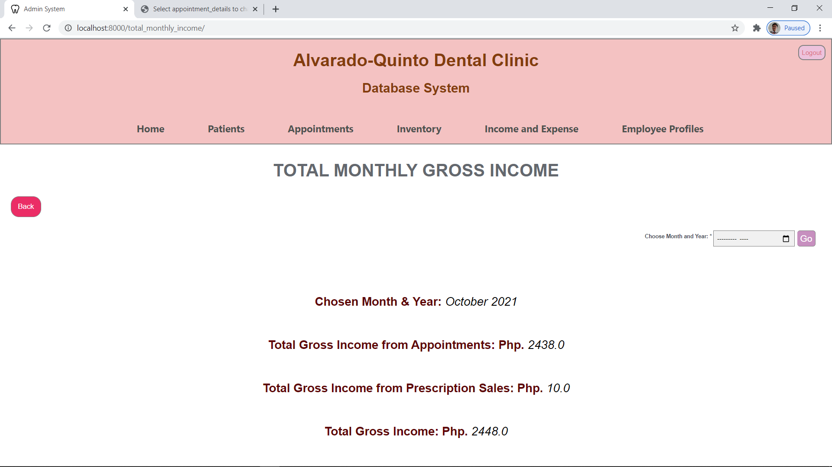

**EXPENSES PAGE**

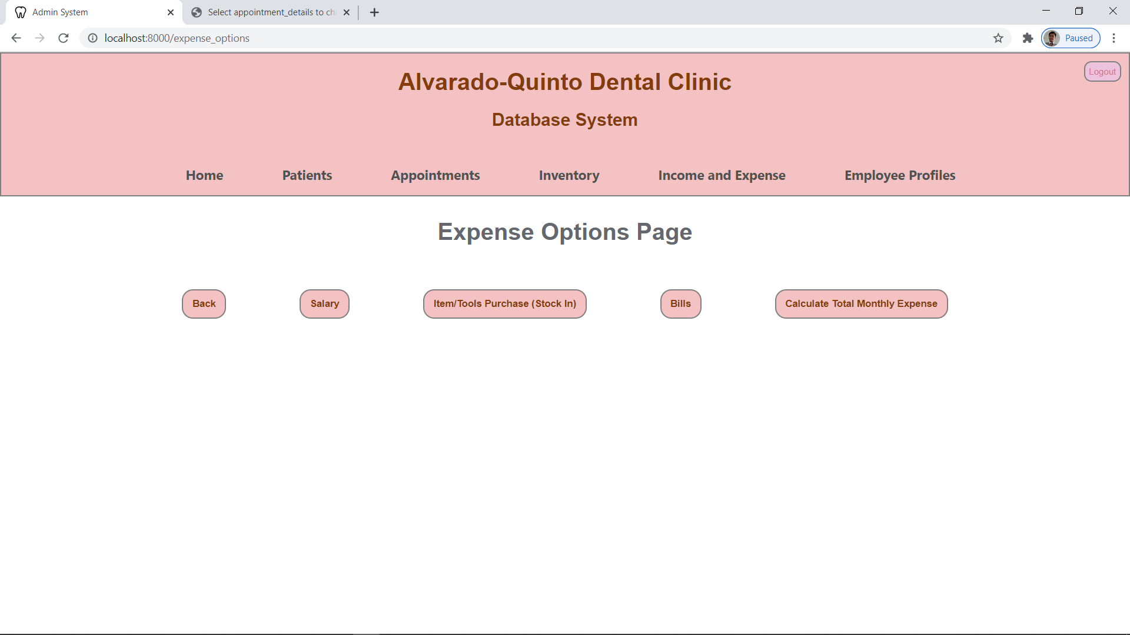

**SALARY EXPENSE DETAILS**

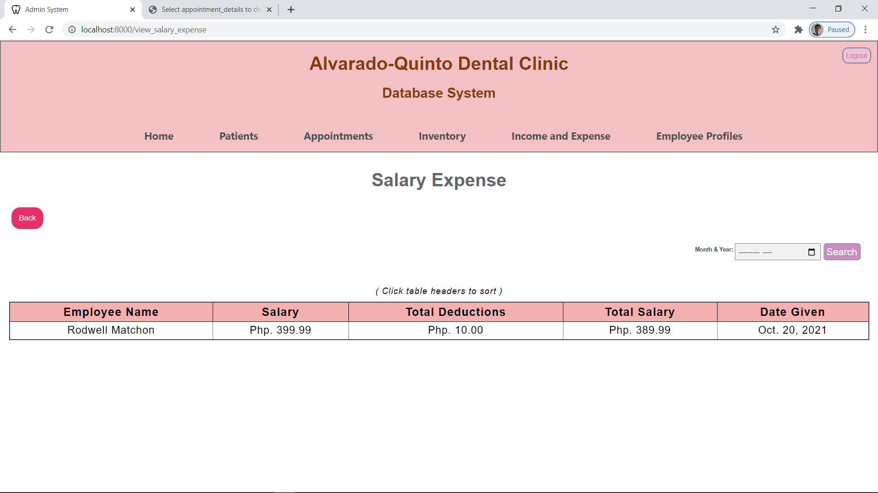

**STOCK IN EXPENSE DETAILS**

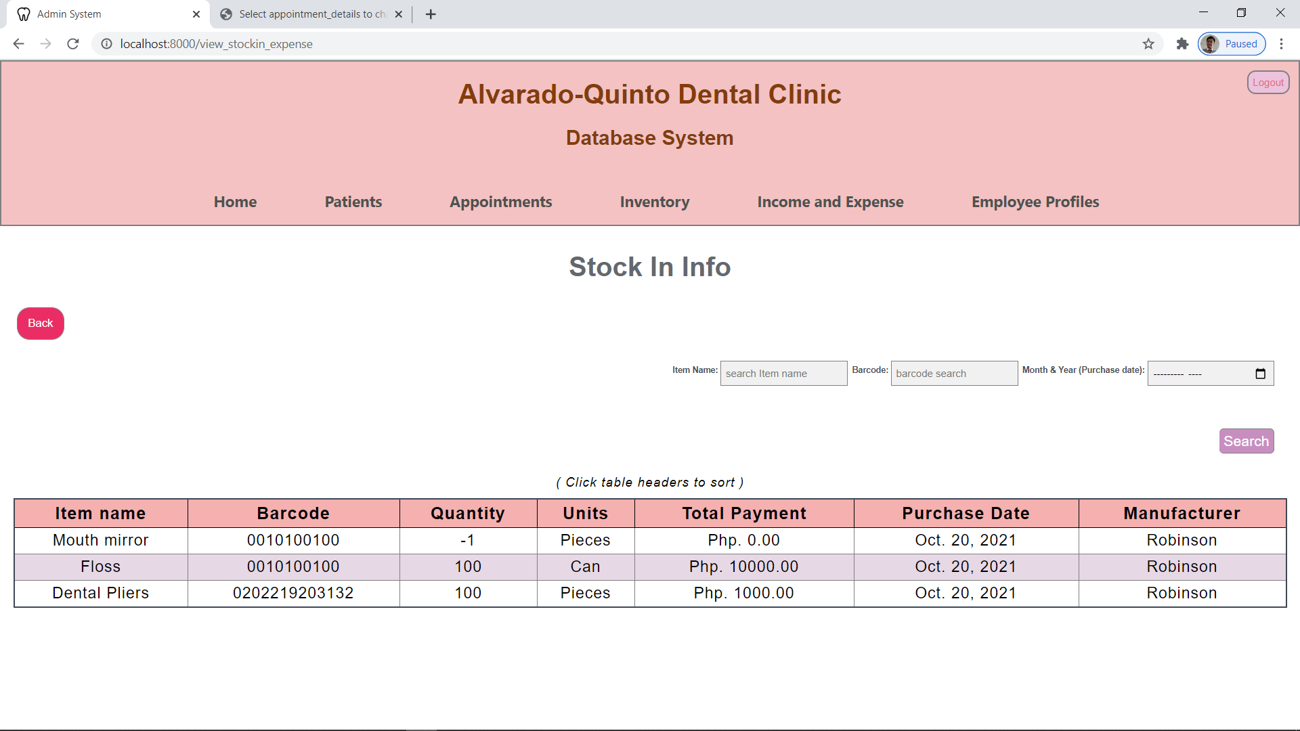

**BILLS EXPENSE DETAILS**

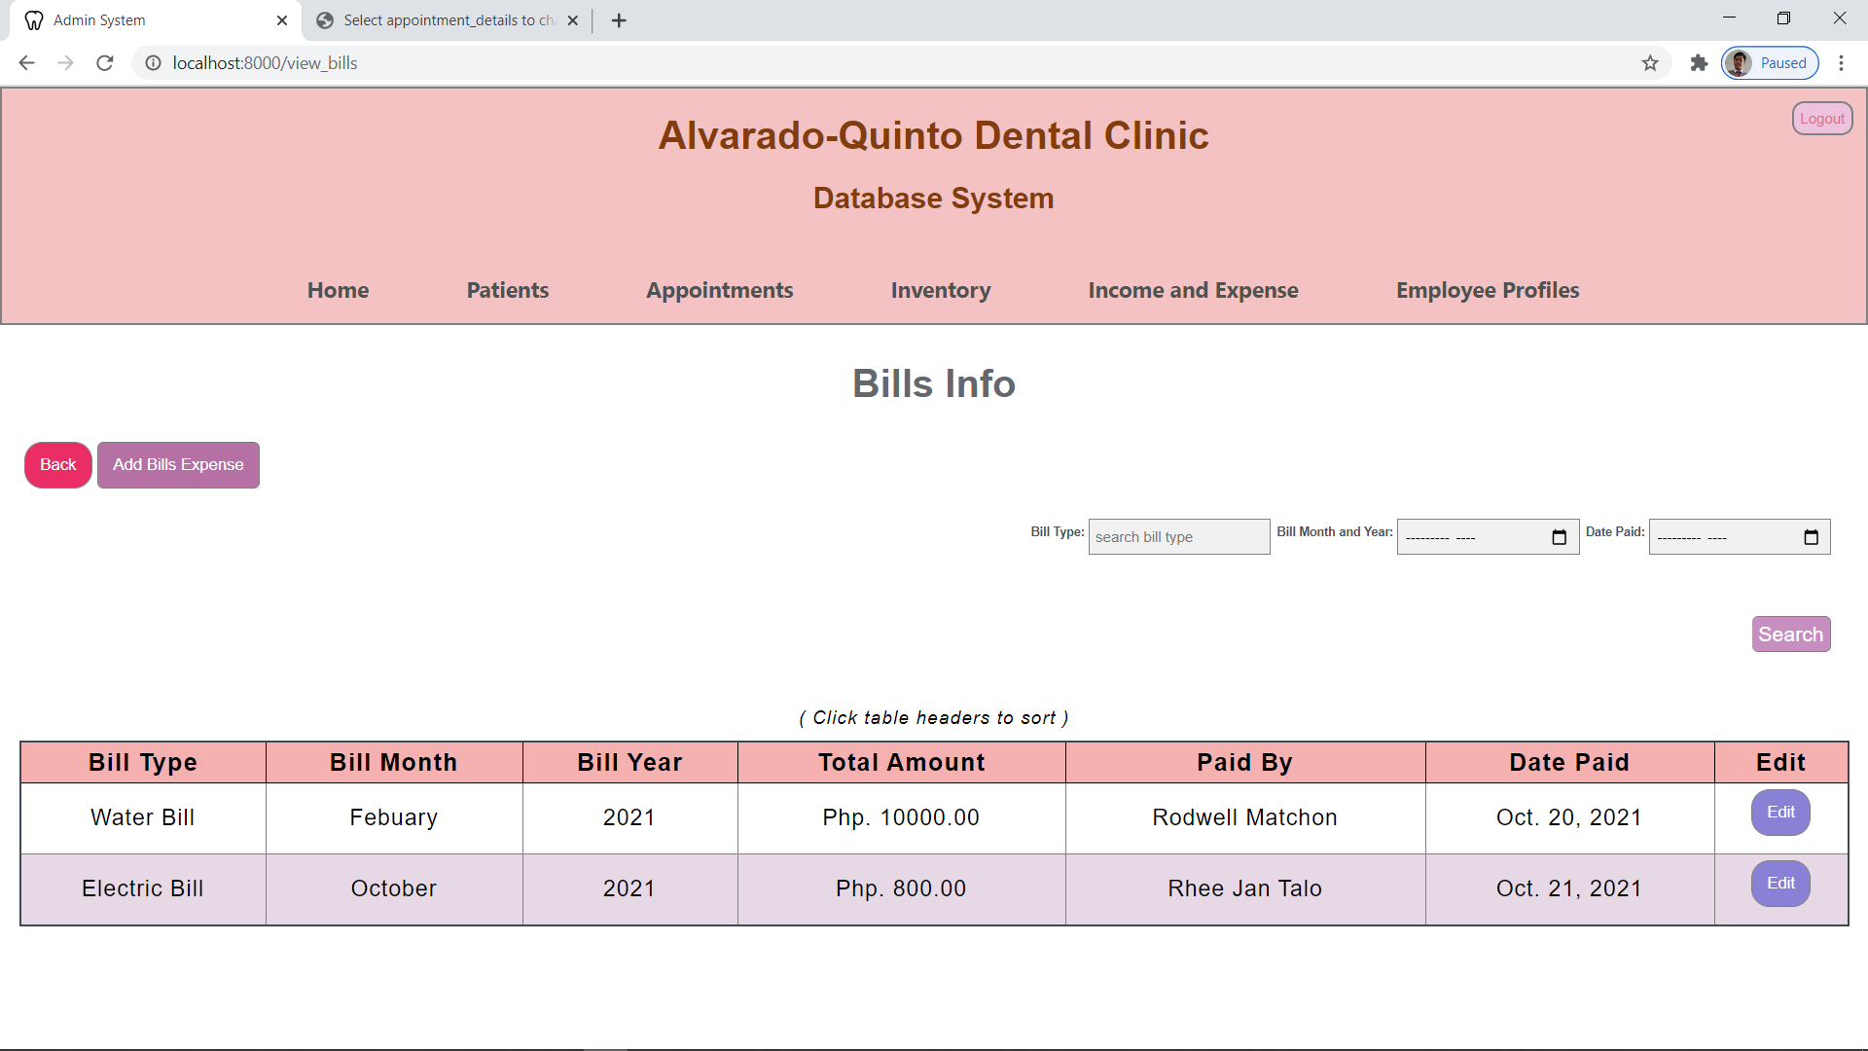

**ADDING OF EXPENSE DETAILS**

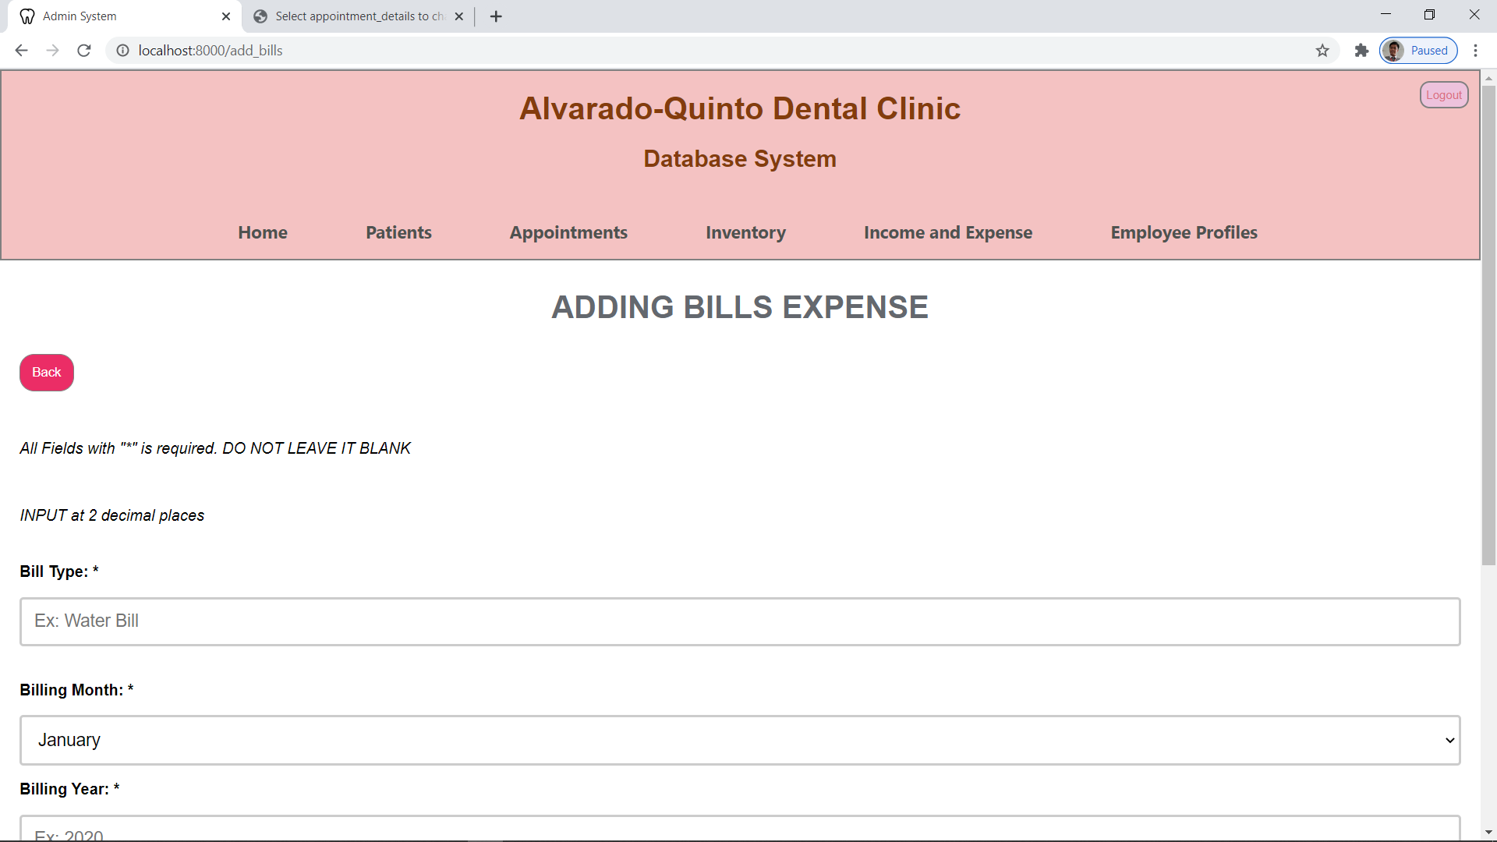

**EDITING EXPENSE DETAILS**

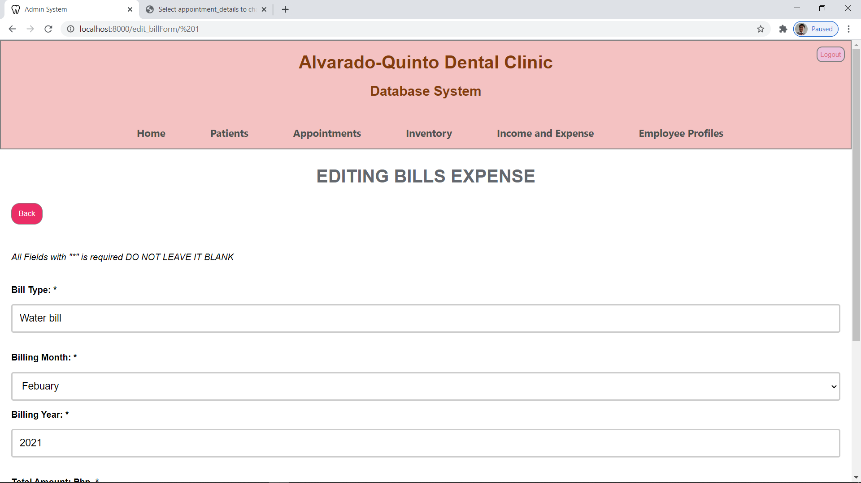

**TOTAL MONTHLY EXPENSES**

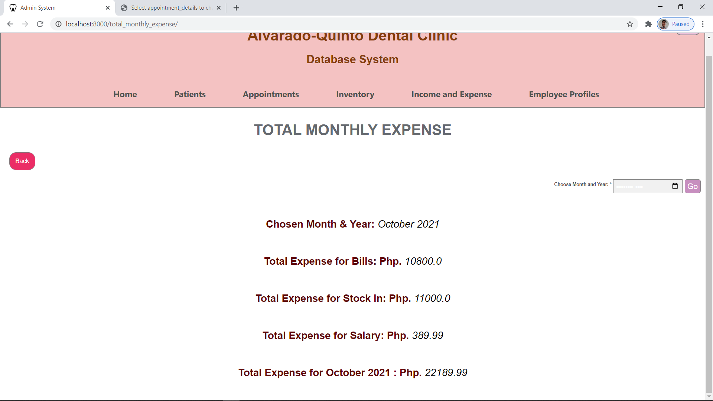

**TOTAL MONTHLY NET INCOME PAGE**

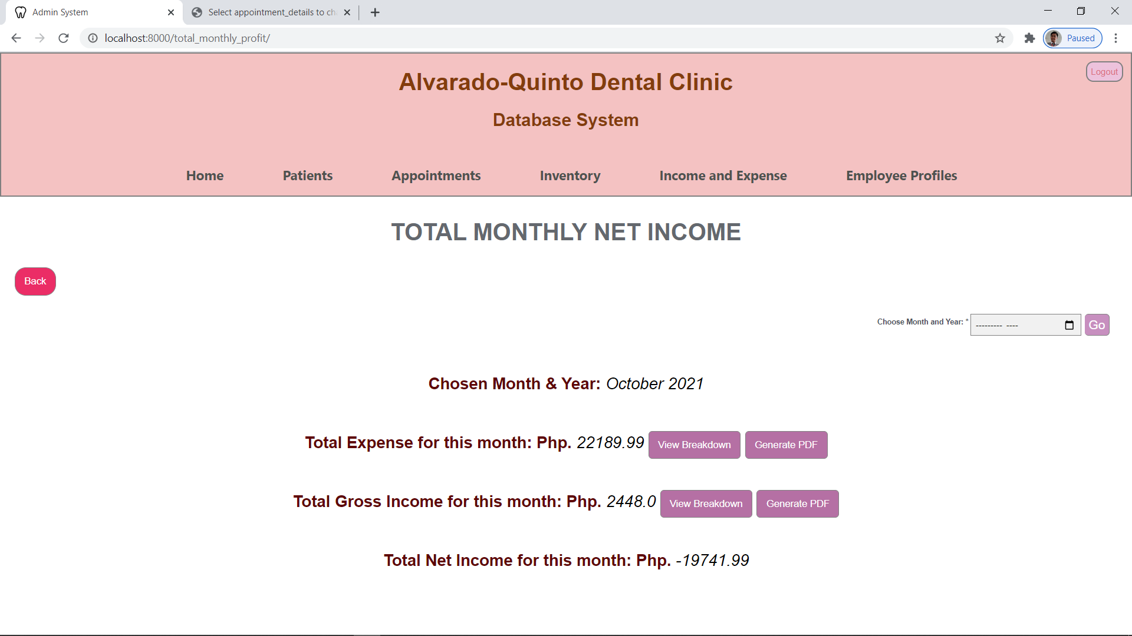

**EXPENSES BREAKDOWN (MONTHLY)**

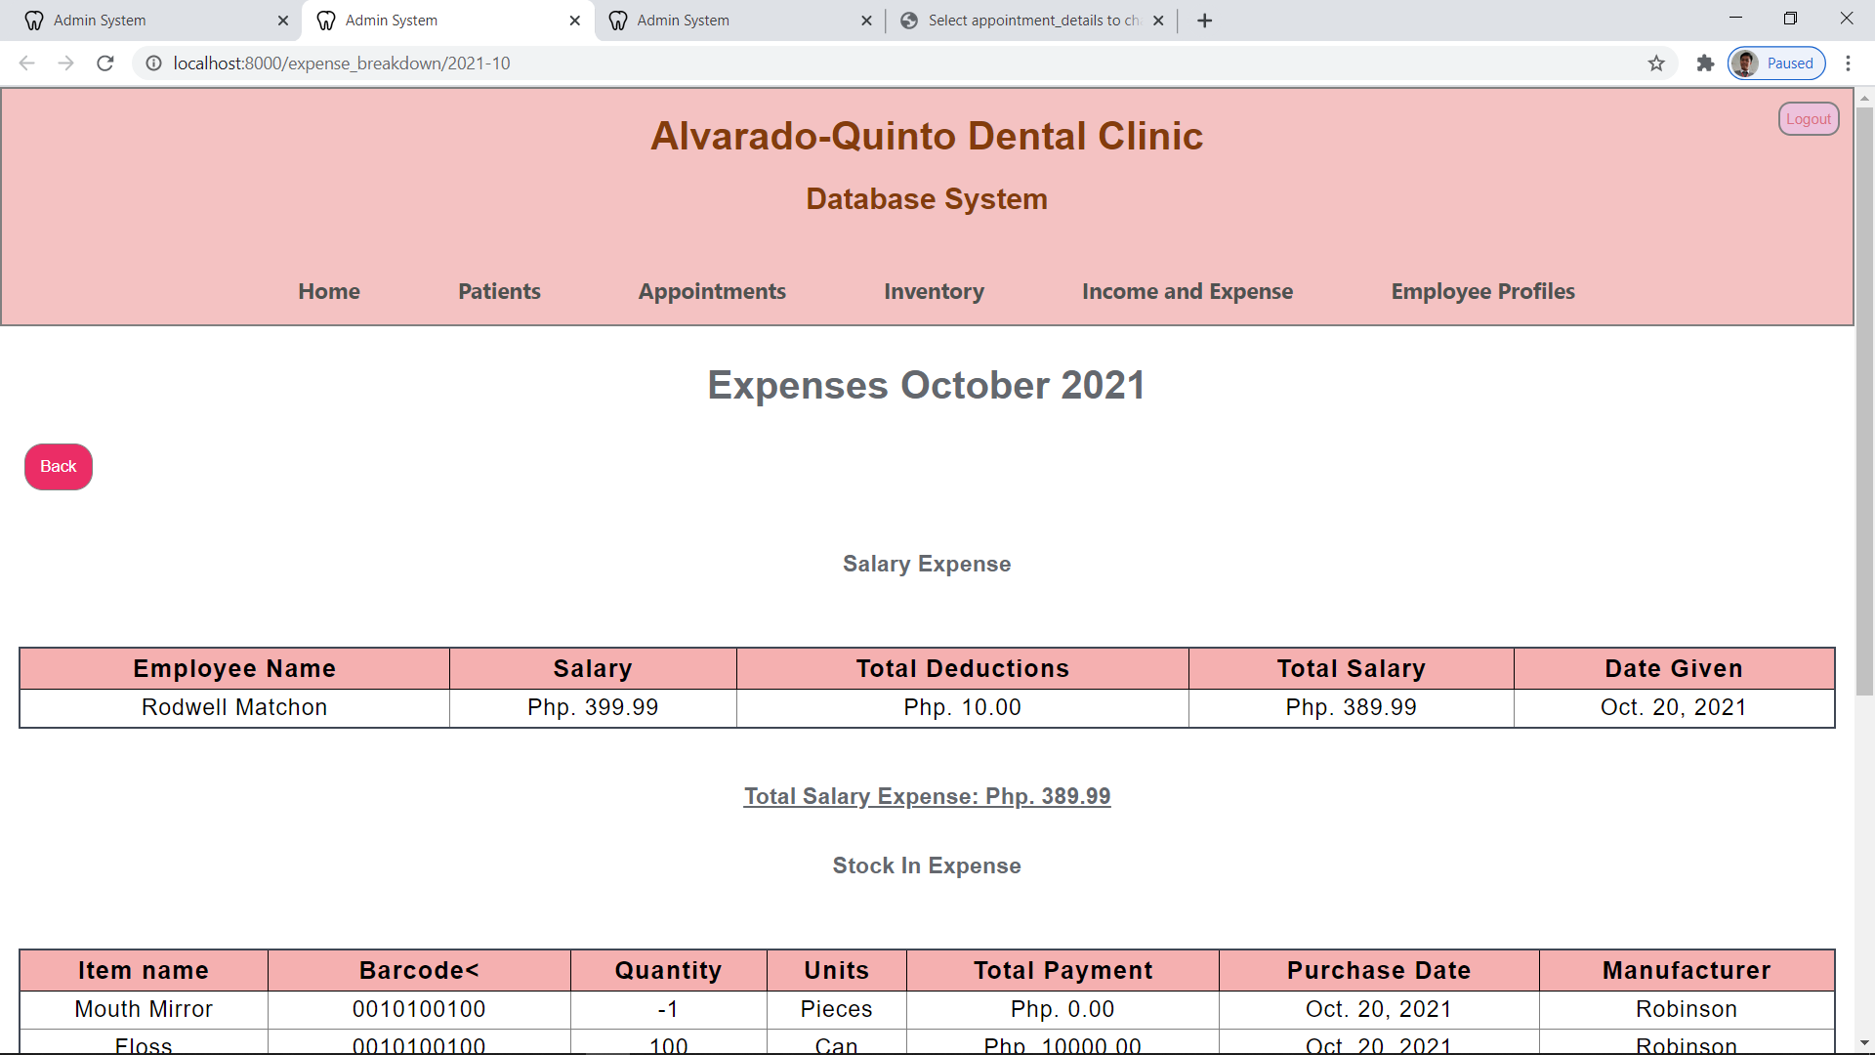

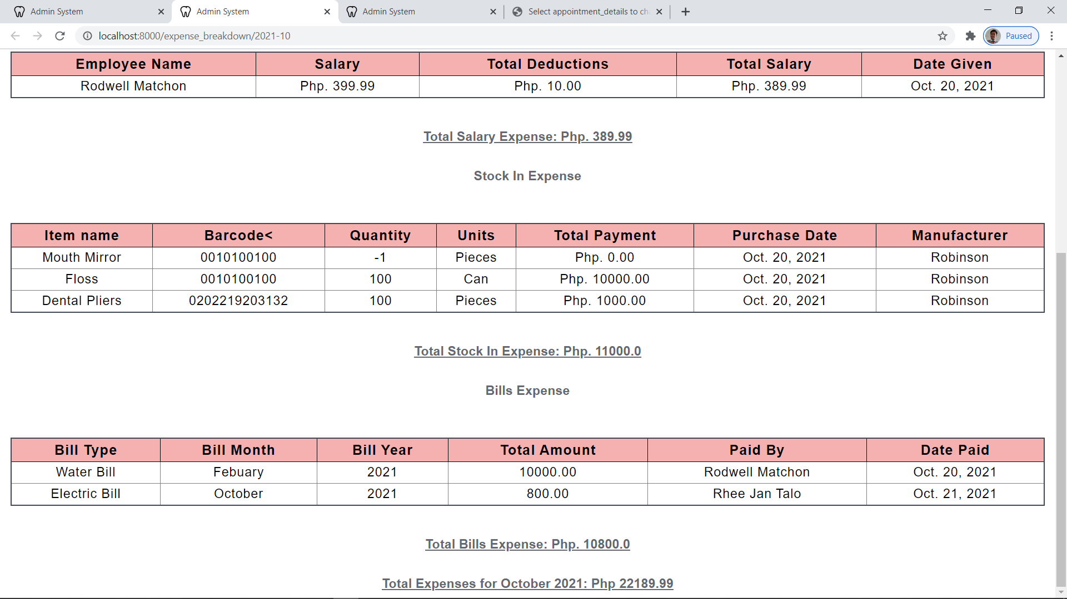

**INCOME BREAKDOWN (MONTHLY)**

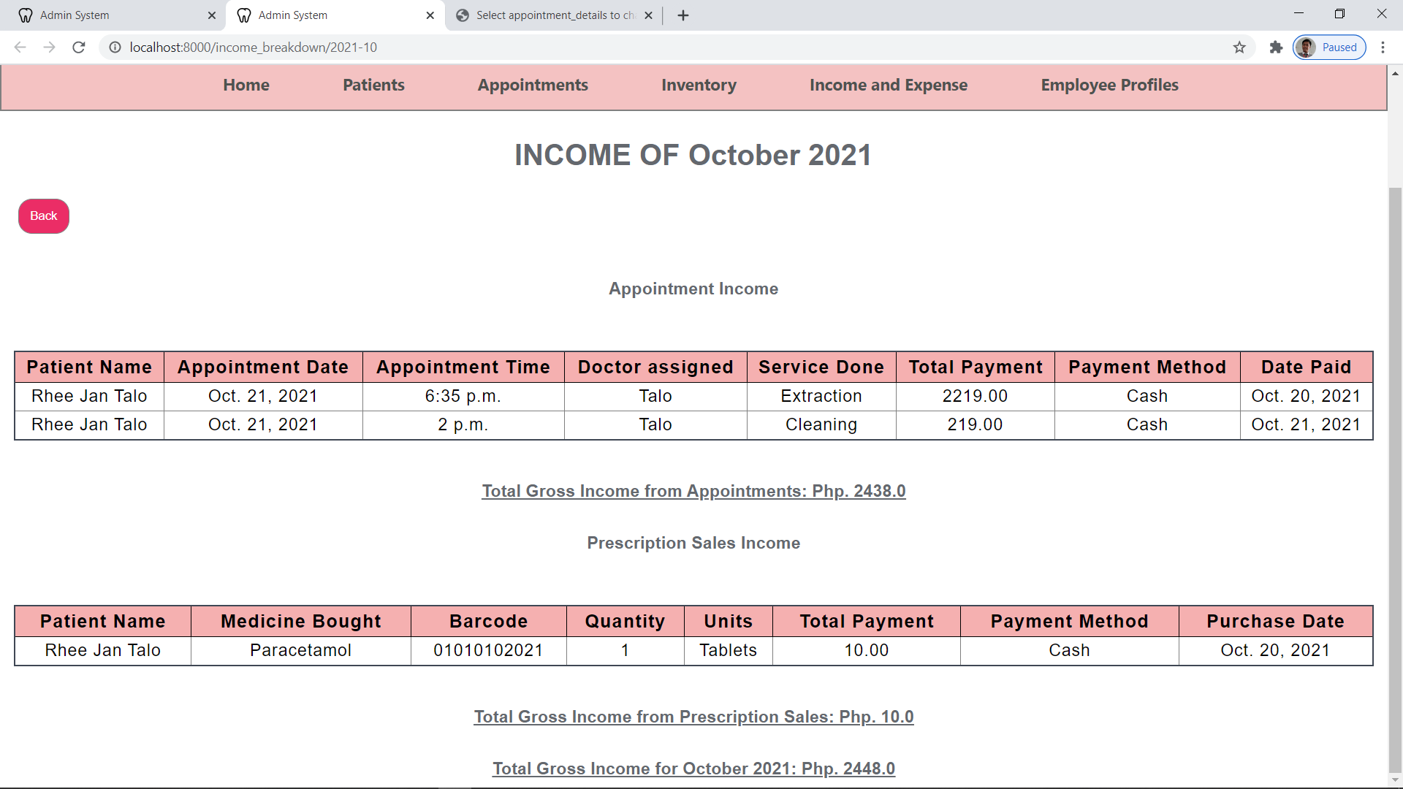

**EXPENSE REPORT(MONTHLY)**

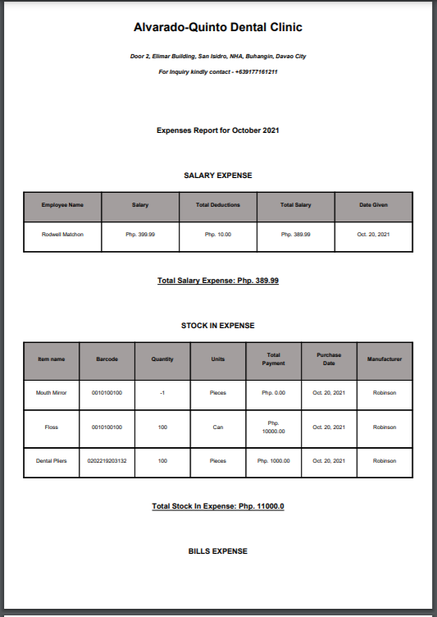

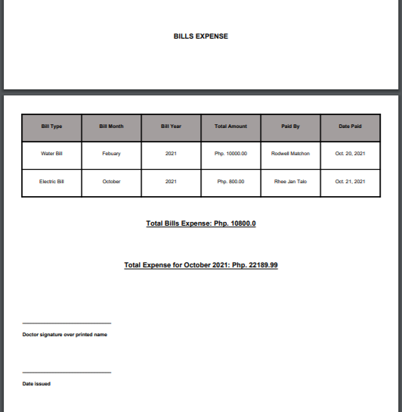

**INCOME REPORT(MONTHLY)**

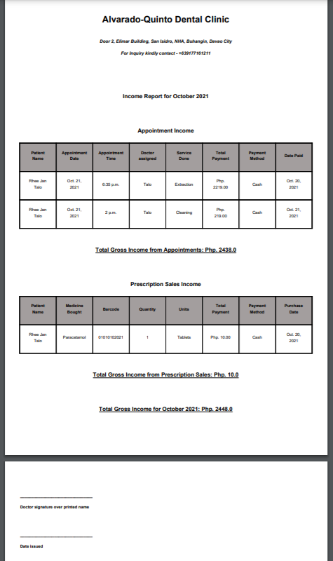

**Appendix(new):**

**Events Table**

|  |  |  |  |  |  |
| --- | --- | --- | --- | --- | --- |
| **Event** | **Trigger** | **Source** | **Use Case** | **Response** | **Destination** |
| ***Account*** |  |  |  |  |  |
| Patient profiling | New patient | Secretary/dentist | Crete new patient’s profile | New patient’s profile | Secretary/dentist |
| Update patient profile | New profile | Secretary/dentist | Update old patient profile | Updated patient profile | Secretary/dentist |
| Check patient profile | Check patient’s history | Secretary/dentist | Display patient’s profile | Show patient’s profile | Secretary/dentist |
| Employee profiling | New employee | Secretary/dentist | Create new employee’s profile | New employee’s profile | Secretary/dentist |
| Update employee profile | New profile | Secretary/dentist | Update old employee profile | Updated employee profile | Secretary/dentist |
| Check employee profile | Check employee’s history | Secretary/dentist | Display employee profile | Show employee profile | Secretary/dentist |
| ***Patient*** |  |  |  |  |  |
| Input patient address | New patient | Secretary/dentist | Create new patient’s address | New patient’s address | Secretary/dentist |
| Update patient address | New patient address | Secretary/dentist | Update old employee address | Updated employee profile | Secretary/dentist |
| Check patient address | Check patient’s address | Secretary/dentist | Display patient address | Show patient address | Secretary/dentist |
| Input patient allergies | Patient with allergies | Secretary/dentist | Create record of a patient’s allergies | New record of patient’s allergies | Secretary/dentist |
| Update patient allergies | New status of patient’s allergies | Secretary/dentist | Update record of patient’s allergies | Updated record of patient’s allergies | Secretary/dentist |
| Check patient allergies | Check patient’s allergies | Secretary/dentist | Display record of patient’s allergies | Show record of patient’s allergies | Secretary/dentist |
| Input medication history | New patient | Secretary/dentist | Create patient’s new medication history | New record of patient’s medication history | Secretary/dentist |
| Update medication history | Patient’s new medication history | Secretary/dentist | Update patient’s medication history | Updated patient’s medication history | Secretary/dentist |
| Check medication history | Check patient’s medication history | Secretary/dentist | Display medication history | Show medication history | Secretary/dentist |
| Input emergency contact person | New patient | Secretary/dentist | Create patient’s emergency contact person | New patient’s emergency contact person | Secretary/dentist |
| Update emergency contact person | New emergency contact person | Secretary/dentist | Update patient’s new emergency contact person | Updated patient’s new emergency contact person | Secretary/dentist |
| Check emergency contact person | Check patient’s emergency contact person | Secretary/dentist | Display patient’s emergency contact person | Show display patient’s emergency contact person | Secretary/dentist |
| Input patient teeth chart | New patient | Secretary/dentist | Create patient’s teeth chart | New patient’s teeth chart | Secretary/dentist |
| Check patient teeth chart | Check patient’s teeth chart | Secretary/dentist | Display teeth chart | Show patient’s teeth chart | Secretary/dentist |
| Update patient teeth chart | New teeth type of patient | Secretary/dentist | Update patient’s teeth chart | Updated patient’s teeth chart | Secretary/dentist |
| ***Employee*** |  |  |  |  |  |
| Input employee position | New employee | Secretary/dentist | Create new employee’s position | New employee’s position | Secretary/dentist |
| Update employee position | New employee’s position | Secretary/dentist | Update employee’s position | Updated employee’s position | Secretary/dentist |
| Check employee position | Check employee’s position | Secretary/dentist | Display employee’s position | Show employee’s position | Secretary/dentist |
| Input employee address | New employee | Secretary/dentist | Create new employee’s address | New employee’s address | Secretary/dentist |
| Update employee address | New employee’s address | Secretary/dentist | Update employee’s address | Updated employee’s address | Secretary/dentist |
| Check employee address | Check employee’s address | Secretary/dentist | Display employee’s address | Show employee’s address | Secretary/dentist |
| Input employee admin account | New employee | dentist | Create new employee’s admin account | New employee’s admin account | Secretary/dentist |
| Assign employee role | New Employee | Dentist | Assign employee role | Give employee job role | Dentist |
| ***Inventory*** |  |  |  |  |  |
| Input new items | New items | Secretary/dentist | Create records of new items | Record of new items | Secretary/dentist |
| Check items | Check items | Secretary/dentist | Display items | Show items | Secretary/dentist |
| Input stock in of inventory | New stocks of items | Secretary/dentist | Add stocks to the item’s records | Updated stocks of items | Secretary/dentist |
| Check stock in history | Check stock in history | Secretary/dentist | Display stock in history | Show stock in history | Secretary/dentist |
| Input stock out of inventory | Lesser stocks or lacking item | Secretary/dentist | Add stock out to item’s records | Updated stocks of items | Secretary/dentist |
| Check stock out history | Check stock history | Secretary/dentist | Display stock out history | Show stock out history | Secretary/dentist |
| Input item category | New item | Secretary/dentist | Create new item category | New item category | Secretary/dentist |
| Update item category | New item | Secretary/dentist | Update list of items in a category | Updated list of items in a category | Secretary/dentist |
| Check item category | Check item category | Secretary/dentist | Display list of items in a category | Show list of items in a category | Secretary/dentist |
| Input item location | New item | Secretary/dentist | Create new item location | New item location | Secretary/dentist |
| Update item location | New item | Secretary/dentist | Update item’s location | Updated item’s location | Secretary/dentist |
| Check item location | Check item location | Secretary/dentist | Display item location | Show item location | Secretary/dentist |
| Put inventory quantity or status | New item | Secretary/dentist | Create new item’s quantity or status | New item’s quantity or status | Secretary/dentist |
| Update inventory quantity or status | Time | Secretary/dentist | Update inventory quantity or status | Updated inventory quantity or status | Secretary/dentist |
| Check inventory quantity or status | Check item’s quantity or status | Secretary/dentist | Display inventory quantity or status | Show inventory quantity or status | Secretary/dentist |
| Input expiration date of perishable items | New perishable item | Secretary/dentist | Create data of perishable item with expiration date | New perishable item with expiration date | Secretary/dentist |
| Check expiration date of perishable items | Check expiration dates | Secretary/dentist | Display expiration dates of perishable items | Show expiration dates of perishable items | Secretary/dentist |
| Disregard expired items | Automatically stockout expired items | Time | Remove the expired items in the inventory | No expired items in the inventory | Database |
| ***Appointments*** |  |  |  |  |  |
| Update daily appointments | New appointment | Secretary/dentist | Update daily appointments | Updated daily appointments | Secretary/dentist |
| Check daily appointments | Check daily appointments | Secretary/dentist | Display daily appointments | Show daily appointments | Secretary/dentist and patient |
| Update scheduled appointments | New future appointment | Secretary/dentist | Update scheduled appointments | Updated scheduled appointments | Secretary/dentist |
| Check scheduled appointments | Check scheduled appointments | Secretary/dentist | Display scheduled appointments | Show scheduled appointments | Secretary/dentist and patient |
| Input walk-in treatments | New walk-in patients | Secretary/dentist | Create record of patient’s walk-in treatment | New record of patient’s walk-in treatment | Secretary/dentist |
| Check walk-in treatments history | Check walk-in treatments history | Secretary/dentist | Display patient’s record of walk-in treatment history | Show patient’s record of walk-in treatment history | Secretary/dentist and patient |
| Input actual appointments | New appointment | Secretary/dentist | Create patient’s new record of appointment | Patient’s new record of appointment | Secretary/dentist |
| Check actual appointments | Check patient’s actual appointments history | Secretary/dentist | Display patient’s actual appointments history | Show patient’s actual appointments history | Secretary/dentist and patient |
| Update available doctors | Availability of doctors | Secretary/dentist | Update availability of doctors | Updated availability of doctors | Secretary/dentist |
| Check available doctors | Check availability of doctors | Secretary/dentist | Display availability of doctors | Show availability of doctors | Secretary/dentist and patient |
| Input prescription | After treatment | Secretary/dentist | Create new prescription | New prescription | Secretary/dentist and patient |
| Check prescription | Check patient’s prescription history | Secretary/dentist | Display prescription history | Show prescription history | Secretary/dentist and patient |
| Record item/tools used | After treatment | Secretary/dentist | Record item/tools used for documentation | Record item/tools used to stock out database | Secretary/dentist |
| ***Finance*** |  |  |  |  |  |
| Input patient’s payment | After treatment | Secretary/dentist | Create record of patient’s new payment | New payment in patient’s record | Secretary/dentist and patient |
| Check patient’s payment | Check patient’s payment history | Secretary/dentist | Display payment history | Show payment history | Secretary/dentist |
| Input expenses | expenses | Secretary/dentist | Create record of expenses | Record of expenses | Secretary/dentist |
| Check daily expenses | Check daily expenses | Secretary/dentist | Display daily expenses | Show daily expenses | Secretary/dentist |
| Input expense details | New expense details | Secretary/dentist | Create new expense details | New expense details | Secretary/dentist |
| Check expense details | Check expense details | Secretary/dentist | Display expense details | Show expense details | Secretary/dentist |
| Input income | New income | Secretary/dentist | Create record of income | Record of income | Secretary/dentist |
| Check daily income | Check daily income | Secretary/dentist | Display daily income | Show daily income | Secretary/dentist |
| Input income details | New income details | Secretary/dentist | Create new income details | New income details | Secretary/dentist |
| Check income details | Check income details | Secretary/dentist | Display income details | Show income details | Secretary/dentist |
| ***Treatments*** |  |  |  |  |  |
| Input treatment name | New treatment | Secretary/dentist | Create new treatment record | New treatment record | Secretary/dentist |
| Update treatment name | Changed treatment | Secretary/dentist | Update treatment | Updated treatment | Secretary/dentist |
| Check treatment name | Check treatment name | Secretary/dentist | Display treatment name | Show treatment name | Secretary/dentist |
| Input treatment price | New treatment | Secretary/dentist | Create new treatment’s price | New treatment’s price | Secretary/dentist |
| Update treatment price | Changed treatment’s price | Secretary/dentist | Update treatment’s price | Updated treatment’s price | Secretary/dentist |
| Check treatment price | Check treatment price | Secretary/dentist | Display treatment’s price | Show treatment’s price | Secretary/dentist |
| Input treatment category | New treatment category | Secretary/dentist | Create new treatment category | New treatment category | Secretary/dentist |
| Update treatment category | Changed treatment category | Secretary/dentist | Update treatment category | Updated treatment category | Secretary/dentist |
| Check treatment category | Check treatment category | Secretary/dentist | Display treatment category | Show treatment category | Secretary/dentist |
| Input treatment status | New treatment | Secretary/dentist | Create new treatment’s status | New treatment’s status | Secretary/dentist |
| Update treatment status | Changed treatment status | Secretary/dentist | Update treatment’s status | Updated treatment’s status | Secretary/dentist |
| Check treatment status | Check treatment status | Secretary/dentist | Display treatment’s status | Show treatment’s status | Secretary/dentist |
| ***Accounts*** |  |  |  |  |  |
| Create admin account | New admin | Dentist | Create new admin account | New admin account | Database |
| View admin account | Check admin account | Dentist | Display admin account | Show admin account details | Dentist |
| Create employee account | New employee | Dentist | Create new employee account | New employee account | Database |
| View employee account | Check employee account | Dentist | Display employee account | Show employee account details | Dentist |
| Disables employee account | An employee left the clinic | Dentist | Lock and hide the employee account | Inactive employee account | Database |

**Fully developed Use Case**

1. **Employee Profiling**

|  |  |  |  |  |  |  |  |  |  |
| --- | --- | --- | --- | --- | --- | --- | --- | --- | --- |
| Use case name | Scenario | Triggering event | Brief description | Actors | Related use cases | Preconditions | Post conditions | Flow of events | Exception condition |
| Search employee profile | Search an employee profile | -Actor wants to look at the profile of an employee | Actor wants to look at the profile of an employee and find data that are needed to be updated | Doctor |  | There must be an existing employee profile | Profile doesn’t need to be updated | |  |  | | --- | --- | | Actor | System | | -The doctor wants to view the profile on an employee | - The system then will show the employee’s profile | | If the searched employee is not in the database then, the query will submit an error |
| Create new employee profile | Creates a new employee profile | -New employee has been hired | New employee has been hired and his profile is needed to be in the database | Doctor |  | The new employee must not be in the database | New employee profile has been created | |  |  | | --- | --- | | Actor | System | | -The doctor wants to add a new employee profile to the system | -after inputting all of the needed information, then the employee’s profile will be added to the database | | All needed information should be inputted and if not, creating the new profile will submit an error |
| Assign employee role | Assigning role to a new employee | -New employee | The new employee needs to have its role for the business | Doctor |  | The employee must not have a role yet | The employee is assigned to a specific role for the business | |  |  | | --- | --- | | Actor | System | | -The doctor will give the employee its role for the business | -The role given will reflect to the database | | The role given to the employee is open |
| Update employee profile | Updates the employee’s profile | -New job role  -New address  -change of name (if married)  -employee got fired | The employee got promoted/demoted or the employee got married and changed her name or the employee got fired | Doctor |  | Old employee information needs to be updated | All information about an employee is up-to-date | |  |  | | --- | --- | | Actor | System | | -The doctor will choose an employee and update its information | -The system will view all information about the employee  - All changes will reflect to the database | | If inputted information is incomplete, it will submit an error |

1. **Patient Profiling**

|  |  |  |  |  |  |  |  |  |  |
| --- | --- | --- | --- | --- | --- | --- | --- | --- | --- |
| Use case name | Scenario | Triggering event | Brief description | Actors | Related use cases | Preconditions | Post conditions | Flow of events | Exception condition |
| Search patient profile | Search a customer profile | -Actor wants to look at a patient profile | -Actor wants to check the patient profile and find the data that need to be updated | Nurse/  Secretary/  Doctor |  | There must be an existing patient profile | Profile doesn’t need to be updated | |  |  | | --- | --- | | Actor | System | | -The doctor/secretary wants to view the profile on a patient | -The system will show the patient’s profile | | If the searched patient is not in the database then, the query will submit an error |
| Create new patient profile | Creates a new patient profile | -New patient | -New patient had a dental service in the clinic for the first time | Nurse/  Secretary/  Doctor |  | The patient must not be in the database | New patient profile has been created | |  |  | | --- | --- | | Actor | System | | -The doctor/secretary wants to add a new patient profile to the system | -after inputting all of the needed information, then the patient profile will be added to the database | | All needed information should be inputted and if not, creating the new profile will submit an error |
| Create patient’s emergency contact person profile | Creates new patient’s emergency contact person profile | -New patient | -New patient had a dental service in the clinic for the first time | Nurse/  Secretary/  Doctor |  | The patient must not be in the database | New patient’s emergency contact person’s profile has been created | |  |  | | --- | --- | | Actor | System | | - The doctor/secretary wants to add a new patient profile to the system | -after inputting all of the needed information, then the patient profile will be added to the database | | All needed information should be inputted and if not, creating the new profile will submit an error |
| Update patient’s emergency contact person profile | Updates patient’s emergency contact person profile | -New emergency contact person  -New address or number of the emergency contact person | New emergency contact person information for the patient | Nurse/  Secretary/  Doctor |  | Old patient’s emergency contact person information needs to be updated | All information about the patient’s emergency contact person is up-to-date | |  |  | | --- | --- | | Actor | System | | -The doctor/secretary will choose a patient’s emergency contact person and update its information | -The system will view all information about the patient’s emergency contact person  - All changes will reflect to the database | | If inputted information is incomplete, it will submit an error |
| Update patient profile | Updates patient profile | -New name  -New address | The patient has new information about himself/herself | Nurse/  Secretary/  Doctor |  | Old patient information needs to be updated | All information about the patient is up-to-date | |  |  | | --- | --- | | Actor | System | | -The doctor/secretary will choose a patient and update its information | -The system will view all information about the patient  - All changes will reflect to the database | | If inputted information is incomplete, it will submit an error |
| Input patient teeth chart | Inputs patient teeth chart | -New patient | -New patient had a dental service in the clinic for the first time | Nurse/  Secretary/  Doctor |  | The patient must not be in the database | New patient’s teeth chart in his/her profile has been created | |  |  | | --- | --- | | Actor | System | | - The doctor/secretary wants to add a new patient profile to the system | -after inputting all of the needed information, then the patient profile will be added to the database | | If inputted information is incomplete, it will submit an error |
| Check patient teeth chart | Views patient teeth chart | -Actor wants to look at a patient’s teeth chart | -Actor wants to check the patient profile and find the data that need to be updated | Nurse/  Secretary/  Doctor |  | There must be an existing patient teeth chart | Profile doesn’t need to be updated | |  |  | | --- | --- | | Actor | System | | -The doctor/secretary wants to view the teeth chart on a patient’s profile | -The system will show the patient’s teeth chart | | If the searched patient is not in the database then, the query will submit an error |
| Update patient teeth chart | Updates patient teeth chart | -New teeth type of a patient | The patient’s teeth type is now an adult type | Nurse/  Secretary/  Doctor |  | Old patient information needs to be updated | All information about the patient is up-to-date | |  |  | | --- | --- | | Actor | System | | -The doctor/secretary will choose a patient and update its teeth chart | -The system will view all information about the patient  - All changes will reflect to the database | | If inputted information is incomplete, it will submit an error |

1. **Finance management**

|  |  |  |  |  |  |  |  |  |  |
| --- | --- | --- | --- | --- | --- | --- | --- | --- | --- |
| Use case name | Scenario | Triggering event | Brief description | Actors | Related use cases | Preconditions | Post conditions | Flow of events | Exception condition |
| View expense details | View expense details | -Actor wants to see the details of a specific expense | -Showing the details of the expense | Nurse/  Secretary/  Doctor |  | There is a record of all expenses | Shows the specific expense details that the actor wants to see | |  |  | | --- | --- | | Actor | System | | -The actor will choose a date and/or time of an expense | -Shows the detailed information of an expense. | | -There are no expense records |
| View all listed expenses | View all listed expenses | -Actor wants to see all expenses | -Showing all expenses | Nurse/  Secretary/  Doctor |  | There is a record of all expenses | Shows the record of all expenses | |  |  | | --- | --- | | Actor | System | | -The actor will access the record of all expenses | -Shows the list of all expenses | | - There are no expense records |
| Add expense details | Adds expense details | -Actor wants to add new expense details | -Adding expense details | Nurse/  Secretary/  Doctor |  | The specific expense details must not be existed in the database | Creates new expense details | |  |  | | --- | --- | | Actor | System | | -The actor will input new expense details | -Adds new expense details to the database | | Expense details already existed |
| Calculate monthly savings | Calculates monthly savings | -Actor wants to know the monthly savings | Calculates and shows the monthly savings | Nurse/  Secretary/  Doctor |  | Monthly savings are not calculated | Shows the result of the calculation of the monthly savings | |  |  | | --- | --- | | Actor | System | | -The actor wants to calculate the monthly savings | -Solves and prints the monthly savings | | Monthly savings are already calculated |
| Add income details | Adds income details | -Actor wants to add new income details | -Adding income details | Nurse/  Secretary/  Doctor |  | The specific income details must not be existed in the database | Creates new income details | |  |  | | --- | --- | | Actor | System | | -The actor will input new income details | -Adds new income details to the database | | Income details already existed |
| View listed income | Views all listed income | -Actor wants to see all income | -Showing all income | Nurse/  Secretary/  Doctor |  | There is a record of all income | Shows the record of all income | |  |  | | --- | --- | | Actor | System | | -The actor will access the record of all income | -Shows the list of all income | | - There are no income records |
| View income details | Views income details | -Actor wants to see the details of a specific income | -Showing the details of the income | Nurse/  Secretary/  Doctor |  | There is a record of all income | Shows the specific income details that the actor wants to see | |  |  | | --- | --- | | Actor | System | | -The actor will choose a date and/or time of an income | -Shows the detailed information of an income. | | -There are no expense records |
| View all listed calculated savings per month | Views all listed calculated savings per month | -Actor wants to see all calculated monthly savings | -Showing all monthly savings | Nurse/  Secretary/  Doctor |  | There is a record of all monthly savings | Shows the record of all monthly savings | |  |  | | --- | --- | | Actor | System | | -The actor will access the record of all monthly savings | -Shows the list of all monthly savings | | - There are no monthly savings records |
| Record tools/items used | Record tools/items used | After successful treatment | Record used tools/items for stock out documentation | Nurse/  Secretary/  Doctor |  | Tool/items were used during the treatment | Tool/items used got documented | |  |  | | --- | --- | | Actor | System | | -The actor will record all of the items/tools that was used during the treatment | -- All of the inputted data will be reflected on the database  - The system will send all of the recorded data to the patient’s medication history and the stock-out database | | -No tool/items were used |

1. **After Treatment**

|  |  |  |  |  |  |  |  |  |  |
| --- | --- | --- | --- | --- | --- | --- | --- | --- | --- |
| Use case name | Scenario | Triggering event | Brief description | Actors | Related use cases | Preconditions | Post conditions | Flow of events | Exception condition |
| Record Services done | Record the services done after the treatment | After treatment | Records all of the services done to the patient and add it to the database for proper documentation | Nurse/  Secretary/  Doctor |  | The treatment was done | The successful treatment reflects to the patient’s medical record | |  |  | | --- | --- | | Actor | System | | -The actor will record the services done to the patient into his/her medication history | - All of the inputted data will be reflected on the database  - The system will send all of the recorded data to the patient’s medication history | | The patient did not/failed to go to the appointment |
| Record payment info | Record the payment information done by the patient | After treatment | Record the payment information done by the patient for proper documentation | Nurse/  Secretary/  Doctor |  | The payment is done | The successful payment reflects to the patient’s medical record | |  |  | | --- | --- | | Actor | System | | -The actor will record the payment info of the patient into his/her medication history | - All of the inputted data will be reflected on the database  - The system will send all of the recorded data to the patient’s medication history | | The patient did not/failed to go to the appointment |
| Calculate total payment | Calculate total payments needed to be paid by the costumer | After treatment | Calculate the service fee, consultation fee and other services availed by the patient | Nurse/  Secretary/  Doctor |  | The payment is being processed | The payment is ready to be processed | |  |  | | --- | --- | | Actor | System | | -The actor will input all of the fees needed to be paid | - The system will calculate the total amount needed to be paid | | The patient did not/failed to go to the appointment |
| Record meds prescription | Record the meds prescription given to the patient | After treatment | After the successful treatment, the doctor will give med prescription which will be recorded to the database | Nurse/  Secretary/  Doctor |  | The treatment is done | All of the doctor’s prescription will reflect to the patient’s medical record | |  |  | | --- | --- | | Actor | System | | -The actor will record the meds prescription given to the patient into his/her medication history | - All of the inputted data will be reflected on the database  - The system will send all of the recorded data to the patient’s medication history | | The patient did not/failed to go to the appointment |

1. **Appointment Management**

|  |  |  |  |  |  |  |  |  |  |
| --- | --- | --- | --- | --- | --- | --- | --- | --- | --- |
| Use case name | Scenario | Triggering event | Brief description | Actors | Related use cases | Preconditions | Post conditions | Flow of events | Exception condition |
| Add patient appointment information | Adding patient appointment details | Patient requested for an appointment | The patient requested for an appointment to cure his dental problems | Nurse |  | The patient is registered in the database | The patient will have his/her appointment in the decided schedule | |  |  | | --- | --- | | Actor | System | | -the actor will input all of the decided service, time sched, and chosen doctor of the patient | - All of the inputted data will be reflected on the database  - The system will send all of the recorded data to the patient’s medication history | | Patient does not exist in the database. |
| Show available service | Show available services | Setting up an appointment for the patient | Show available services offered by the clinic | Nurse |  | The patient wants to make an appointment | The patient will decide what services he/she will avail | |  |  | | --- | --- | | Actor | System | | -The actor will show the available services they offer to the patient | -show all available services that the clinic offers | | There are no available services for the time-being. |
| Add chosen service | Add chosen service | Setting up an appointment for the patient | Add the chosen service to the patient appointment details | Nurse |  | The patient decided what services he/she will avail | The patient agreed to avail the services he/she chose | |  |  | | --- | --- | | Actor | System | | -The actor will input the chosen services that the patient wants to avail. | -the system will then input the chosen service and record it on the database  - The system will send all of the recorded data to the patient’s appointment information. | | The chosen service is unavailable |
| Add appointment type | Add appointment type | Setting up an appointment for the patient | Add the appointment type to the patient appointment details | Nurse |  | The patient wants to make an appointment | The patient made an appointment | |  |  | | --- | --- | | Actor | System | | -The actor will input what type of appointment the patient wants | -the system will then input the data given and record it on the database  - The system will send all of the recorded data to the patient’s appointment information. | |  |
| Add chosen appointment schedule. | Add chosen appointment schedule. | Setting up an appointment for the patient. | Add the chosen appointment schedule to the patient appointment details. | Nurse |  | The desired service is inputted. | No conflicts to other appointment schedules. | |  |  | | --- | --- | | Actor | System | | -The actor will discuss to the patient when is his/her desired time schedule.  -The actor will input the chosen time schedule of the patient. | -the system will show all of the appointment schedules.  - The system will record the chosen time schedule of the patient.  - The system will send all of the recorded data to the patient’s appointment information. | | No conflicts to other appointment schedule, if there is conflict then repeat the use case. |
| Show available doctors | Show available doctors | Setting up an appointment for the patient | Show available doctors by the scheduled time slot | Nurse |  | The patient wants to choose the doctor he/she wanted to do the services | The patient can now decide on the Doctor he wanted. | |  |  | | --- | --- | | Actor | System | | -The actor will show the available doctors that can do the treatment | -The system will show the doctors that are currently available | | There are no currently available doctors for the chosen time and or chosen service |
| Add chosen doctor | Add the chosen doctor | Setting up an appointment for the patient | Add the chosen doctor to the patient appointment details | Nurse |  | The patient decided on the doctor he/she wanted | The doctor is free on the chosen time and can do the chosen service | |  |  | | --- | --- | | Actor | System | | -The actor will input the patient’s chosen doctor | -the system will then input the chosen doctor and record it on the database  - The system will send all of the recorded data to the patient’s appointment information. | | No conflicts on the doctor’s schedule and he/she can do the chosen service, if there is conflict and/or cannot do the chosen service, then repeat the use case. |
| Show patient appointment information | Show patient appointment information | Setting up an appointment for the patient | Shows patient appointment information for documentation purposes | Nurse |  | The patient has an appointment | The nurse can now disseminate the information to the doctor | |  |  | | --- | --- | | Actor | System | | -The actor will show the patient’s appointment information to the doctor | -The system will show the availed services, chosen doctor, and the time schedule of the patient | | The patient doesn’t have an appointment |
| Show appointment schedules | Show appointment schedules | -Check appointment schedules for the day | Shows all appointment schedules categorized by patient and date | Nurse |  | There are appointment schedules for the day | The nurse can now disseminate the information to the doctor | |  |  | | --- | --- | | Actor | System | | -The actor will look at the appointment schedules for the day | -The system will show the appointment schedules categorized by patient and date. | | There are no scheduled appointments for the day |

1. **Inventory Management**

|  |  |  |  |  |  |  |  |  |  |
| --- | --- | --- | --- | --- | --- | --- | --- | --- | --- |
| Use case name | Scenario | Triggering event | Brief description | Actors | Related use cases | Preconditions | Post conditions | Flow of events | Exception condition |
| Show inventory items | Shows inventory items | -Actor wants to see the items | Shows the inventory items | Nurse/  Secretary/  Doctor |  | There is a record of inventory items | Shows the list of inventory items | |  |  | | --- | --- | | Actor | System | | -Actor will access the records of inventory items | -The system will show the records of inventory items | | No records of inventory items |
| Add inventory items | Adds inventory items | New items | Adds new records of the new inventory items | Nurse/  Secretary/  Doctor |  | No existing records of the new inventory items | New inventory items added in the database | |  |  | | --- | --- | | Actor | System | | -Actor will input the new inventory items in the system | -New inventory items have records in the database | | New inventory items already existed in the database |
| Show item location | Shows item location | Actor wants to see the locations of the items | Shows the locations of each items | Nurse/  Secretary/  Doctor |  | Items are distributed and placed on their respective locations | Shows the exact location of a certain item | |  |  | | --- | --- | | Actor | System | | -Actor will search the location of an item | The system will show the location of the item searched by the actor | | Items do not have a location assigned to them |
| Show item quantity | Shows item quantity | Actor wants to know the quantity of an item | Shows the quantity of the item | Nurse/  Secretary/  Doctor |  | Items has a quantity to be shown | Shows the quantity of the item | |  |  | | --- | --- | | Actor | System | | -Actor will search an item to know its quantity left | The system will show the quantity of the searched item | | Items do not exist |
| Notify if item is low in stock | Notifies if item is low in stock | Actor wants to be updated of the quantity of an item | Notifies the actor if there is an item that is low in stock | Nurse/  Secretary/  Doctor |  | Item is low in stock | Notifies the actor about which item has low in stock | |  |  | | --- | --- | | Actor | System | | -Actor will wait for the system to notify if there’s an item that is low in stock | Notifies the actor if an item is low in stock | | Items do not exist |
| Show item status | Shows item status | Actor wants to know the status of an item | Shows the status of an item | Nurse/  Secretary/  Doctor |  | Item’s status is initialized or changed | Shows the status of the item | |  |  | | --- | --- | | Actor | System | | -Actor will search for an item to know its status | Shows the status of the searched item | | Items do not exist |
| Update inventory status | Updates inventory status | Actor wants to change the status of an inventory | Updates the status of the inventory | Nurse/  Secretary/  Doctor |  | Item’s status needs to be changed | New status for the inventory | |  |  | | --- | --- | | Actor | System | | -Actor will input a new status of an inventory | New status of an inventory | | If inputted information is incomplete, it will submit an error |
| Record stock in date | Records stock in dates | Actor wants to keep a record of the stock in dates | Records dates of stock ins | Nurse/  Secretary/  Doctor |  | No records of stock ins dates | New records of stock in dates | |  |  | | --- | --- | | Actor | System | | -Actor will input new record of a stock in dates | New record of stock in dates | | Same stock in date and item already existed in the database |
| Record stock out date | Records stock out dates | Actor wants to keep a record of the stock out dates | Records dates of stock outs | Nurse/  Secretary/  Doctor |  | No records of stock outs dates | New records of stock out dates | |  |  | | --- | --- | | Actor | System | | -Actor will input new record of a stock out dates | New record of stock out dates | | Same stock out date and item already existed in the database |
| Record stock out details | Records stock out details | Actor wants to keep a record of the stock out details | Records details of stock outs | Nurse/  Secretary/  Doctor |  | No records of stock outs details | New records of stock out details | |  |  | | --- | --- | | Actor | System | | -Actor will input new record of a stock out  details | New record of stock out details | | Same stock out details and item already existed in the database |
| Input expiration dates of perishable items | New perishable item | Actor wants to record the expiration date of an item | Records expiration date of an item | Nurse/  Secretary/  Doctor |  | No records of perishable items with expiration dates | New records of perishable items with expiration dates | |  |  | | --- | --- | | Actor | System | | -Actor will input new expiration dates of perishable items | New record of perishable items with updated expiration dates | | No perishable items in the inventory database |
| Check expiration date of perishable items | Checking the expiration dates of perishable items | Actor wants to check the expiration dates of perishable items | Viewing the expiration dates | Nurse/  Secretary/  Doctor |  | There are perishable items with expiration dates | Shows the list of expiration dates of perishable items | |  |  | | --- | --- | | Actor | System | | -Actor wants to view the expiration dates of each perishable items | Displays the expiration dates | | No perishable items with expiration dates |
| Disregard expired items | The expiration date is already exceeded | Time | Automatically stockouts the expired items | Database |  | There are perishable items with expiration dates | No expired items in the inventory | |  |  | | --- | --- | | Actor | System | | -The expiration date of a perishable item is exceeded by the current date | Removes the expired items in the database | | There are still no expired items |

**7. Accounts Management**

|  |  |  |  |  |  |  |  |  |  |
| --- | --- | --- | --- | --- | --- | --- | --- | --- | --- |
| Use case name | Scenario | Triggering event | Brief description | Actors | Related use cases | Preconditions | Post conditions | Flow of events | Exception condition |
| Create admin account | Creates new admin account | -New admin | Creates a new admin account | Doctor |  | There is an admin account to create new accounts | New admin account | |  |  | | --- | --- | | Actor | System | | -Actor will create new admin account | -Creates new admin account | | No preexisting admin account |
| View admin account | Checks admin account | Actor wants to check admin account details | Checking admin account | Doctor |  | There is an admin account | Shows admin account details | |  |  | | --- | --- | | Actor | System | | -Actor will check the admin account | Displays the details of an admin account | | No other admin account |
| Create employee account | Creates new employee account | -New employee | Creates a new employee account | Doctor |  | There is an admin account to create new accounts | New employee account | |  |  | | --- | --- | | Actor | System | | -Actor will create new employee account | -Creates new employee account | | No preexisting admin account |
| View employee account | Checks employee account | Actor wants to check employee account details | Checking employee account | Doctor |  | There is an employee account | Shows employee account details | |  |  | | --- | --- | | Actor | System | | -Actor will check the employee account | Displays the details of an employee account | | No admin account |
| Disable employee account | Disables employee account | An employee leaves the clinic | An employee account would be inactive since the employee is no longer in the clinic anymore | Doctor |  | Employee account no longer has an owner | Inactive employee account | |  |  | | --- | --- | | Actor | System | | -Actor will disable the employee account | The employee account will be locked and hidden | | Employee is still working in the clinic |